NAME ____________________________

BIO I SEMESTER REVIEW

1The sum of all the chemical reactions in a cell is called _____________________.

- In animal cells glucose molecules are stored in long chains called __________________.

starch cellulose glycogen

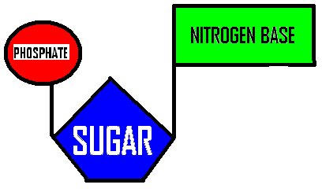
- This subunit is ___________________

glucose an amino acid a nucleotide a phospholipid

- This molecule could be joined together with others like it to make _______________

proteins nucleic acids lipids glycogen
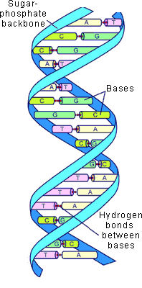

- The function of this molecule is to ________

Store energy
Carry information from nucleus to ribosomes
Store genetic information
Make cell membranes

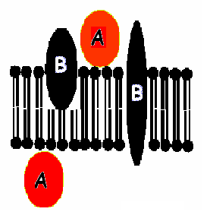

6. In this diagram of a cell membrane, which of the labeled molecules are PERIPHERAL PROTEINS?
A or B

7. The process of maintaining stable internal conditions is called ______________________.

8. Name a molecule found in cell membranes. ______________________________________

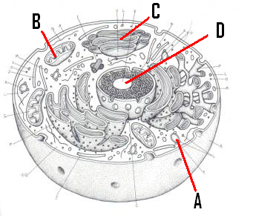

9. Name C

10. What is the function of C ?
- make ribosomes
- act as intracellular highway
- make proteins
  - package molecules for transport

11. Which of the following is a kind of ACTIVE TRANSPORT?
- Osmosis
- Ion channels
- Facilitated diffusion
- Pinocytosis

12. Name the kind of transport used by large molecules or whole cells to enter cells.

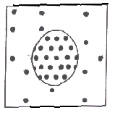
This diagram shows a cell in a solution.
The black dots represent solute molecules.

13. This cell is in a ________tonic solution.

14. What will happen to this cell?
- It will shrink
- It will swell and explode
It will stay the same size

15. Which cell organelle provides the energy used in active transport ?

16. DNA that is spread out in the nucleus of a NON-dividing cell is
called _____________.

17. Type of reproduction in which offspring are produced
from the genetic material of only ONE parent. __________________________________

18. The phase of mitosis in which the nucleus and nucleolus disappear, spindle fibers and centrioles appear, and DNA scrunches up into chromosomes = ________________________

19. The matching up of homologous chromosomes during prophase I of meiosis is called ___________________________________

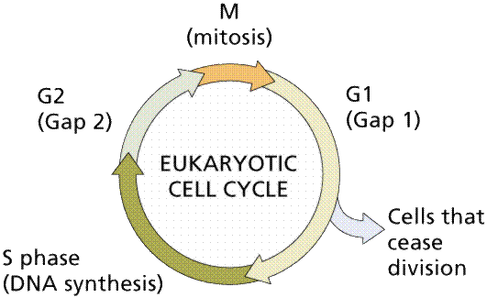
20. In which phase at the left does the cell spend most of its time “doing it’s
job” ?
________________

21. A person with an A and a B allele having AB type blood is an example of
__________ dominance.

Complete Co incomplete

22.Another name for homozygous is _______________________.

hybrid pure dominant mutant polygenic

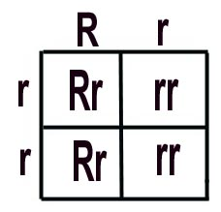
23. What is the probability that an offspring from this cross will show the DOMINANT trait?

0% 25% 50% 75% 100%

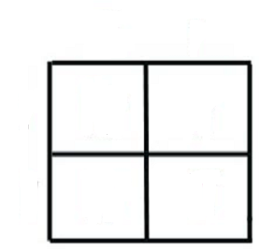
24.This Punnett square would be used to show the offspring from a ___________ cross.

MONOHYBRID DIHYBRID

25. The genes an organism has is called its ______________________.

PHENOTYPE GENOTYPE

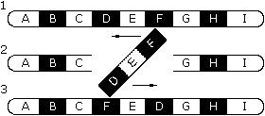

26. This mutation is called a(n) ____________________________.

Substitution translocation deletion inversion nondisjuction

27. Name the genetic disorder in which chloride ion channel proteins are changed and thick mucous builds up in the lungs and digestive organs.
____________________________

28. A gene that masks or hides another is called ________________________.

29. _________ cell mutations happen in sperm or egg cells so they are passed on to offspring.

SOMATIC GERM

30. Which of the following is caused by nondisjunction?
    - Huntington’s
    - Hemophilia
    - Down syndrome
    - PKU
    - cystic fibrosis

