WHAT SHOULD I KNOW FOR THE TEST

INTRO TO BIOLOGY-Chapters 1 & 2

CHARACTERISTICS OF LIVING THINGS:
What is the science that studies living things? BIOLOGY

What is another name for a living thing? ORGANISM

An organism that can make its own food = AUTOTROPH; also called a PRODUCER

An organism that can’t make its own food and gets its energy by eating other organisms
= HETEROTROPH; also called a CONSUMER

What is an organism made of only one cell called? UNICELLULAR

What is an organism made of many cells called? MULTICELLULAR

Which of these words describes you? MULTICELLULAR HETEROTROPHS

What kind of reproduction makes offspring using the DNA from only one parent? ASEXUAL

What kind of reproduction makes offspring using the DNA from two parents? SEXUAL

Process by which organisms maintain a relatively stable internal environment = HOMEOSTASIS.

All the chemical reactions that build up and break down molecules in living things = METABOLISM
The process by which cells change to become different kinds of cells with different functions = DIFFERENTIATION

The process by which organisms as a group change over time;
Process by which modern organisms have descended from ancient organisms = EVOLUTION

What do we call embryonic cells that have the potential to become different kinds of cells? STEM CELLS

A signal to which an organism responds = STIMULUS

A LITTLE CHEMISTRY

Know the symbols for the ATOMS/IONS IMPORTANT TO LIVING THINGS:

ATOMS | SYMBOL |  | IONS | SYMBOL
CARBON | C |  | SODIUM ION | Na+
HYDROGEN | H |  | POTASSIUM ION | K+
OXYGEN | O |  | CHLORIDE ION | Cl-
PHOSPHORUS | P |  | HYDROGEN ION | H+
NITROGEN | N

H+ ions are measured with a pH scale and determine the acidity of a solution.

ATOMS with an electric charge = IONS.

MOLECULES that have an uneven pattern of electric charge with more + in one area; more - in another = POLAR

Molecules that are “water fearing” and try to stay away from water or other polar molecules
= HYDROPHOBIC

Molecules that are “water loving” and try to be near water or other polar molecules = HYDROPHILIC

POLAR molecules are HYDROPHILIC

NON-POLAR molecules are HYDROPHOBIC

Which part of a phospholipid molecule is polar and hydrophilic? HEAD
Which parts of a phospholipid molecule are non-polar and hydrophobic? TAILS

The attraction between the hydrogen atom in one molecule and the negatively charged part of a nearby molecule is an example of a HYDROGEN BOND.

Reaction that forms a bond by removing an H and OH to make a water molecule
= DEHYDRATION SYNTHESIS

Reaction that breaks a bond by adding an H and OH from a water molecule = HYDROLYSIS

Be able to identify these in a diagram.
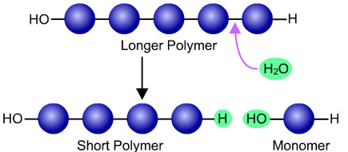  HYDROLYSIS | 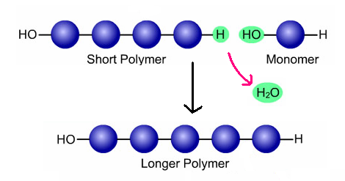  DEHYDRATION SYNTHESIS
What molecules speed up chemical reactions in living things? ENZYMES
The macromolecule that can acts as an enzyme = PROTEINS

Enzymes are UNCHANGED and REUSABLE
What is the place on an enzyme where the substrate attaches? = ACTIVE SITE

What attaches to the active site and is the reactant in an enzyme reaction called? SUBSTRATE

Which ending is often found at the end of enzyme names? - ASE

BE ABE TO IDENTIFY THESE IN A DIAGRAM:.
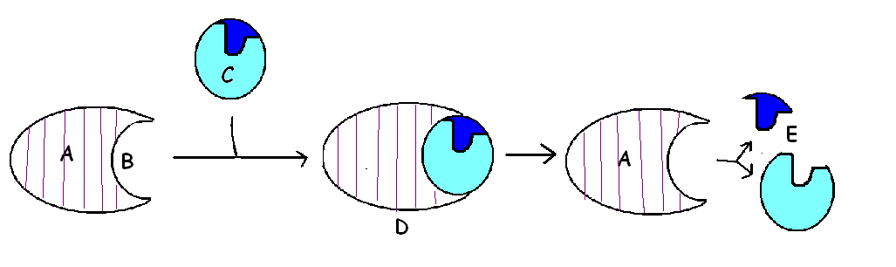
_____ PRODUCTS
_____ SUBSTRATE
_____ ACTIVE SITE
_____ ENZYME-SUBSTRATE COMPLEX
_____ ENZYME

What is it called when a protein unwinds? DENATURING

What can cause enzymes to denature? pH or TEMPERATURE
BIOMOLECULES
1. CARBOHYDRATES-have 1C : 2H : 1O ratio
SUGARS - Ex: GLUCOSE- burned for fuel
POLYSACCHARIDES made of MANY SUGARS
EX: GLYCOGEN-way ANIMALS store glucose for later
STARCH – way PLANTS store glucose for later
CELLULOSE- makes PLANTS sturdy

2. PROTEINS-made from AMINO ACID subunits
Ex: HEMOGLOBIN- carries oxygen in red blood cells
INSULIN- tells cells to save glucose as glycogen; missing in people with DIABETES

3. LIPIDS- mainly HYDROGEN and CARBON; HYDROPHOBIC
Includes: OIL, FAT, STEROIDS

4. NUCLEIC ACIDS – INFORMATION molecules made of NUCLEOTIDE subunits
EX: DNA – DOUBLE stranded: has DEOXYRIBOSE SUGAR and A, T, C, & G
RNA - SINGLE stranded; has RIBOSE SUGAR and A, U, C, & G

In a DNA molecule which nitrogen bases always bond with each other? A-T and G-C

Which macromolecules are important in making cell membranes? PHOSPHOLIPIDS & PROTEINS

Which molecule makes up the genetic code? DNA
Which molecule carries info from DNA to cell and helps make proteins? RNA
Which molecule stores and transports energy in cells? ATP
Which molecule is burned by cells for energy? GLUCOSE

Which molecules are important for cell recognition? GLYCOPROTEINS

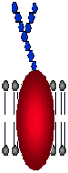  GLYCOPROTEIN  identify “self” | 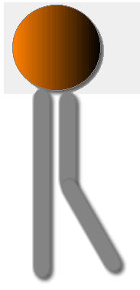  PHOSPHOLIPID  Makes cell membranes | 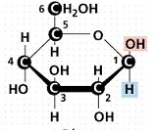  GLUCOSE  SUGAR burned for energy  Used to make POLYSACCHARIDES
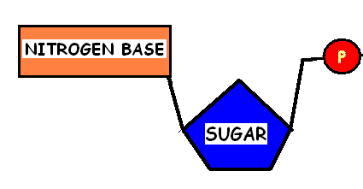  NUCLEOTIDE  used to make NUCLEIC ACIDS | 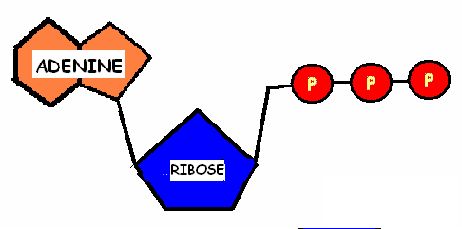  ATP  “rechargeable battery”  Store and transport energy | 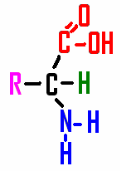  AMINO ACID  Used to make PROTEIJNS

