NAME ______________________________

PUNNETT SQUARE PRACTICE #1
Use a Punnett Square to show the possible offspring from the crosses given and answer the questions:

IN PEAS: R = round T = tall Y = yellow peas P = purple flowers
r = wrinkled t = short y = green peas p = white flowers

MAKING MONOHYBRID CROSSES:
Use colors to circle the offspring with the same phenotype.
What is the genotype of a HOMOZYGOUS YELLOW SEED plant? = ________

What is the genotype of A HOMOZYGOUS GREEN SEED plant? = ________

What is the genotype of a HETEROZYGOUS YELLOW plant? = ________

Make a cross between a PURE YELLOW SEED parent and a PURE GREEN SEED parent.

POSSIBLE OFFSPRING
GENOTYPE PHENOTYPE

_________ _________________

What is the probability an offspring will show the DOMINANT TRAIT (YELLOW SEEDS)? _________

What is the probability an offspring will show the RECESSIVE TRAIT (GREEN SEEDS)? ________

* * * * * * * * * * * * * * *

MAKING MONOHYBRID CROSSES:
Use colors to circle the offspring with the same phenotype.

What is the genotype of a PURE PURPLE FLOWERED plant ? = ________

What is the genotype of a PURE WHITE FLOWERED plant? = _________

What is the genotype of a HYBRID PURPLE FLOWERED plant? = ________

Make a cross between a HOMOZYGOUS PURPLE FLOWERED plant and a HOMOZYGOUS WHITE FLOWERED plant.

POSSIBLE OFFSPRING
GENOTYPE PHENOTYPE

________ _________________

What is the probability an offspring will show the DOMINANT TRAIT (PURPLE FLOWERS)? ___________

What is the probability an offspring will show the RECESSIVE TRAIT (WHITE FLOWERS)? _____________

MAKING MONOHYBRID CROSSES:
Use colors to circle the offspring with the same phenotype.

WHAT IS THE GENOTYPE OF A HOMOZYGOUS TALL plant ? = ________

WHAT IS THE GENOTYPE OF A HETEROZYGOUS TALL plant? = _______

WHAT IS THE GENOTYPE OF A PURE SHORT plant? = ________

Make a cross between a HOMOZYGOUS TALL plant and a PURE SHORT plant.

POSSIBLE OFFSPRING
GENOTYPE PHENOTYPE

________ _________________

What is the probability an offspring will show the DOMINANT TRAIT (TALLNESS)? ___________

What is the probability an offspring will show the RECESSIVE TRAIT (SHORTNESS)? _____________

* * * * * * * * * * * * * *

SEE A PATTERN FOR HOMOZYGOUS MONOHYBRID CROSSES:

If you cross plants that are PURE DOMINANT for a trait with plants that are PURE RECESSIVE for that trait, ________ % of the offspring will show the DOMINANT trait and the ___________________ trait will not show at all.

USE THE PATTERN ABOVE TO MAKE PREDICTION ABOUT A CROSS

If you cross a HOMOZYGOUS ROUND SEED plant with a PURE WRINKLED SEED plant

100% will look __________________

0% will look ____________________

The offspring will have a 100% probability of having the ______ genotype.

* * * * * * * * * * * * * *

MAKE SOME HETEROZYGOUS MONOHYBRID CROSSES

A black coat (B) is DOMINANT in guinea pigs. A brown coat (b) is RECESSIVE.
What is the genotype of a HOMOZYGOUS BLACK guinea pig? = _______

What is the GENOTYPE of a HETEROZYGOUS BLACK guinea pig? =_________

What is the GENOTYPE of a brown guinea pig? =__________
Make a cross between TWO HETEROZYGOUS BLACK guinea pigs.
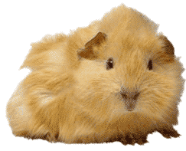
POSSIBLE OFFSPRING
GENOTYPE PHENOTYPE

___________ _________________

___________ __________________

___________ _________________

What is the probability that a baby will be black? _________

What is the probability that a baby will be brown? _________
What is the probability the baby will be a HYBRID? ________

What is the probability the baby will be HOMOZYGOUS DOMINANT ? _________

What is the probability the baby will be HOMOZYGOUS RECESSIVE? ___________

* * * * * * * * * * * * * * *
Purple fur (P) is DOMINANT in monsters. Yellow fur (p) is RECESSIVE.

What is the genotype of a PURE PURPLE monster? = ________

What is the GENOTYPE of a HETEROZYGOUS purple monster? _________

What is the GENOTYPE of a YELLOW monster? = ________

Make a cross between TWO HETEROZYGOUS PURPLE MONSTERS.


POSSIBLE OFFSPRING
GENOTYPES PHENOTYPES

___________ _________________

___________ _________________

___________ _________________

What is the probability that a baby will be purple ? __________
What is the probability that a baby will be yellow? __________
What is the probability the baby will be a heterozygous? _________
What is the probability the baby will be HOMOZYGOUS DOMINANT ? _________
What is the probability the baby will be HOMOZYGOUS RECESSIVE? ___________

Tallness (T) is DOMINANT in pea plants. Shortness (t) is RECESSIVE.

What is the GENOTYPE of a HOMOZYGOUS TALL pea plant? = _____
What is the GENOTYPE of a HYBRID TALL pea plant? = _______

What is the GENOTYPE of a SHORT pea plant ? = ________

Make a cross between two HYBRID TALL pea plants.

POSSIBLE OFFSPRING
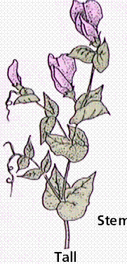
GENOTYPE PHENOTYPE

_________ _________________

_________ _________________

_________ _________________

What is the probability that an offspring plant will be tall ? __________

What is the probability that an offspring plant will be short? ___________

What is the probability that an offspring plant will be a HYBRID? _____________

What is the probability that an offspring plant will be HOMOZYGOUS DOMINANT? ___________

What is the probability that an offspring plant will be HOMOZYGOUS RECESSIVE? ___________

* * * * * * * * * * * * * *
SEE A PATTERN FOR HETEROZYGOUS MONOHYBRID CROSSES:

If you cross 2 parent plants that are BOTH HETEROZYGOUS for a trait the offspring will show a ____ : ____ phenotypic ratio.

________ % of the offspring will show the DOMINANT trait and
________ % of the offspring will show the RECESSIVE trait.

USE DOMINANT OR RECESSIVE TO FILL IN THE BLANKS BELOW:
¼ of the offspring will have two __________________ alleles,
½ will be hybrids with one _______________ and one _______________ allele, and
¼ will have two _________________ alleles.

USE THE PATTERN ABOVE TO MAKE PREDICTION ABOUT A CROSS
If you cross two HETEROZYGOUS ROUND SEED plants
75% will look __________________
25% will look __________________
The probability is:
¼ will have the genotype ______ ½ will have the genotype _____ ¼ will have the genotype _____

Scientists have been investigating the genetic make up of the residents in Bikini Bottom.
Complete the following questions about these inhabitants.

For each genotype below, indicate whether it is HETEROZYGOUS (HE) or HOMOZYGOUS (HO).

TT _______ Bb ________ DD _______ tt ________ Ff _______

Dd _______ ff _________ bb ________ BB _______ FF ______

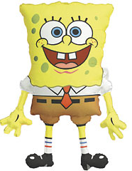
Determine the PHENOTYPE for each genotype given. IN SPONGE PEOPLE the allele for YELLOW BODY COLOR (Y) is DOMINANT to BLUE (y).

YY = ________________ Yy = __________________ yy = __________________

IN SPONGEPEOPLE the allele for SQUARE SHAPE (S) is dominant to ROUND (s).

SS = _______________ Ss = _________________ ss = ___________________

* * * * * * * * * * * * * * *

SpongeBob Squarepants recently met SpongeSuzie Roundpants at a dance.
SpongeBob is HETEROZYGOUS for his square pants, but Suzie is ROUND.
Use the gene code above to create a Punnett square to show the possibilities that could result if SpongeBob and SpongeSuzie had children.
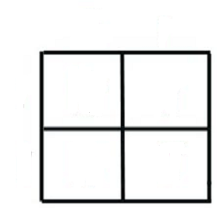

What is Spongbob’s genotype? _____________

What is Spongesuzie’s genotype? ___________

What are the chances a child will have a square shape?
________ out of 4 OR _______%

What are the chances a child will have a round shape?
________ out of 4 OR _______%

* * * * * * * * * * * * * *

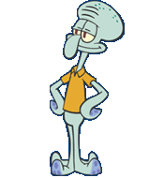
In SQUID PEOPLE the allele for LIGHT BLUE SKIN (B) is DOMINANT over the GREEN (b) allele. Everyone in Squidward’s family has light blue skin. His family brags that they are a “purebred” line. He recently married a nice girl with light green skin, which is recessive. Create a Punnett square to show the
possible offspring from this match.

List the possible genotypes and phenotypes for the kids

_________ ______________________

What are the chances of a child with green skin? ______%

Would Squidward’s children still be considered “purebreds”? YES NO
EXPLAIN WHY or WHY NOT.

_______________________________________________________________________

