NAME __________________________

MUTATIONS and GENE REGULATION
Chapter 12-4 & 12-5
MULTIPLE CHOICE:
Circle the letter of the answer that best completes the statement.

A group of genes that operate together is known as a(n) _______________________
A. codon
B. operator
C. operon
D. gene group

The place where RNA polymerase binds to start transcribing a gene is called the _______________
A. operator
B. promoter
C. repressor
D. anticodon

When the lac repressor protein binds to the ____________________, the lac operon is turned OFF.
A. anticodon
B. promoter
C. operator
D. hox gene

When lactose is present, it binds to the __________________ so the lac operon is turned ON.
A. operator
B. promoter
C. repressor
D. anticodon

The hox genes are a series of genes that control _________________________________.
A. the lac operon
B. the burning of glucose in mitochondria
C. the replication of DNA
D. the sequential development of an animal’s basic body plan

The lac operon is found in _______________________
A. prokaryotes
B. eukaryotes

The TATA box sequence is found in _____________________ cells
A. prokaryotes
B. eukaryotes

The function of the TATA box is to ________________________________.
A. bind the lac repressor
B. turn on cell division genes
C. help position the RNA polymerase
D. edit introns

Proteins that bind to enhancer sequences in eukaryotes can do a number of things including ___________
A. attract RNA polymerase
B. open up tightly packed DNA
C. block access to genes
D. all of these

MATCH THE MUTATION WITH ITS DESCRIPTION

FRAMESHIFT POINT DUPLICATION INSERTION INVERSION

TRANSLOCATION SUBSTITUTION DELETION POLYPLOIDY

___________________________ Change in one or just a few nucleotide in the code

___________________________ Deletion or insertion that causes the remaining nucleotides to be regrouped & read incorrectly

___________________________ One nucleotide in code is replaced by another

___________________________ Complete set of chromosomes fails to separate resulting in 3N or 4N organisms

___________________________ Piece of DNA is broken off and lost

___________________________ Piece of DNA breaks off and reattaches to another
NON-homologous chromosome

___________________________ Piece of DNA breaks off, flips, and reattaches so that it reads backwards

___________________________ Piece of DNA is added to the code

___________________________ Extra copies of part of a chromosome are made

WHICH TYPE OF CHROMOSOMAL MUTATION IS SHOWN BELOW?

Original chromosome
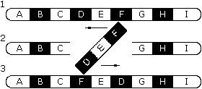
__________________________

Mutation

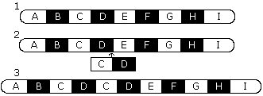
Original chromosome
________________________
Mutation

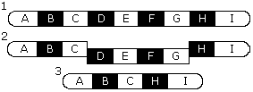
Original chromosome ________________________
Mutation

Original chromosomes
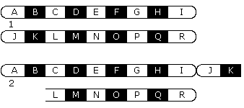

_________________________

Mutation

COMPARE AND CONTRAST:

 | OPERATOR | PROMOTER | REPRESSOR
Function?

SHORT ANSWER:

Explain the function of the TATA box

___________________________________________________________________________________

How does the presence of the sugar LACTOSE help start the transcription of the lac genes?

___________________________________________________________________________________

Explain how gene regulation is related to cell specialization (differentiation).

___________________________________________________________________________________

___________________________________________________________________________________

Explain why a frame shift mutation at the beginning of a gene sequence is more damaging than one at the end of a sequence.

____________________________________________________________________________

____________________________________________________________________________

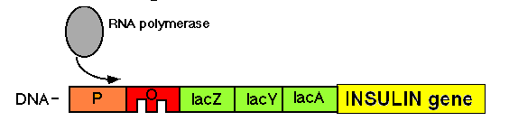
Scientists have been able to transfer human insulin genes into bacteria and produce insulin for diabetics. If the human insulin gene is attached to the lac operon, what do you think scientists do to get the bacteria to make insulin? (HINT: Look at your answer to #2 above)

_____________________________________________________________________

