NAME___________________________________

PATERNITY PROBLEM #1
Mr. I. M. Megabucks, the wealthiest man in the world, recently died. Since his death, three women have come forward. Each woman claims to have a child by Megabucks and demands a substantial share of his estate for her child. Lawyers for the estate have insisted on DNA typing of each of the alleged heirs. Fortunately, Megabucks anticipated trouble like this before he died, and he arranged to have a sample of his blood frozen for DNA typing.
Your job is to analyze the data and determine whether any of the children could be Megabucks' heir. Remember: not every band in the mother’s and father’s profile will appear in the child’s lane, but every band a child has must come from EITHER MOTHER OR FATHER.
Choose a color to represent Megabucks and a different color to represent each mother.
Color in each corresponding band in the child’s lane to identify if it came from mother, Megabucks, OR SOMEONE ELSE.
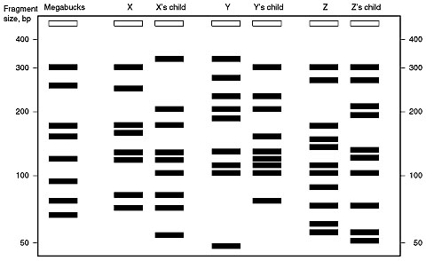

Is Megabucks the father of X’s child? __________
Is Megabucks the father of Y’s child? __________
Is Megabucks the father of Z’s child? __________

From: http://www.accessexcellence.org/AE/AEPC/ASM/act26.php
HOSPITAL MIX UP:
On June 6 at approximately 1:00 p.m., Mrs. Smith, Mrs. Stevenson, and Mrs. Jones each delivered a healthy baby boy at Metropolitan General Hospital. At 1:20 p.m., the hospital's fire alarm sounded. Nurses and orderlies scrambled to evacuate patients, and the three new babies were rushed to safety. After the danger had passed, the hospital staff was distressed to find that in the confusion, they had forgotten which baby was which! Since the babies were rescued before receiving their identification bracelets, there was no easy way to identify them. Dr. Anne Robinson, head of pediatrics, ordered that DNA typing be performed on the babies and their parents

.The DNA typing laboratory looked at two different highly variable chromosome regions. The DNA profiles are shown below. Your job is to decide which baby belongs to which set of parents. To assign a baby to a set of parents, every band in the baby's profile should match a band from either the mother or the father. Not all of the bands in the mother's or father's profiles will have a counterpart in the baby's DNA profile. Hint: Use a ruler or a straightedge to help you line up the bands.

Use a different color for each father and mother. Color in the bands in the parent lanes and color the matching bands in the child’s lane with the same color. Which baby belongs to which couple?

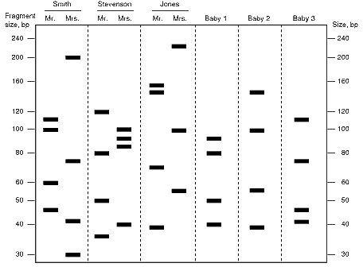

From:

Baby 1 belongs to Mr. & Mrs. __________________________
Baby 2 belongs to Mr. & Mrs. __________________________
Baby 3 belongs to Mr. & Mrs. __________________________

FROM: http://www.accessexcellence.org/AE/AEPC/ASM/act25.php

