EVOLUTION VOCAB QUIZ Chapters 15 & 16 Name __________________________

Matching; Within each of the section, match the letter of the term with its definition by placing the letter of the term in the blank. All terms are used and used only once.

______ An inherited characteristic that increases an A) fitness
organism’s chance of survival by better suiting
an organism to its environment B) hypothesis

______ The ability of an individual to survive and reproduce C) adaptation
in its specific environment
D) descent with modification
_____ The need for members of a species to compete regularly
for food, living space, and other necessities of life E) struggle for existence

_____ principle that each living species has descended, F) theory
with changes, from other species over time
G) geology
_____ A well supported, testable explanation for phenomena
that have occurred in the natural world

_____ A possible explanation for a set of observations or a
possible answer to a scientific question

_____ The study of the history of the Earth, especially the Earth’s history as recorded in rock

_____ the idea that individuals better suited to their environment survive
and reproduce most successfully, passing on their fitness to their
offspring and increasing the fitness of the species over time H) common descent
(also called natural selection)
I) convergent evolution
_____ The principle that all living things are derived from common ancestors
J) adaptive radiation
_____ Process by which unrelated organisms independently evolve
similarities when adapting to similar environment K) survival of the fittest

_____ the practice of humans selecting traits they find useful from L) evolution
the variation provided by nature.
M) fossil
_____ The preserved remains of an ancient organism
N) artificial selection
_____ Process by which a single species or small group of species
evolves into several different forms that live in different ways;
(also called divergent evolution)

____ Change over time;
The process by which modern organisms have descended from ancient organisms;
A change in the relative frequency of alleles in a population

_____ A trait controlled by a single gene with two alleles

_____ A change in the DNA sequence caused by a mistake A) gene pool
in DNA replication or exposure to radiation or chemicals
B) vestigial organs
_____ Structures, like the limbs of vertebrate animals, that
have different mature forms in different organisms but C) homologous structures
develop from the same embryonic tissues
D) mutation
_____ A trait (like skin color or intelligence) that is controlled by
two or more genes E) polygenic trait

_____ Structures that are reduced in size and function so that F) single-gene trait
they resemble just a trace of homologous structures in other species

_____ All the genes, including all the different alleles, in a population

_____ The idea that allele frequency will remain constant unless
one or more factors cause those frequencies to change G) genetic drift

_____ A change in allele frequencies due to the migration of a small H) founder effect
subgroup of a population to a new place
I) genetic equilibrium
_____ A situation in which the allele frequencies in a population
do not change and the population does not evolve J) relative frequency

_____ The number of times a certain allele occurs in a gene pool K) Hardy-Weinberg principle
compared to the number of times other alleles for that same
gene occur

_____ Changes in allele frequency in a small population that are due
to random chance and don’t follow the laws of probability

*************************************************************************************************

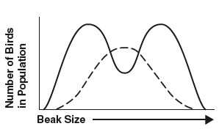
_____ The effect of natural selection when individuals at one L) DISRUPTIVE
end of the normal distribution curve have higher fitness SELECTION
than individuals in the middle or at the other end of the curve

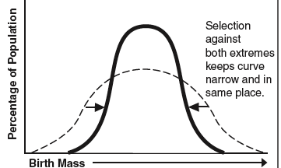
_____ The effect of natural selection when individuals at the M) STABILIZING
extreme ends of the normal distribution curve have higher SELECTION
fitness than those near the center of the curve

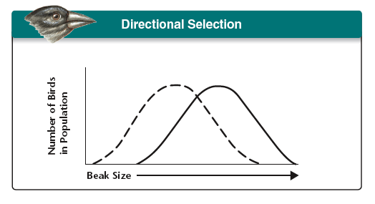
_____ The effect of natural selection when individuals near the N) DIRECTIONAL
center of the normal curve of distribution have higher fitness SELECTION
than those at the extreme ends of the population

EVOLUTION VOCAB QUIZ Chapters 15 & 16 Name __________________________

Matching; Within each of the section, match the letter of the term with its definition by placing the letter of the term in the blank. All terms are used and used only once.

______ An inherited characteristic that increases an A) geology
organism’s chance of survival by better suiting
an organism to its environment B) adaptation

______ The ability of an individual to survive and reproduce C) fitness
in its specific environment
D) struggle for existence
_____ The need for members of a species to compete regularly
for food, living space, and other necessities of life E) descent with modification

_____ principle that each living species has descended, F) hypothesis
with changes, from other species over time
G) theory
_____ A possible explanation for a set of observations or a
possible answer to a scientific question

_____ A well supported, testable explanation for phenomena
that have occurred in the natural world

_____ The study of the history of the Earth, especially the Earth’s history as recorded in rock

_____ the idea that individuals better suited to their environment survive
and reproduce most successfully, passing on their fitness to their
offspring and increasing the fitness of the species over time H) evolution
(also called natural selection)
I) artificial selection
_____ The principle that all living things are derived from common ancestors
J) survival of the fittest
_____ Process by which unrelated organisms independently evolve
similarities when adapting to similar environment K) common descent

_____ the practice of humans selecting traits they find useful from L) fossil
the variation provided by nature.
M) adaptive radiation
_____ The preserved remains of an ancient organism
N) convergent evolution
____ Change over time;
The process by which modern organisms have descended from ancient organisms;
A change in the relative frequency of alleles in a population

_____ process by which a single species or small group of species
evolves into several different forms that live in different ways;
(also called divergent evolution)

_____ A trait controlled by a single gene with two alleles

_____ A change in the DNA sequence caused by a mistake A) vestigial organs
in DNA replication or exposure to radiation or chemicals
B) homologous structures
_____ Structures, like the limbs of vertebrate animals, that
have different mature forms in different organisms but C) polygenic trait
develop from the same embryonic tissues
D) single-gene trait
_____ A trait (like skin color or intelligence) that is controlled by
two or more genes E) gene pool

_____ Structures that are reduced in size and function so that F) mutation
they resemble just a trace of homologous structures in other species

_____ All the genes, including all the different alleles, in a population

_____ The idea that allele frequency will remain constant unless
one or more factors cause those frequencies to change G) genetic equilibrium

_____ A change in allele frequencies due to the migration of a small H) Hardy-Weinberg principle
subgroup of a population to a new place
I) genetic drift
_____ A situation in which the allele frequencies in a population
do not change and the population does not evolve J) founder effect

_____ The number of times a certain allele occurs in a gene pool K) relative frequency
compared to the number of times other alleles for that same
gene occur

_____ Changes in allele frequency in a small population that are due
to random chance and don’t follow the laws of probability

*************************************************************************************************

_____ The effect of natural selection when individuals at one L) STABILIZING
end of the normal distribution curve have higher fitness SELECTION
than individuals in the middle or at the other end of the curve

_____ The effect of natural selection when individuals at the M) DIRECTIONAL
extreme ends of the normal distribution curve have higher SELECTION
fitness than those near the center of the curve

_____ The effect of natural selection when individuals near the N) DISRUPTIVE
center of the normal curve of distribution have higher fitness SELECTION
than those at the extreme ends of the population

