NAME __________________________
Evolution TEST - Chapter 15

MULTIPLE CHOICE
Write the letter for the answer that best completes the statement on the blank at the left.

______ A well supported, testable explanation of phenomena that have occurred in the natural world is called a ________________
A. hypothesis
B. theory
C. law
D. prediction

______ Darwin’s voyage on the H.M.S.__________________ led him to propose a revolutionary
hypothesis about life.
A. Collie
B. Cheetah
C. Beagle
D. Lion

______ Darwin’s hypothesis about how life changes over time in now called the Theory of ____________.
A. Evolution
B. Variation
C. Derived characters
D. Use and disuse

______ Of all the places he visited, the ___________________ Islands influenced Darwin’s ideas about evolution the most.
A. Hawaiian
B. Aleutian
C. Beagle
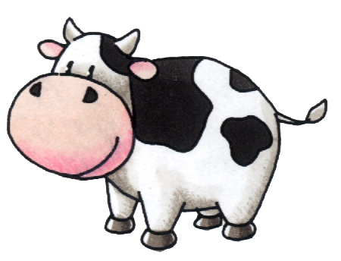
D. Galápagos

______ When farmers select the largest hogs, the fastest horses, or the cows
that produce the most milk for breeding it is called ________________.
A. natural selection
B. artificial selection
C. survival of the fittest
D. homologous variation

______ In addition to observing living organisms, Darwin studied the preserved remains of ancient organisms called _________________
A. fossils
B. homologous structures
C. adaptations
D. vestigial organs

______ On the Galápagos Islands, Darwin observed that the characteristics of many animals and plants
A. all looked alike
B. were completely unrelated
C. were acquired through use
D. varied from island to island

______ When lions prey on a herd of antelope, some antelope are killed and some escape. Which part of Darwin’s concept of natural selection might be used to describe this situation?
A. acquired characteristics
B. common descent
C. descent with modification
D. survival of the fittest

______Which of the following ideas, proposed by Lamarck, was later found to be INCORRECT?
A. All species were descended from other species
B. Acquired characteristics can be inherited.
C. Living things change over time.
D. Organisms are adapted to their environments.

______ When Darwin returned from his voyage, he __________________________
A. immediately published his ideas about evolution
B. realized his ideas about evolution were wrong
C. wrote about his ideas but waited many years to publish them
D. copied the evolutionary theory of Wallace

______ Survival of the fittest was also called ____________________________ by Darwin.
A. Use it or lose it
B. genetic drift
C. natural selection
D. struggle for existence

______ Struggle for existence could also be called _______________________________.
A. adaptation
B. survival of the fittest
C. use it or lose it
D. competition

______ Structures that are so reduced in size that they are nonfunctional are called_________ organs
A. vestigial
B. homologous
C. Darwinian
D. adaptive

______ Adaptive radiation could also be called ______________________ evolution.
A. convergent evolution
B. divergent evolution
C. coevolution

______ Which of the following is NOT part of Darwin’s Theory of Evolution?
A. Natural variation exists in a population
B. Organisms must compete with each other to survive.
C. Organisms with the highest fitness will survive and reproduce and others will die out.
D. Traits an organism acquires through use during its lifetime can be passed on to offspring.
E. Species alive today are descended with modification from ancestral species and are linked to a single “tree of life”
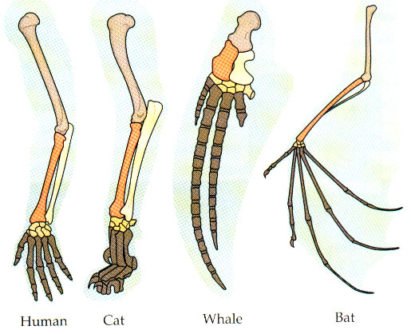
______ Vertebrate limbs which have different mature forms but develop from the same embryonic tissue are examples of
A. homologous structures
B. acquired traits
C. vestigial organs
D. homozygous structures

______Darwin’s concept of evolution was influenced by all of the following EXCEPT _________________
A. the work of Charles Lyell and James Hutton
B. his collection of specimens and fossils
C. his knowledge of the structure of DNA
D. his voyage around the world

______ All of these statements about the structure of human chromosome #2 provide evidence for
evolution EXCEPT _______________________
A. Its banding pattern matches the pattern seen on two smaller chimp chromosomes
B. It has telomeres in the center, as well as at the ends
C. It carries a functional gene for making vitamin C
D. It has an extra non-functional centromere.

______ According to Darwin’s theory of natural selection, the individuals that tend to survive are those that have _____________________.
A. characteristics their parents acquired by use and disuse
B. characteristics that plant and animal breeders value
C. the greatest number of offspring
D. variations best suited to their environment

_____ The idea that all living things are derived from a common ancestor and linked together in a “single tree of life” is called __________________
A. survival of the fittest
B. inheritance of acquired traits
C. common descent
d. artificial selection

______ The inability of humans and other primates to make ___________________ suggests a common ancestor and supports the idea of evolution.
A. myosin
B. vitamin C
C. proteins
D. DNA

_____ Adaptations can be ____________________
A. physical or behavioral
B. physical or geographical
C. acquired during an organism’s lifetime

_____ Darwin was prompted to publish his ideas about evolution by
A. an essay by Wallace on evolution
B. the publication of Lamarck’s theory of evolution
C. his wife Emma
D. the work of Hutton and Lyell

_____ Which of the following best describes how DARWIN would explain giraffes with long necks?
A. Long-necked giraffes eat more grass than short necked giraffes so their necks grow longer.
B. Natural variation in the population produces some longer and some shorter-necked giraffes and longer necked giraffes can reach food more easily and survive to pass on their genes.
C. Some giraffes have acquired longer necks by stretching to reach food and passed that trait on.
D. Giraffes just started out with long necks and haven’t changed

_____ Which of the following best describes how LAMARCK would explain giraffes with long necks?
A. Long-necked giraffes eat more grass than short necked giraffes so their necks grow longer.
B. Natural variation in the population produces some longer and some shorter-necked giraffes and longer necked giraffes can reach food more easily.
C. Some giraffes have acquired longer necks by stretching to reach food and passed that trait on.
D. Giraffes just started out with long necks and haven’t changed.

_____ Whales, sharks, and penguins all have streamlined bodies and fins/flippers for moving in water even though they belong in different classes of animals (mammals, birds, fish). This is an example of _________________ evolution.
A. divergent
B. convergent

____ The Galápagos finches evolved through natural selection from a common ancestor into a wide variety of different looking species with different kinds of beaks. This is an example of ______________ evolution.
A. divergent
B. convergent

* * * * * * * * * * * * * * *

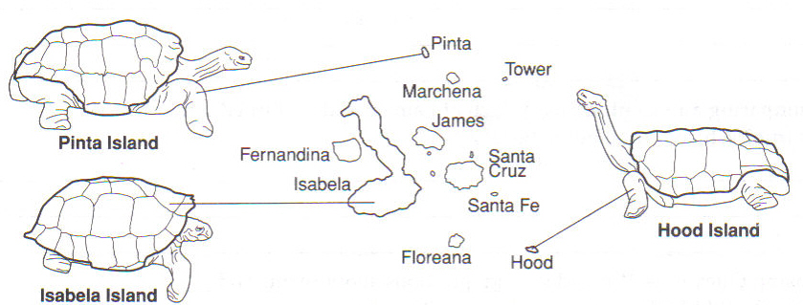

_______ Tortoises eat plants. Which island do you think has plants that grow very close to the ground.
A. Isabela Island
B. Hood Island
C. Pinta Island

______ Which island do you think has sparse vegetation that is hard to reach?
A. Isabela Island
B. Hood Island
C. Pinta Island

______ What would you predict the vegetation and rainfall are like on Pinta Island?
A. more rain and vegetation than either Hood or Isabela
B. less rain and less vegetation than both Hood and Isabela
C. rainfall and vegetation somewhere between that of Hood and Isabela

MATCHING: Match the letter of the scientist with the description of his contributions to the formation of the Theory of Evolution.

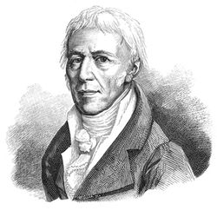 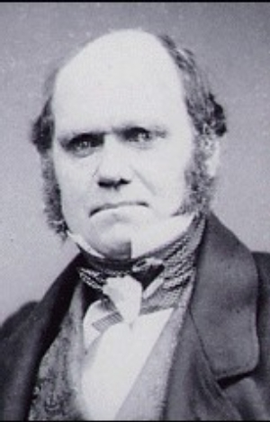 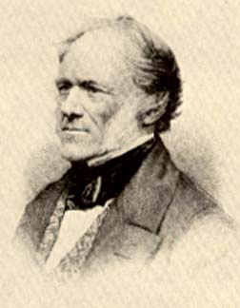
A. Jean-Baptiste B. Charles C. Charles
Lamarck Darwin Lyell

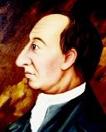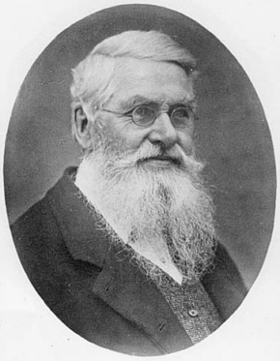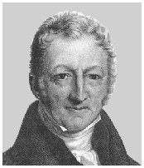
D. James E. Alfred F. Thomas
Hutton Wallace Malthus

_____ & _____ These TWO explained that the Earth that the Earth is very old and has been shaped by geological forces over long periods of time, and that these processes can still be seen happening today.

______ English naturalist who made numerous observations during his travels which led him to propose
a theory about how life changes over time through natural selection

______ French naturalist who proposed that the selective use or disuse of an organ led to a change in the organ and that these acquired traits could be passed on to offspring

______ English economist who predicted that the human population would grow faster than the resources needed to sustain it

______ Naturalist who published his own theory of evolution about evolution about the same time as Charles Darwin.

MATCH THE VOCAB WORD WITH ITS DEFINITION:
_____ Any inherited characteristic that increases an A. STRUGGLE FOR EXISTANCE
organism’s chance for survival
B. DESCENT WITH MODIFICATION
_____ The ability of an organism to survive and reproduce
C. MUTATION
_____ Idea that the fittest individuals in a population
will survive and reproduce while those with low D. SURVIVAL OF THE FITTEST
fitness will die or leave fewer offspring
E. FITNESS
_____ Idea that members of each species must compete
regularly for food, space, and mates F. ADAPTATION
_____ Idea that characteristics acquired by an individual G. INHERITANCE OF ACQUIRED
through use in its lifetime can be passed on to offspring TRAITS

_____ Idea that each living species has descended with
changes from other ancestral species over time

_____ A change in the DNA sequence caused by a mistake in
replication or exposure to radiation or chemicals
* * * * * * * * * * * * * * *

SHORT ANSWER: Fill in the blanks with an answer that best completes the question

Name 4 kinds of evidence that supports Darwin’s theory of Evolution.

__________________________________

__________________________________

__________________________________

__________________________________

Give an example of a vestigial organ _________________________

* * * * * * * * * * * * * *

BONUS:
Name an adaptation shown by the tortoises on the Galapagos islands. ____________________________

A gene that is present but has mutated so it has lost its function is called a
____________________________
NAME __________________________
Evolution TEST - Chapter 15

MULTIPLE CHOICE
Write the letter for the answer that best completes the statement on the blank at the left.

______ A well supported, testable explanation of phenomena that have occurred in the natural world is called a ________________
A. prediction
B. law
C. theory
D. hypothesis

______ Darwin’s voyage on the H.M.S.__________________ led him to propose a revolutionary
hypothesis about life.
A. Lion
B. Cheetah
C. Collie
D. Beagle

______ Darwin’s hypothesis about how life changes over time in now called the Theory of ____________.
A. Variation
B. Evolution
C. Derived characters
D. Use and disuse

______ Of all the places he visited, the ___________________ Islands influenced Darwin’s ideas about evolution the most.
A. Galápagos
B. Aleutian
C. Beagle
D. Hawaiian

______ When farmers select the largest hogs, the fastest horses, or the cows
that produce the most milk for breeding it is called ________________.
A. natural selection
B. survival of the fittest
C. artificial selection
D. homologous variation

______ In addition to observing living organisms, Darwin studied the preserved remains of ancient organisms called _________________
A. homologous structures
B. fossils
C. adaptations
D. vestigial organs

______ On the Galápagos Islands, Darwin observed that the characteristics of many animals and plants
A. varied from island to island
B. were completely unrelated
C. were acquired through use
D. all looked alike

______ When lions prey on a herd of antelope, some antelope are killed and some escape. Which part of Darwin’s concept of natural selection might be used to describe this situation?
A. acquired characteristics
B. survival of the fittest
C. descent with modification
D. common descent

______Which of the following ideas, proposed by Lamarck, was later found to be INCORRECT?
A. All species were descended from other species
B. Organisms are adapted to their environments
C. Living things change over time.
D. Acquired characteristics can be inherited.

______ When Darwin returned from his voyage, he __________________________
A. immediately published his ideas about evolution
B. realized his ideas about evolution were wrong
C. copied the evolutionary theory of Wallace
D. wrote about his ideas but waited many years to publish them

______ Survival of the fittest was also called ____________________________ by Darwin.
A. Use it or lose it
B. natural selection
C. genetic drift
D. struggle for existence

______ Struggle for existence could also be called _______________________________.
A. competition
B. survival of the fittest
C. use it or lose it
D. adaptation

______ Structures that are so reduced in size that they are nonfunctional are called_________ organs
A. adaptive
B. homologous
C. Darwinian
D. vestigial

______ Adaptive radiation could also be called ______________________ evolution.
A. divergent evolution
B. convergent evolution
C. coevolution

______ Which of the following is NOT part of Darwin’s Theory of Evolution?
A. Natural variation exists in a population
B. Organisms must compete with each other to survive.
C. Traits an organism acquires through use during its lifetime can be passed on to offspring..
D. Organisms with the highest fitness will survive and reproduce and others will die out
E. Species alive today are descended with modification from ancestral species and are linked to a single “tree of life”
______ Vertebrate limbs which have different mature forms but develop from the same embryonic tissue are examples of
A. vestigial organs
B. acquired traits
C. homologous structures
D. homozygous structures

______Darwin’s concept of evolution was influenced by all of the following EXCEPT _________________
A. the work of Charles Lyell and James Hutton
B. his collection of specimens and fossils
C. his voyage around the world
D. his knowledge of the structure of DNA

______ All of these statements about the structure of human chromosome #2 provide evidence for
evolution EXCEPT _______________________
A. Its banding pattern matches the pattern seen on two smaller chimp chromosomes
B. It carries a functional gene for making vitamin C
C. It has telomeres in the center, as well as at the ends
D. It has an extra non-functional centromere.

______ According to Darwin’s theory of natural selection, the individuals that tend to survive are those that have _____________________.
A. characteristics their parents acquired by use and disuse
B. characteristics that plant and animal breeders value
C. the greatest number of offspring
D. variations best suited to their environment

_____ The idea that all living things are derived from a common ancestor and linked together in a “single tree of life” is called __________________
A. survival of the fittest
B. inheritance of acquired traits
C. artificial selection
d. common descent

______ The inability of humans and other primates to make ___________________ suggests a common ancestor and supports the idea of evolution.
A. vitamin C
B. myosin
C. proteins
D. DNA

_____ Adaptations can be ____________________
A. physical or geographical
B. physical or behavioral
C. acquired during an organism’s lifetime

_____ Darwin was prompted to publish his ideas about evolution by
A. his wife Emma
B. the publication of Lamarck’s theory of evolution
C. an essay by Wallace on evolution
D. the work of Hutton and Lyell

_____ Which of the following best describes how DARWIN would explain giraffes with long necks?
A. Giraffes just started out with long necks and haven’t changed
B. Long-necked giraffes eat more grass than short necked giraffes so their necks grow longer..
C. Natural variation in the population produces some longer and some shorter-necked giraffes and longer necked giraffes can reach food more easily and survive to pass on their genes
D. Some giraffes have acquired longer necks by stretching to reach food and passed that trait on.

_____ Which of the following best describes how LAMARCK would explain giraffes with long necks?
A. Long-necked giraffes eat more grass than short necked giraffes so their necks grow longer.
B. Natural variation in the population produces some longer and some shorter-necked giraffes and longer necked giraffes can reach food more easily.
C. Some giraffes have acquired longer necks by stretching to reach food and passed that trait on.
D. Giraffes just started out with long necks and haven’t changed.

_____ Whales, sharks, and penguins all have streamlined bodies and fins/flippers for moving in water even though they belong in different classes of animals (mammals, birds, fish). This is an example of _________________ evolution.
A. convergent
B. divergent

____ The Galápagos finches evolved through natural selection from a common ancestor into a wide variety of different looking species with different kinds of beaks. This is an example of ______________ evolution.
A. convergent
B. divergent

* * * * * * * * * * * * * * *

_______ Tortoises eat plants. Which island do you think has plants that grow very close to the ground.
A. Pinta Island
B. Hood Island
C. Isabela Island

______ Which island do you think has sparse vegetation that is hard to reach?
A. Hood Island
B. Isabela Island
C. Pinta Island

______ What would you predict the vegetation and rainfall are like on Pinta Island?
A. more rain and vegetation than either Hood or Isabela
B. less rain and less vegetation than both Hood and Isabela
C. rainfall and vegetation somewhere between that of Hood and Isabela

MATCHING: Match the letter of the scientist with the description of his contributions to the formation of the Theory of Evolution.

A.Charles B. Charles C. Jean-Baptiste
Darwin Lyell Lamarck

D. James E. Thomas F. Alfred
Hutton Malthus Wallace

_____ & _____ These TWO explained that the Earth that the Earth is very old and has been shaped by geological forces over long periods of time, and that these processes can still be seen happening today.

______ English naturalist who made numerous observations during his travels which led him to propose
a theory about how life changes over time through natural selection

______ French naturalist who proposed that the selective use or disuse of an organ led to a change in the organ and that these acquired traits could be passed on to offspring

______ English economist who predicted that the human population would grow faster than the resources needed to sustain it

______ Naturalist who published his own theory of evolution about evolution about the same time as Charles Darwin.

MATCH THE VOCAB WORD WITH ITS DEFINITION:
_____ Any inherited characteristic that increases an A. SURVIVAL OF THE FITTEST
organism’s chance for survival
B. ADAPTATION
_____ The ability of an organism to survive and reproduce
C. FITNESS
_____ Idea that the fittest individuals in a population
will survive and reproduce while those with low D. STRUGGLE FOR EXISTANCE
fitness will die or leave fewer offspring
E. MUTATION
_____ Idea that members of each species must compete
regularly for food, space, and mates F. DESCENT WITH MODIFICATION
_____ Idea that characteristics acquired by an individual G. INHERITANCE OF ACQUIRED
through use in its lifetime can be passed on to offspring TRAITS

_____ Idea that each living species has descended with
changes from other ancestral species over time

_____ A change in the DNA sequence caused by a mistake in
replication or exposure to radiation or chemicals
* * * * * * * * * * * * * * *
SHORT ANSWER: Fill in the blanks with an answer that best completes the question

Name 4 kinds of evidence that supports Darwin’s theory of Evolution.

__________________________________

__________________________________

__________________________________

__________________________________

Give an example of a vestigial organ _________________________

* * * * * * * * * * * * * *

BONUS:
Name an adaptation shown by the tortoises on the Galapagos islands. ____________________________

A gene that is present but has mutated so it has lost its function is called a
____________________________

