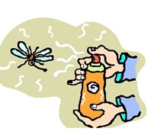
EAGLES, EGGS, and ECOSYSTEMS
Environmental concerns have been around for a long time and humans can be one of the biggest threats to the environment because we can quickly impact an otherwise healthy ecosystem. Besides habitat loss, one of the biggest environmental concerns in the past century is the miss-use of pesticides. Pesticides are any substances used to control unwanted or harmful living organisms, such as insects, fungi, plants, or bacteria. Most pesticides are sprayed on crops and other plants to protect them from the destruction caused by insects. Pesticides are used every day by millions of people throughout the world. In addition to their agricultural use, pesticides are often sprayed around homes, lawns, parks, gardens, golf courses, and other places where unwanted pests occur. Unfortunately, the same substances that destroy pests may also harm plants and other living organisms.

Bioaccumulation occurs when harmful substances or toxins build-up in the body tissues of organisms. Many of these toxic substances are pesticides or other environmental contaminants. When pesticides are applied to kill or control pests, they make their way into waterways and soil, slowly traveling through the food chain when insects, fish and small mammals consume them. This concentration within the food chain at higher and higher trophic levels is referred to as biological magnification. Some pesticides do not decompose and retain their potency for a long time, lasting decades or longer in the environment. As a predator eats more and more contaminated prey items the
concentration of the toxins builds up in the animal's tissues. Scientists often measure the amount of pesticides
found in the environment in ppm or parts per million. When toxins enter the environment only trace amounts are detected, or parts per trillion, but by the time the pesticides reach large predators they can be detected up
to 20 ppm. Research shows levels above 4 ppm can be toxic to Osprey and other large predators. This process of increased concentration has occurred in several bird of prey species, including the Peregrine Falcon, Osprey and Bald Eagle.
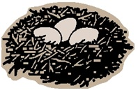
Biological magnification within the food chain usually does not kill an animal directly, but may cause numerous long-term effects, consequently harming raptors and other large predators. This is especially true if the animal has consumed large quantities of pesticides over a long period of time, as large predators typically outlive smaller ones and consume larger amounts of food over their lifetime.

Because of their vulnerability to environmental contaminants, raptors are recognized as barometers of the health of the environment. When the environment can no longer support raptor populations, the health of the environment itself is in jeopardy. One of the biggest threats to the survival of birds of prey during the late 1950s until the early 1970s was the reproductive failure that resulted from pesticide build-up in the body tissue of birds of prey, altering the bird's ability to absorb calcium. When the eggshell formed there was not enough calcium for it to develop properly. Then, when the eggs were incubated they were not strong enough to withstand the bird's weight and broke, or ultimately failed to hatch because of a significant decrease in the number and size of pores within the eggshell. Birds of prey were hard hit as predators at the top of the food chain, because they consume many prey items over a long period of time. It is important to note the biggest problems with pesticides arise from their miss-use. Properly used pesticides can be very beneficial for controlling mosquito-borne illnesses and destruction caused by pests on crops or other plants.

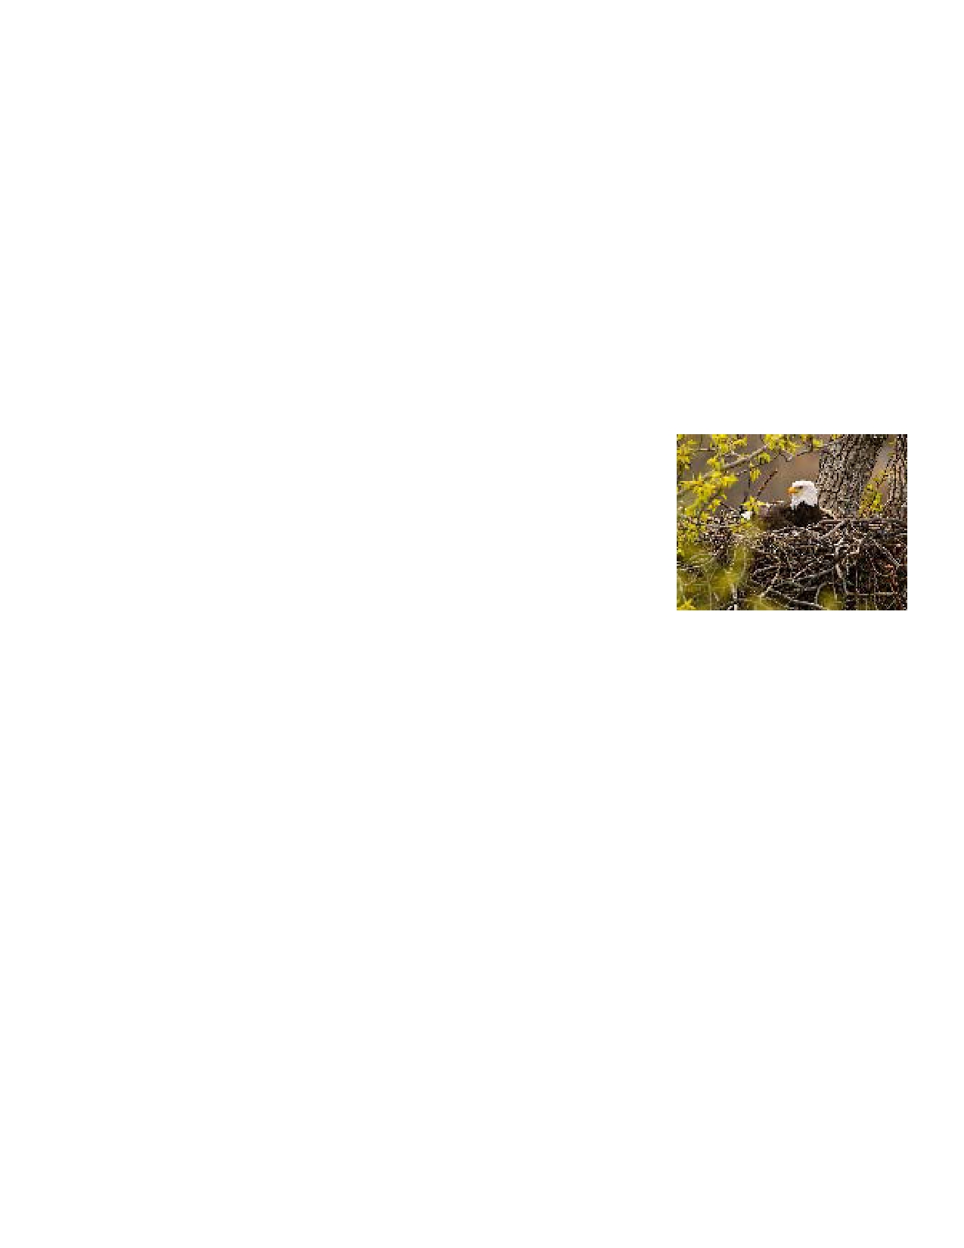
The Effects of DDT
One of the most well-known and widespread pesticides is DDT. Prevalent in agriculture after WWII, it is an
inexpensive and broad-spectrum pesticide that has been used to protect people from mosquito-borne illnesses,
such as yellow-fever and malaria. Miss-use of this pesticide caused the populations of many species of birds of prey to drop drastically during the 1950s and 1960s. Concerns about DDT came to light after the publication of Rachel Carson's book Silent Spring. The wide-spread use of DDT was banned in the United States in 1972. Unfortunately, the miss-use of DDT still occurs today in many countries throughout the world.

Our National Symbol at Risk
There were a few factors leading to the decline of Bald Eagles. First of all, they are large predators, living 25
years or more. Together with their inability to reproduce until five years of age, and their preference to consume
a diet of mostly fish, the eagle population was particularly devastated by the use of DDT during the 1950s -
1970s. Listed as an endangered species in 1967, the Bald Eagle was at an all-time low with only 417 breeding pairs recorded in the lower 48 states and was at risk for becoming extirpated (completely wiped out) within the lower 48 states. Many people believed each eagle they saw would be their last. However, due mostly to the ban on DDT, a successful breeding program, reintroduction efforts, and increased
protection through the Endangered Species Act, the Bald Eagle population began
to climb steadily. Its recovery is a remarkable journey made in a relatively short
amount of time. Today, 40 years after DDT was banned, there are more than
10,000 nesting pairs of Bald Eagles in the lower 48 states and an estimated
20,000 pairs residing in Alaska. The species was removed from the Endangered
Species List in 2007, though it is still protected through legislation such as the
Bald and Golden Eagle Protection Act and the Migratory Bird Treaty Act.

Rachel Carson

Rachel Carson was an American marine biologist and conservationist whose writings are credited with advancing the global environmental movement. She wrote several books about life in different ecosystems. Late in the 1950s, Carson turned her attention to conservation, especially some environmental problems that she believed were caused by synthetic pesticides. She began researching and documenting what was causing many species of plants and animals to become sick and die. Rachel Carson used annual Bald Eagle migration counts to provide evidence that the numbers of immature eagles were declining steadily during the 1950s.

Her book, Silent Spring (1962), brought environmental concerns to the attention of the average American. Although Silent Spring was met with fierce opposition by chemical companies, it spurred a reversal in National pesticide policy, which lead to a nationwide ban on DDT and other pesticides, and it inspired a grassroots environmental movement that lead to the first Earth Day in 1970, the creation of the U.S. Environmental Protection Agency (EPA) in 1970, and the passage of the Clean Water Act (1972). Carson was posthumously awarded the Presidential Medal of Freedom by President Jimmy Carter.

Eagles, Eggs, and Ecosystems Name ___________________________

Directions: Use the Bald Eagle data provided and the Eagles, Eggs, and Ecosystems reading to complete the activity.

1. Make a GRAPH: Use the graph paper and the Migration Counts to make a line graph showing the number of migrating Bald Eagles for ALL ODD YEARS. Plot the information and connect the points with a line.

2. Label the GRAPH properly with a TITLE and AXIS LABELS.

Use the GRAPH to answer Questions 1-6:
1. What year did the number of migrating Bald Eagles begin to decline? ___________________

2. Approximately what year did they begin to rebound? _______________________________

3. Which year had the lowest count of migrating Bald Eagles? ___________________________

4. Which year had the highest count of migrating Bald Eagles? __________________________

5. Calculate the rate of increase of the eagle population from 1996-2011. SHOW YOUR WORK.
Rate of increase = the slope of the line between these dates

6, MAKE A PREDICTION
If the eagle population continues to grow at this rate, how many Bald Eagles do you think Hawk Mountain will count in five years?

How many Bald Eagles do you think they would have counted in this year? ________________
************************************************************************************************
RACHEL CARSON
What book, written by Rachel Carson, spurred the environmental movement in the United States and lead to the first Earth Day celebration (1970), the creation of the Environmental Protection Agency (1970), and the passage of the Clean Water Act in 1972?

What environmental problem did Rachel Carson research that became the topic of this book?

What effect did DDT have on prey birds that caused their populations to decrease after long term exposure to DDT?

What do you think the name of her book, Silent Spring, means?

EVALUATE DATA
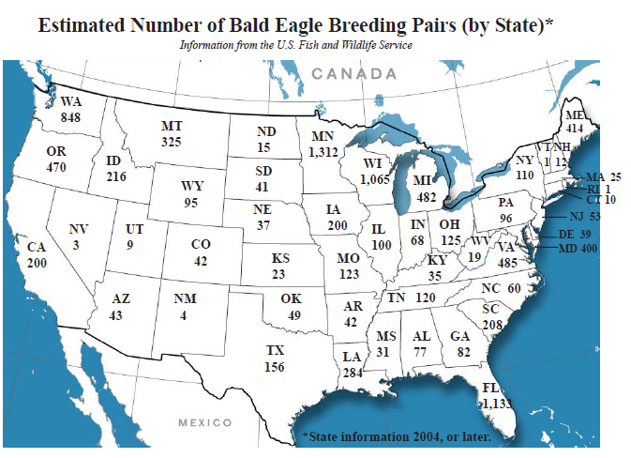

1. Shade in the 5 states with the highest number of nesting pairs of Bald Eagles.
2. Use a different color to shade in the 5 states with less than 10 pairs of Bald Eagles.

Questions
1. Look at the states with the highest number of breeding pairs, what characteristics do these states have in common?

2. Look at the states with the lowest number of breeding pairs, what characteristics do these states have in common?

3. Compare the states with the highest and lowest Bald eagle populations. What can you deduce about the types of habitats Bald Eagles prefer?

4. MAKE A HYPOTHESIS: What could states do to increase their Bald Eagle populations?

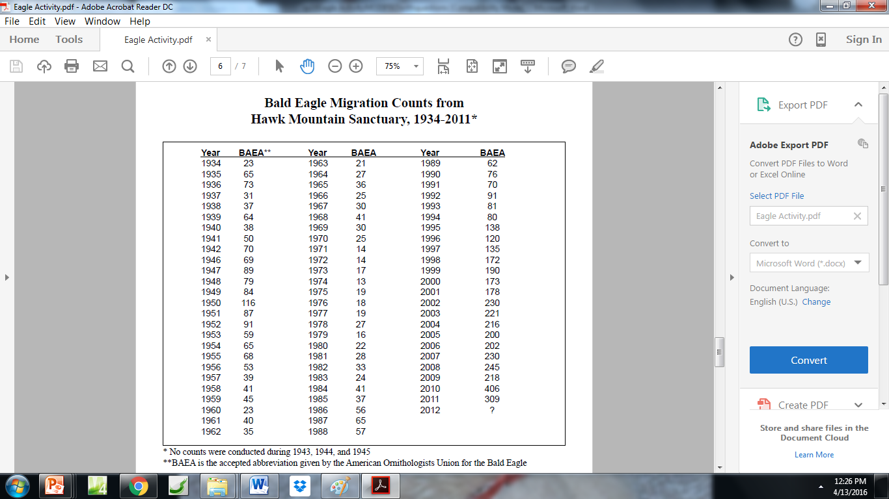
Hawk Mountain Sanctuary in Pennsylvania is the place where Rachel Carson collected her data about birds of prey populations she described in her book, Silent Spring. This raptor conservation and research facility has counted and recorded the number of migrating raptors since 1934. This long-term count of raptors has taught scientists a lot about the trends and migration patterns of birds of prey.

