HUMAN IMPACT ON ENVIRONMENT #1 NAME ________________________________
INVASIVE DISRUPTOR DEPLETION CALCIUM OZONE HYDROLOGIC
ULTRAVIOLET GYRE FOSSIL FUELS SINKHOLE DDT OXYGEN
PESTICIDE POLLUTANT CHLOROFLUOROCARBON CFC’s

Use words from the word bank above to complete the following.
1. Bisphenol A (BPA) is an endocrine ________________________, because it can interfere with
hormones, cause tumors or birth defects, and change the sex in some fish and amphibians.
2. An atmospheric layer containing a high concentration of ___________________ gas protects living things from the damaging effects of too much __________________________ light.
3. DDT is a ________________________ that was widely used in the 1950’s and 1960’s which caused Bald Eagle populations to decline after eating contaminated fish.
4. Humans are causing the _________________________ of aquifers because we are using fresh water from aquifers for agriculture and household use faster than the ___________________________ cycle can replace it.
5. A _______________ is any harmful material that can enter the biosphere through land, water, or air.
6. Bald Eagles that ate fish contaminated by DDT laid eggs that did not have enough ______________________ in their shells to make them sturdy.

7. Plants/animals that have been introduced into places where they are not native and for which there are no natural predators or parasites to control their population are called ____________________ species.

8. A large area in the ocean that contains floating debris and broken pieces of plastic which is held in place by ocean currents is called a garbage _______________.
9. The emptying of aquifer water for agriculture and household use can result in the land above the aquifer caving in called a ____________________.
10. The use of ____________________________________ gases in aerosol cans, fire extinguishers, refrigerators, and air conditioners caused the depletion of ozone in the ozone layer.
11. Currently, the production and use of _________ and ___________ are banned in the United States.
12. Plastic is made from _________________ and when plastic is discarded in landfills, it breaks into smaller pieces but never disappears.
13. Forests could be called “the lungs” of the Earth because they provide living things with _____________________
MULTIPLE CHOICE. CIRCLE ALL THAT ARE TRUE.
There could be more than one correct answer.
Which kind of atom is found in Ozone gas?
A. water
B. hydrogen
C. nitrogen
D. oxygen

Which of the following environmental problems was the Montreal Protocol intended to help?
A. acid rain
B. global warming
C. deforestation
D. ozone depletion

All of the following are consequences of exposure to ultra violet (UV) radiation
A. cataracts
B. increased chance of skin cancer
C. premature aging of skin/wrinkles
D. reduced crop yields
E. asthma
The United States signed on to the Montreal Protocol. TRUE FALSE (Circle one)

SHORT ANSWER
Name the aquifer that supplies water to much of the Midwest, including parts of South Dakota.
_________________________________

Explain what “INVISIBLE WATER” is
_______________________________________________________________________________
_______________________________________________________________________________
Give an example of “invisible water” __________________________________________________

What has happened to the Bald Eagle population since DDT was banned in the United States in 1972.

______________________________________________________________________________
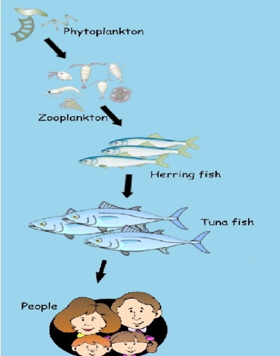
Mercury is a pollutant that is introduced into ecosystems from power plants and factories. Many states, including South Dakota, have issued consumption advisories based on mercury concentrations in fish caught in lakes and rivers. Once in ecosystems mercury can be picked up and passed through food chains. Which organism in this food chain would show the greatest concentration of mercury?

___________________________
What vocab word is used to describe this process?
_______________________________
Tell 3 things you personally could do to conserve water.

______________________________________________

______________________________________________

______________________________________________

Name the animal commonly found in South Dakota, which is responsible for the destruction of ecosystems and the extinction of many native species after its introduction in Australia.
_________________________

Give an example of TWO (2) invasive species in SOUTH DAKOTA.
_________________________ ________________________

MAKE A CONNECTION TO SOMETHING YOU KNOW ABOUT PLANTS AND BIOGEOCHEMICAL CYCLES
Evidence has shown that increased CO₂ in the atmosphere is correlated with increasing average global temperatures on the planet. EXPLAIN WHY trees change the amount of CO₂ in atmosphere.

________________________________________________________________________________________

________________________________________________________________________________________

What effect is DEFORESTATION having on the levels of CO₂ in the atmosphere and the global temperature?

________________________________________________________________________________________
Name the American scientist, who wrote a book which told about the impact of pesticides on birds of prey and started the environmental movement in the United States.
________________________________________
What was the name of her book? _______________________________________

