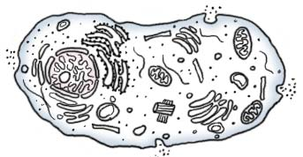
DIFFERENCES IN ANIMAL CELLS, PLANT CELLS, AND BACTERIA

 | ANIMAL CELL | PLANT CELL | BACTERIA
Pro/Eukaryote
Cell
membrane
Nuclear membrane
Cell wall
Ribosomes
DNA
Cytoskeleton
Vacuoles
Lysosomes
Centrioles
Chloroplasts
Cell SIZE

CELL THEORY CELL SIZE

CELL MEMBRANE (=PLASMA MEMBRANE)

Made mainly of:
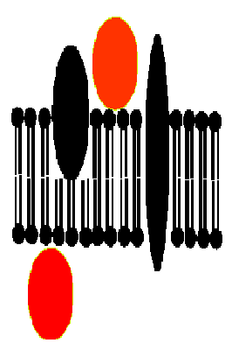

MEMBRANE PROTEINS:
___________________ - stick on inside or outside surface
___________________ - go part way or all the way through
___________________ - recognize “self”
___________________ PROTEINS- move molecules across membrane

FUNCTION:

GOLGI APPARATUS (BODY)

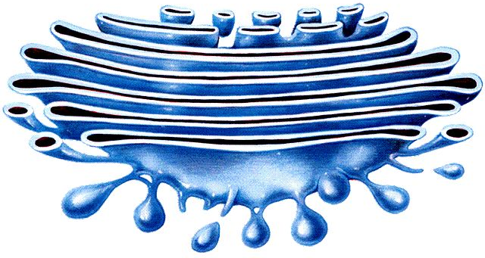
Looks like:

Made of

FUNCTION:
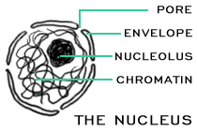
NUCLEUS NUCLEOLUS
FUNCTION:
NUCLEAR MEMBRANE:

NUCLEOLUS:

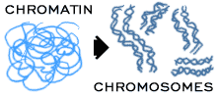
DNA is scrunched up as _________________
in DIVIDING CELLS
DNA is spread out as__________________
in NON-dividing cells

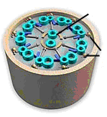
CILIA & FLAGELLA
MADE OF:

LOOKS LIKE:
CILIA FUNCTION:

FLAGELLA FUNCTION:
MITOCHONDRION (plural: MITOCHONDRIA)

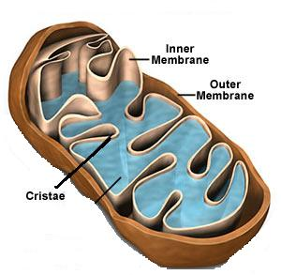
FUNCTION :

Folded inner membrane = ________________ (increases surface area for more chemical reactions)

RIBOSOMES

MADE OF :

FUNCTION:

ENDOPLASMIC RETICULUM(ER)
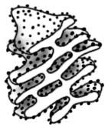
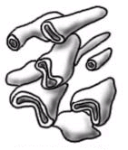
Rough ER:
ROUGH ER SMOOTH ER
(with ribosomes) (NO ribosomes)

LYSOSOMES
MADE OF:
FUNCTION:

CHLOROPLASTS
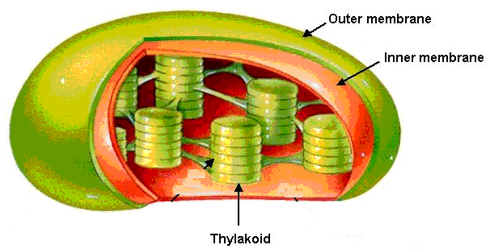
MADE OF:

FUNCTION:

CYTOSKELETON
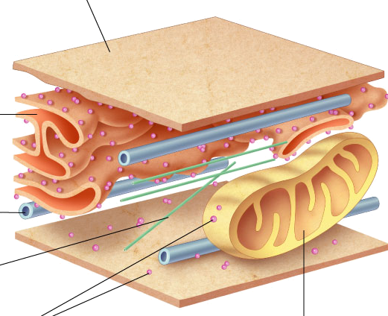
MADE OF:

FUNCTION:
VACUOLE
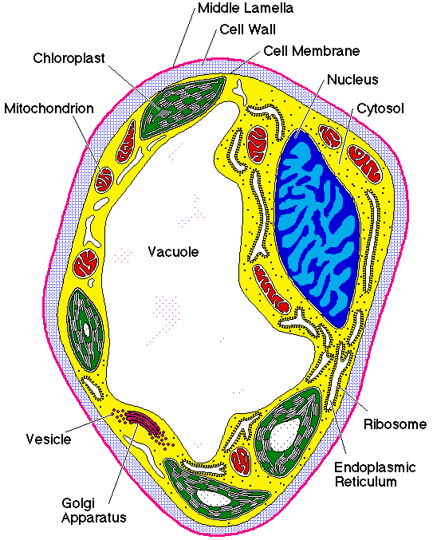
MADE OF:
FUNCTION:

CENTRIOLES

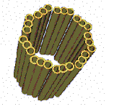
MADE OF:

FUNCTION:

CELL WALL

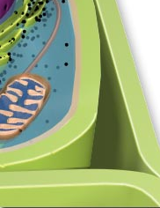
MADE OF:

FUNCTION:

