OSMOSIS & DIFFUSION LAB NAME _____KEY_____________

BEFORE YOU START:

TEST RESULTS

The YELLOW reacting area on the GLUCOSE TEST STRIP will turn __yucky green__ if glucose is present.

IODINE test: The golden brown color will turn __BLACK____ if starch is present.

LAB STATION #1: GLUCOSE test BEFORE EXPERIMENT
TEST THE WATER IN YOUR CUP:
The color of the GLUCOSE TEST STRIP is __yellow_____.

Is there GLUCOSE in the water in your cup at the start of the experiment?

YES NO

QUESTIONS TO ANSWER WHILE EXPERIMENT IS RUNNING: NOTE: START OF EXPERIMENT BEGINS WHEN MEMBRANE TUBE IS DROPPED INTO THE CUP WATER!
Were there STARCH molecules INSIDE the membrane tube YES NO
at the START of the experiment?

How do you know? __We put it in there; __________________________________________

Were there GLUCOSE molecules INSIDE the membrane tube YES NO
at the START of the experiment?

How do you know? ___We put it in there_________________________________________

Were there IODINE molecules INSIDE the membrane tube YES NO
at the START of the experiment?

How do you know? ____Didn’t put any in bag; Bag was not golden brown color _______________

Were there GLUCOSE molecules OUTSIDE the membrane tube YES NO
IN THE CUP WATER at the START of the experiment?

How do you know? __We tested; Test strip did not turn green_________________________

Were there IODINE molecules OUTSIDE the membrane tube YES NO
IN THE CUP WATER at the START of the experiment?

How do you know? ____We put it in there; cup water was golden brown_____________________

THINK ABOUT IT:
If ALL the starch molecules stay in the membrane sac, what color would you expect the water in the cup to be at the end of the experiment?
A. clear
B. golden brown
C. black

If some starch molecules pass through the membrane sac and move into the cup water where the iodine was, what color would the cup water be at the end of the experiment?
A. clear
B. golden brown
C. black

If some of the iodine molecules move from the cup water into the membrane sac with the starch, what color would you expect the membrane sac to be at the end of the experiment?
A. clear
B. golden brown
C. black

If ALL of the iodine molecules stay in the cup water and don’t enter the membrane sac, what color would you expect the membrane sac to be at the end of the experiment?
A. clear
B. golden brown
C. black

If all of the glucose stays in the membrane sac and you test the CUP WATER for glucose what color would you expect the test strip to be?
- yellow
- yucky green

If some of the glucose molecules pass through the membrane sac into the cup water and you test the CUP WATER for glucose, what color would you expect the test strip to be?
- yellow
- yucky green



STOP HERE AND WAIT FOR EXPERIMENT TO RUN!

TESTS AT END OF DAY 1: (Test at end of class)
GLUCOSE TEST: (Test the cup water)
The color of the GLUCOSE TEST STRIP is ___yucky green___.
STARCH TEST: (Look at the membrane sac)
The black color in the membrane tube tells you that
__STARCH____ & _____IODINE___ are both inside the tube.

QUESTIONS TO ANSWER AT THE END OF THE DAY 1:
Were there GLUCOSE molecules OUTSIDE the membrane tube YES NO
at the END of the experiment?

How do you know? ____We tested and test strip turned yucky green______________________

Were there IODINE molecules OUTSIDE the membrane tube YES NO
IN THE CUP WATER at the END of the experiment?

How do you know? ___Can see them; cup water is golden brown_______

Were there STARCH molecules OUTSIDE the membrane tube YES NO
at the END of the experiment?

How do you know? Cup water=golden brown; if starch was in water it would be BLACK_________

Were there IODINE molecules INSIDE the membrane tube YES NO
at the END of the experiment?

How do you know? __Starch + iodine = black; know starch got in because bag turned black

What happened to the STARCH that was INSIDE THE MEMBRANE SAC at the start of the experiment?
A. Some of the starch molecules passed through the membrane sac and moved into the cup water.
B. ALL the starch molecules left the membrane sac and moved into the cup water.
C. All of the starch molecules stayed inside the membrane sac.

What happened to the IODINE that was IN THE CUP WATER at the start of the experiment?
A. SOME of the iodine molecules moved from the cup water into the membrane sac.
B. ALL the iodine molecules left the cup water and moved into the membrane sac.
C. All of the iodine molecules stayed inside the cup water.

What happened to the GLUCOSE that was INSIDE the membrane sac at the start of the experiment?
A. Some of the glucose molecules left the membrane and moved into the cup water
B. All of the glucose stayed inside the membrane sac.

STOP HERE AND WAIT UNTIL TOMORROW!

FINISH THIS EXPERIMENT THE NEXT DAY:

What did the WATER molecules do during this experiment?
A. Water moved from the cup into the membrane sac.
B. Water moved out of the membrane tube into the cup.
C. The water level did not change.

FINAL QUESTIONS:
Which substances were able to pass through the membrane in this experiment?

Glucose starch iodine water

Which substances DID NOT pass through the membrane in this experiment?

Glucose starch iodine water

Draw a picture to show how the molecules moved during this experiment | Use BLUE dots for GLUCOSE  Use RED dots for IODINE  Use GREEN dots for STARCH

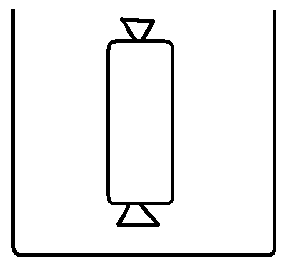

AT START OF EXPERIMENT AT END OF EXPERIMENT

Membranes that allow certain molecules to pass through and NOT others are called ____SELECTIVELY PERMEABLE__________________.

Explain why you could call the membrane sac you used in this experiment “selectively permeable”.
The dialysis tube let some molecules pass through (iodine, glucose, water) but not others (starch)

Look at the molecular structure for GLUCOSE and STARCH below:
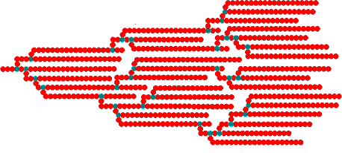
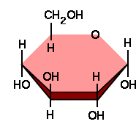

GLUCOSE

STARCH

WHY DO YOU THINK THE GLUCOSE MOLECULES WERE ABLE TO CROSS THE MEMBRANE IN THIS EXPERIMENT AND THE STARCH MOLECULES WERE NOT?

_________________________________________________________________

The membrane tube you used in this experiment was NOT A REAL CELL MEMBRANE.
name the TRANSPORT HELPERS you learned about that real cell membranes use to help the molecules to pass through membranes that can’t get across on their own.

MEMBRANE PROTEIN HELPERS EXO/ENDOCYTOSIS HELPER
_______________________________ ________________________________

_______________________________

_______________________________

