NAME _________________________

Use words from the word bank to fill in the following diagram to show the reactants and products for the two phases of photosynthesis:

CALVIN CYCLE LIGHT-DEPENDENT REACTIONS OXYGEN

SUGAR CARBON DIOXIDE WATER ATP NADPH LIGHT
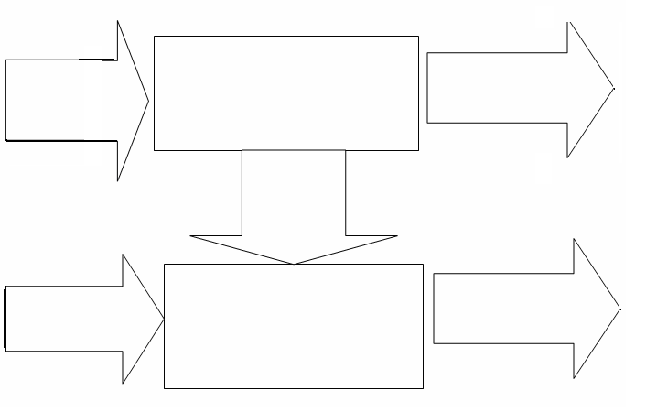

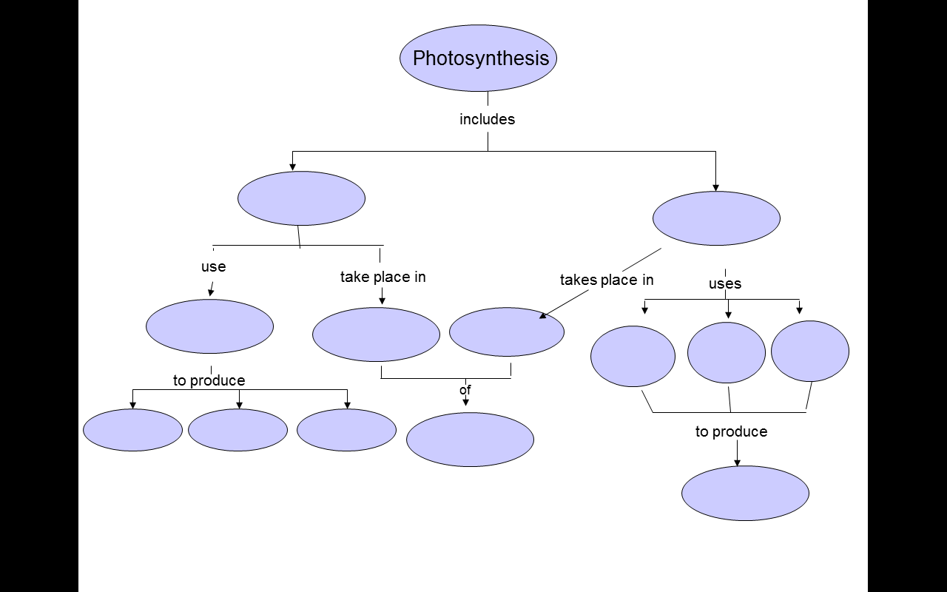
USE WORDS FROM THE WORD BANK TO COMPLETE THE CONCEPT MAP
ATP CALVIN CYCLE LIGHT-DEPENDENT REACTIONS O₂ H₂O CO₂
SUGAR SUNLIGHT THYLAKOID MEMBRANES STROMA CHLOROPLASTS NADPH

