Name 3 conditions required to maintain genetic
equilibrium under the HARDY-WEINBERG PRINCIPLE.

Random mating, large population, no mutations,
No movement in or out, no natural selection

____________________ traits show a bell-shaped
curve when graphed.

SINGLE GENE POLYGENIC

Genetic drift happens in populations that are

Small Large

A ______________ _____________ consists of
all the different alleles that are present in a population.

GENE POOL

In genetic terms, evolution is a change in the
_______________________ of alleles in a population.

RELATIVE FREQUENCY

A situation in which allele frequencies change as a result
of the migration of a small subgroup of the population
is known as the _____________________.

FOUNDER EFFECT
Type of macroevolution in which organisms have evolved
from a common ancestor into very diverse forms.

DIVERGENT EVOLUTION or ADAPTIVE RADIATION

ANOTHER NAME FOR ADAPTIVE RADIATION

DIVERGENT EVOLUTION

ANOTHER NAME FOR DIVERGENT EVOLUTION
ADAPTIVE RADIATION

Type of macroevolution in which two organisms evolve
in response to changes in each other

COEVOLUTION

Type of macroevolution in which large numbers of species
become extinct at the same time

MASS EXTINCTION

Pattern of long, stable periods with little evolutionary change,
interrupted by brief periods of more rapid change

PUNCTUATED EQUILIBRIUM

Pattern of macroevolution which explains why dolphins,
penguins, and sharks all have similar bodies and
appendages for swimming, even though they belong
to different groups (mammals, birds, fish)

CONVERGENT EVOLUTION

The idea that evolution happens slowly over a long period
of time is called __________

GRADUALISM

Type of selection in which the fitness of individuals at
one end of the bell-curve is higher than that of
individuals in the middle or at the other end of the curve

DIRECTIONAL SELECTION

Type of selection in which the fitness of individuals in
the middle of the bell-curve is higher than that of
individuals at the extreme ends

STABILIZING SELECTION

Type of selection in which the fitness of individuals at
the extreme ends of the bell-curve is higher than that
of individuals in the middle

DISRUPTIVE SELECTION

A situation in which allele frequencies in a small group
change as a result of chance and not natural selection

FOUNDER EFFECT

The Galápagos finches evolved through natural selection
from a common ancestor into a wide variety of different
looking species with different kinds of beaks. This is an
example of __________________ .

DIVERGENT EVOLUTION/ADAPTIVE RADIATION

At the end of the Cretaceous period an asteroid hit
the Earth causing the loss of many species including
the dinosaurs. This is an example of ____________

MASS EXTINCTION

Ostriches are native to the savannahs of Africa, while
penguins live in the polar regions. Although these birds
are closely-related, they look very different. This is an
example of __________________ .

DIVERGENT EVOLUTION/ ADAPTIVE RADIATION

Ostriches and giraffes are both native to the savannahs
of Africa. They share the same characteristic of
a very long neck. This is an example of _____________.

CONVERGENT EVOLUTION

A change in the DNA sequence caused by a mistake in
DNA replication or exposure to radiation or chemicals
MUTATION

A trait (like skin color or intelligence) that is controlled
by two or more genes

POLYGENIC TRAIT

Bees can’t see red, but can see blue, yellow and ultra
violet light. Bee-pollinated flowers are usually blue
and yellow with UV nectar guides (landing patterns).
This is an example of what kind of macroevolution?

COEVOLUTION

Human babies with low and high birth weights have
less fitness than medium size babies. Therefore
most babies born are of average weight. This is an
example of ________________ selection.

STABILIZING

Male birds with dull colored feathers don’t attract
mates but having feathers that are too bright also
gets you seen and eaten. Over time most birds have
evolved medium colored feathers.This is an
example of ________________ selection.

STABILIZING

Give an example of a polygenic trait in humans

Height, hair color, eye color, skin color, intelligence

The idea that allele frequency will remain constant unless
one or more factors cause those frequencies to change

HARDY-WEINBERG PRINCIPLE

A situation in which the allele frequencies in a population
do not change and the population does not evolve

GENETIC EQUILIBRIUM
TRUE OR FALSE

When a population is in genetic equilibrium, it is
evolving.

Look at the diagrams on the picture card.
Which of these shows DIRECTIONAL SELECTION

A

Look at the diagrams on the picture card.
Which of these shows DISRUPTIVE SELECTION

C

Look at the diagrams on the picture card.
Which of these shows STABILIZING SELECTION

B

Look at the diagrams on the picture card.
Which of these shows PUNCTUATED EQUILIBRIUM

D

Look at the diagrams on the picture card.
Which of these shows DIVERGENT EVOLUTION

E

EVOLUTION GAME PICTURES

A B C
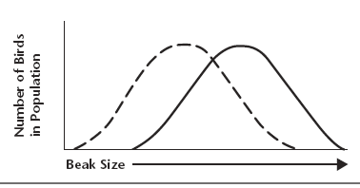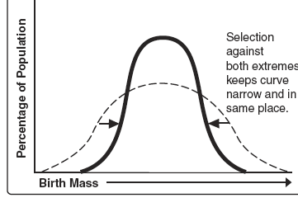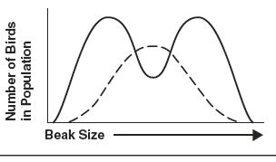

D E


