EVOLUTION REVIEW (Chapter 16 & 17-4) NAME _________________________

1. Name 3 conditions required to maintain genetic equilibrium under the HARDY-WEINBERG PRINCIPLE.

2. TRUE OR FALSE
Most of the time in most populations the conditions for Hardy-Weinberg DO NOT ALL EXIST.

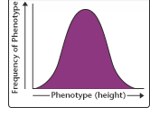
3. Traits that show this kind of distribution (like lima bean length, human intelligence, or skin color) and are determined by more than one gene are
called _____________________,

4. Match the kind of selection with the graph shown below.
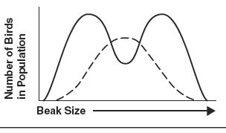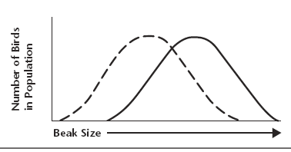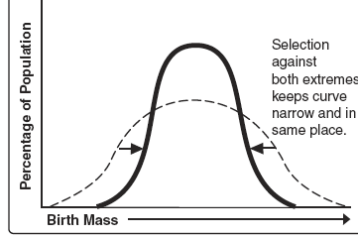
A. B. C.

5. Genetic drift happens in populations that are

Small Large

6. A ___________ __________ consists of all the different alleles that are present in a population.

7. In genetic terms, evolution is a change in the _____________ _______________ of alleles in a population.

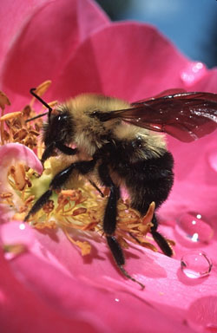
8. Name the type of macroevolution in which two organisms evolve in response to changes in each other.

9. The process by which organisms with different recent ancestors change to become more alike because they live in the same kind of environment is called _______________ evolution.
convergent divergent

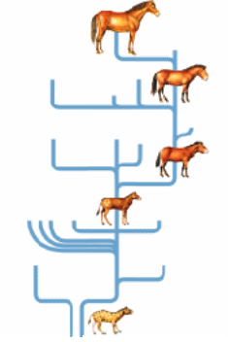
10. Name the kind of macroevolution in which populations show a pattern of long stable periods interrupted by brief periods of rapid change.

11. A situation in which allele frequencies change as a result of the migration of a small subgroup of the population is known as the ________________ _________________.

12. Name the two scientists who came up with a mathematical equation to express the frequencies of alleles in a population.

13. Another name for divergent evolution is ______________ _______________.

14. The process by which organisms that share recent common ancestors change to become different is called _______________ evolution.
convergent divergent
15. Darwin believed in the idea that evolution happened slowly over a long period of time called __________
A. punctuated equilibrium
B. gradualism
C. symbiosis
D. mass extinction

16. A situation in which the allele frequencies change as a result chance is called ___________________ ___________________

17. Evidence suggests that at the end of the Cretaceous period an asteroid hit the Earth causing the loss of many species including the dinosaurs. This is an example of what pattern of evolution?

18. A population of birds lives in an area where plants with medium sized seeds are wiped out by a fungal infection. Birds with unusually large or small beaks would have higher fitness than those with medium sized beaks. Over time the population splits into two subgroups; one that eats small seeds and one that eats large seeds. This is an example of _________________________ selection.
Disruptive Directional Stabilizing

19. In birds, feather color among males is more likely to attract a mate, but also more likely to attract a predator. Over time and many generations, the highest frequency color is for males with medium colors, while males with very dull colors and males with very bright colors became increasingly rare. This is an example of _____________________________ selection.
Disruptive Directional Stabilizing

20. The last test in Biology class was extremely hard. A graph of the scores shows a bell shaped curve with the average score being a 68% D. The teacher curves the test scores so that the new class average is a 77% C. The graph that shows this change would look similar to a graph showing
which kind of selection?

Disruptive Directional Stabilizing

