NAME _______________________________

WHAT DOES STRUCTURE HAVE TO DO WITH FUNCTION?

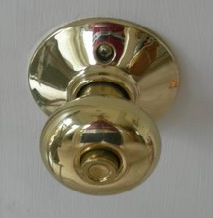
STRUCTURE FUNCTION

_____________________________ ___________________________________

_____________________________ ___________________________________

_____________________________ ___________________________________

Image from: http://picasaweb.google.com/slaintexas/HomeImprovement/photo#5108280860973754738

* * * * * * * * * * * * * * * * *

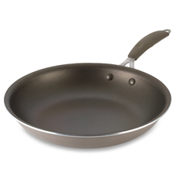
STRUCTURE FUNCTION

_____________________________ ___________________________________

_____________________________ ___________________________________

_____________________________ ___________________________________

Image from: http://www.bedbathandbeyond.com/assets/product_images/230/6344014040420P.JPG

SPORK
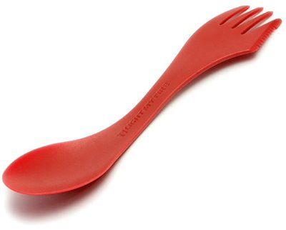
STRUCTURE FUNCTION

_____________________________ ___________________________________

_____________________________ ___________________________________

_____________________________ ___________________________________

Image from: http://www.kirou.com/wp-content/spork-700806.jpg

* * * * * * * * * * * * * * * * * * *


STRUCTURE FUNCTION

_____________________________ ___________________________________

_____________________________ ___________________________________

_____________________________ ___________________________________

Image from: http://site.xara.com/news/october06/img/pencil37.png

Worksheet designed by Brookings Biology http://www.brookings.k12.sd.us/biology

