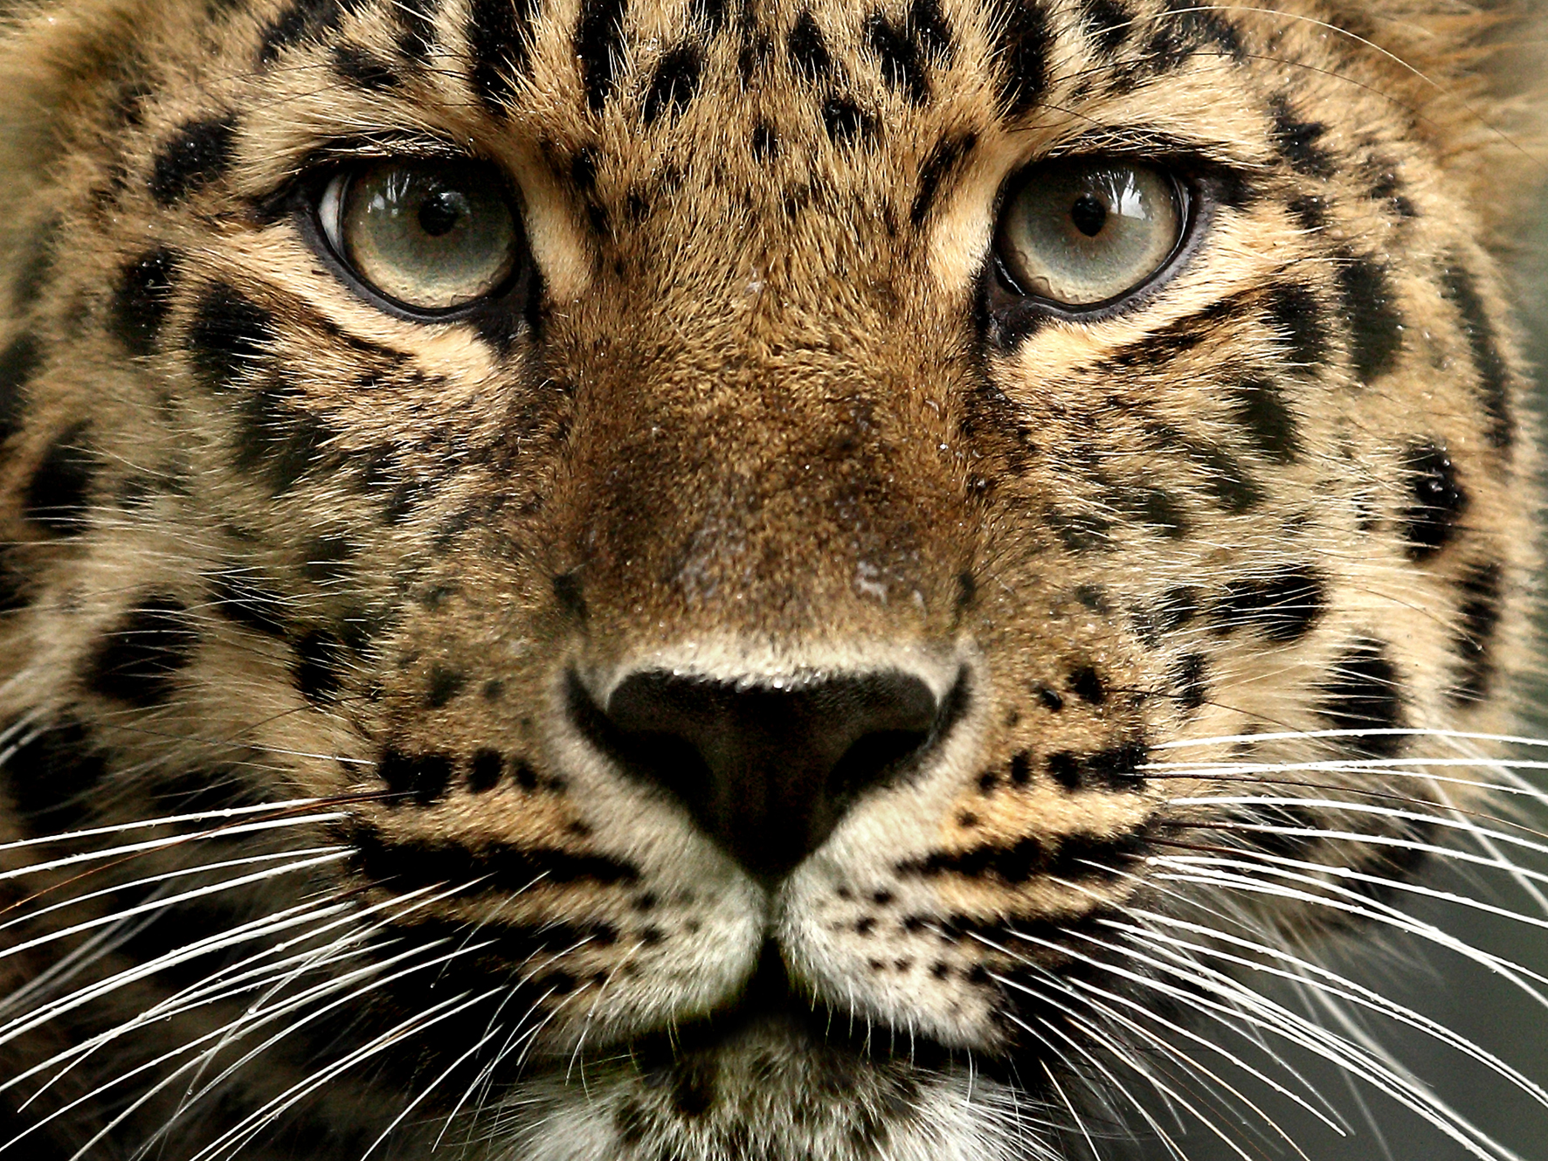
Picture: http://www.altaconservation.org/
Information: http://worldwildlife.org/species/amur-leopard ,

Panthera pardus orientalis is the scientific name of the Amur Leopard.
At 70-105 pounds, it can jump up to 19 feet long and 10 feet high.
Can run up to 37 miles per hour like its cousin the leopard.
Has adapted to the Russian temperate forests in the Far East.
Some males have stuck around t help raise the young.
After eating their fill, the leopard will hide their remaining kill from others.
Locals also hunt the prey of the Amur Leopards further reducing the population.
Several males will follow and fight for a female before reproduction.
The forests in which the leopards live are accessible.
About 30 Amur Leopards are living in the wild, making them critically endangered.
The Land of the Leopard National Park is the name of the Russian sanctuary for the Amur Leopard and hold about 60% of their habitat.
Amur Leopards live for approximately 10-15 years in the wild.

Poachers are able to access the areas where the leopards live this is a huge issue.
These leopards are carnivores and eat hares and local roe and sika deer.

The Amur Leopard is hunted for its beautiful fur.
In the CITES Appendix I all commercial trade of the Amur Leopard is banned.
WWF is allowing people to see what this cat looks like and hopefully gain support to save it.
Furs are being sold for $500-$1000 in villages in the leopard’s area.
The leopards help with the deer (its food) and the Amur Tiger populations.
2012- The Amur Leopards where granted a sanctuary from the Russian Government that is nearly 650,000 acres of land.
The WWF has programs set up in Far East Russia and northeast China.
TRAFFIC is also helping by placing and enforcing trade monitoring.
By Increasing the population of the leopard’s prey, WWF hopes to also increase the leopards numbers.
Reducing logging in unsustainable and illegal was will also help the leopard to return.
WWF along with other organizations convinced the Russian Government to reroute a oil line that would have endangered the habitat in 2007.

