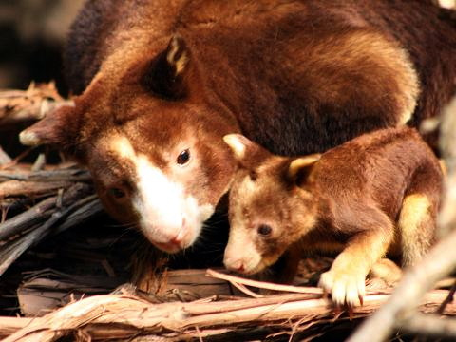

**Goodnight zoo**

**And goodnight tree kangaroo**

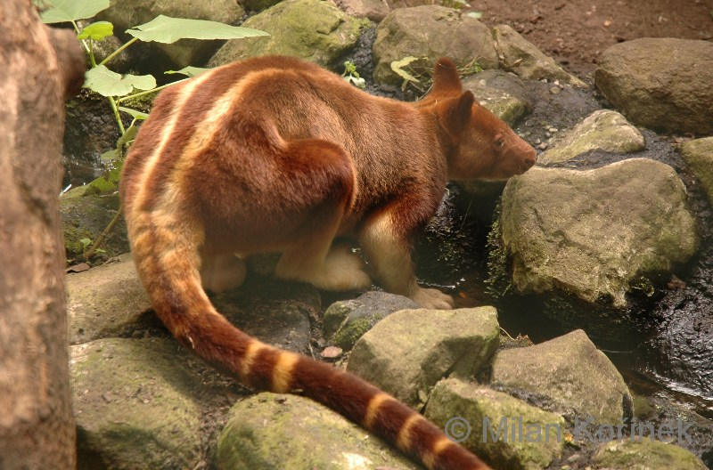

**Goodnight to the most solitary animal**

**Goodnight you little valuable**

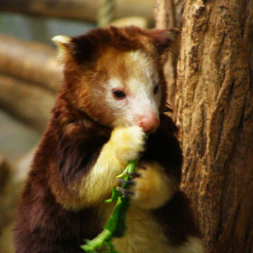

**But only Goodfellow’s has stripes and a banded tail**

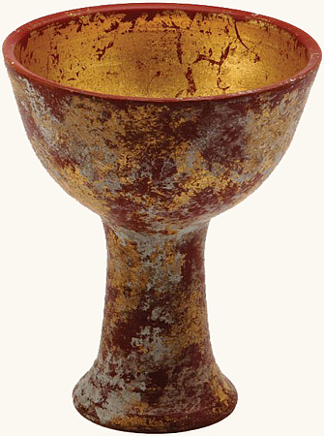

**Colored like the Holy Grail**

http://www.indygear.com/images/props/grail/grail2.jpg

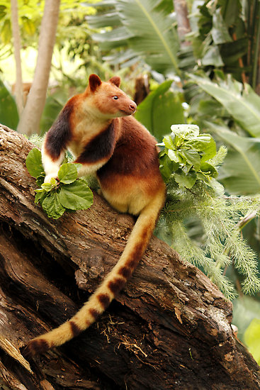

**Goodnight golden back stripes**

**Of tree kangaroos**

**There are only 14 types**

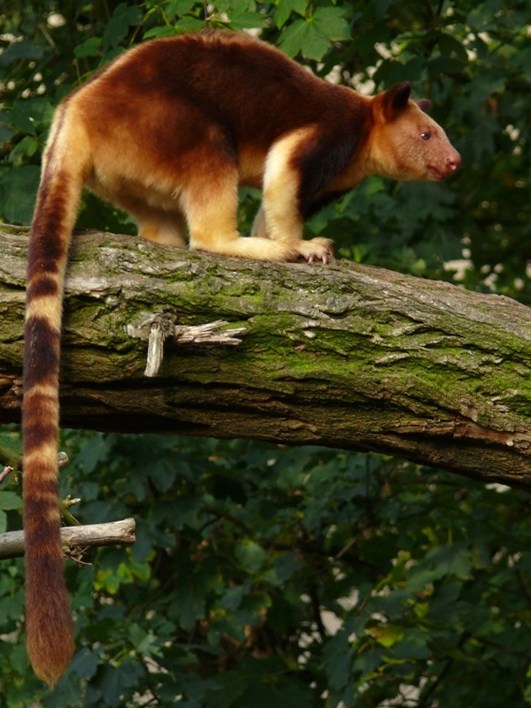

**Goodnight to the food you eat**

**And goodnight to you large clawed feet**

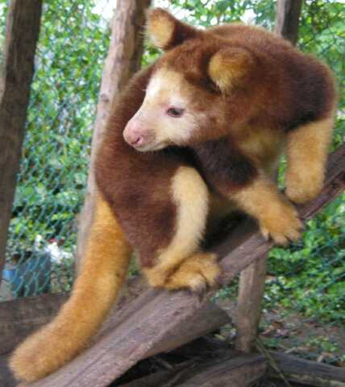

**Goodnight zoo**

http://3.bp.blogspot.com/-KOurYbQSemA/TxX1lUUyQiI/AAAAAAAAAOs/YNM_ePJFzM8/s1600/Tree+Kangaroo+2.jpg

**Goodnight tree kangaroo**

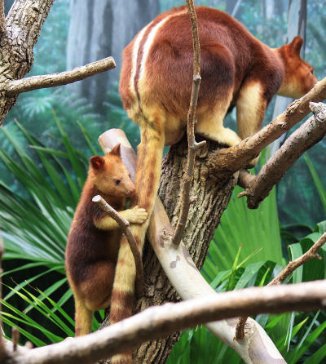

**The Goodfellow tree kangaroo has very distinct features**

**We’ll have to say goodnight to all of them**

**We’ll start around 6 a.m.**

http://d2tq98mqfjyz2l.cloudfront.net/image_cache/1332703279497610.jpg

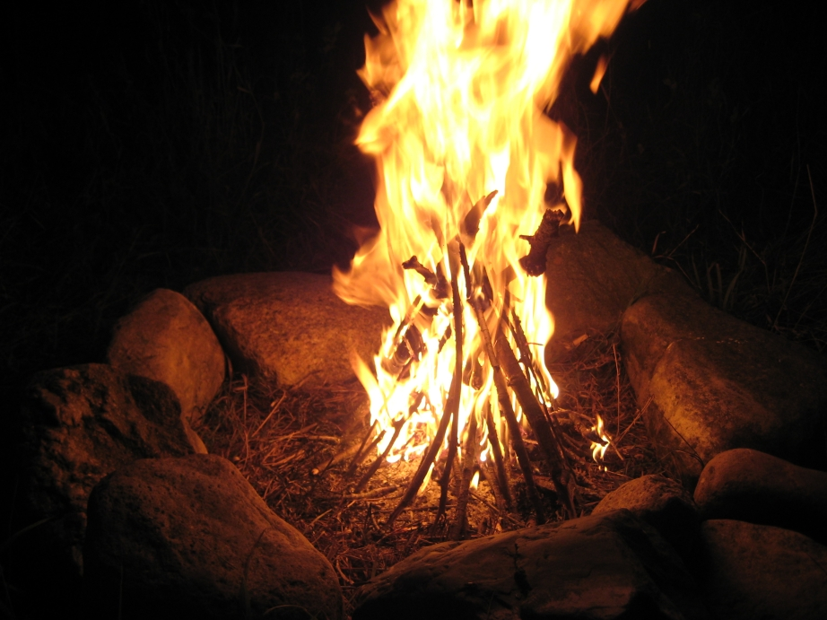

**And write in their journal**

**So a fire should ignite to watch these furry creatures**

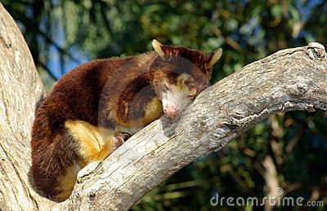

**Since tree kangaroos are mostly nocturnal**

**They sleep during the day**

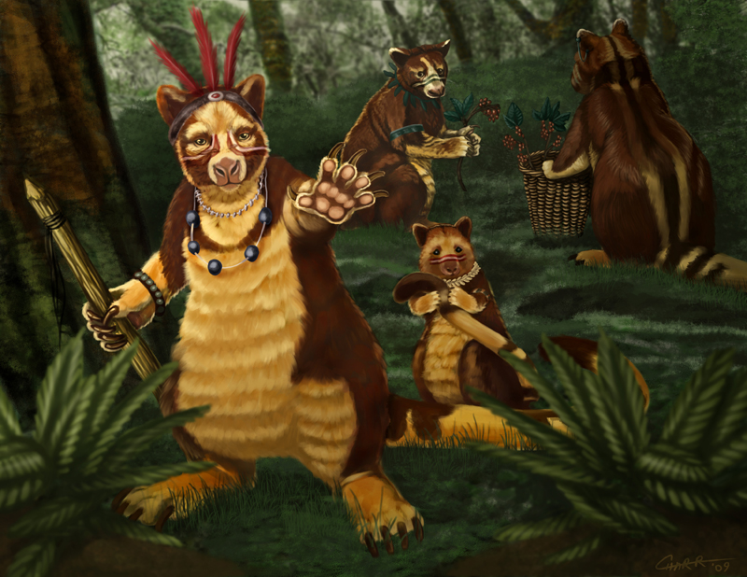

**He likes to pretends they give him super powers**

http://s3.amazonaws.com/files.posterous.com/charreed/yYQN9SYSyVrptrkviZoYMbiuyYFBn7aWsQzOcZ9RfYHefvBpsBSFWbfvlgfr/13TreeKangarooFinal.jpg?AWSAccessKeyId=AKIAJFZAE65UYRT34AOQ&Expires=1364828246&Signature=zzgaszz%2ByGOgHJhrjaN4UbclKU4%3D

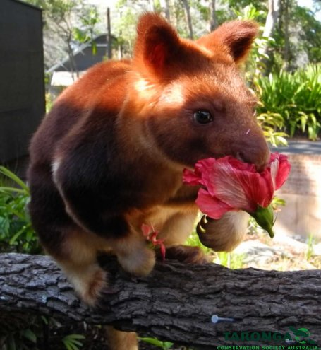

**It’s getting late**

http://taronga.org.au/sites/default/files/imagecache/media_lightbox/salsa.jpg

**He likes water chestnuts and hibiscus flowers**

**It’s time he ate**

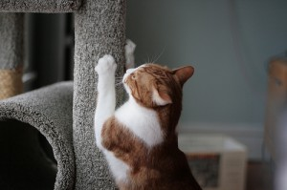

**A cat to a rug**

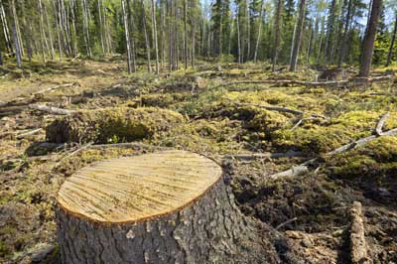

**Humans are the biggest creditors**

**They tear up his home as**

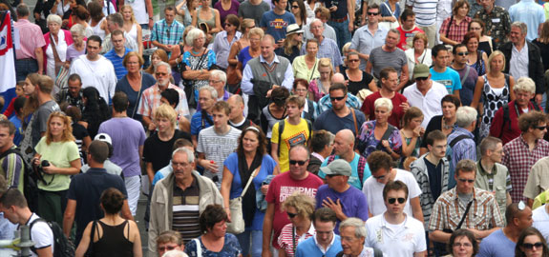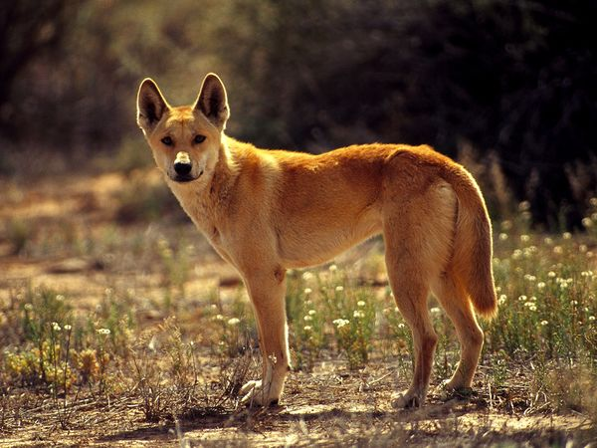

**From his natural predators**

http://www.inc.com/uploaded_files/image/575x270-panoramic_Crowd_of_People_12477.jpg

**Out of the two he has**

http://images.nationalgeographic.com/wpf/media-live/photos/000/005/cache/dingo_514_600x450.jpg

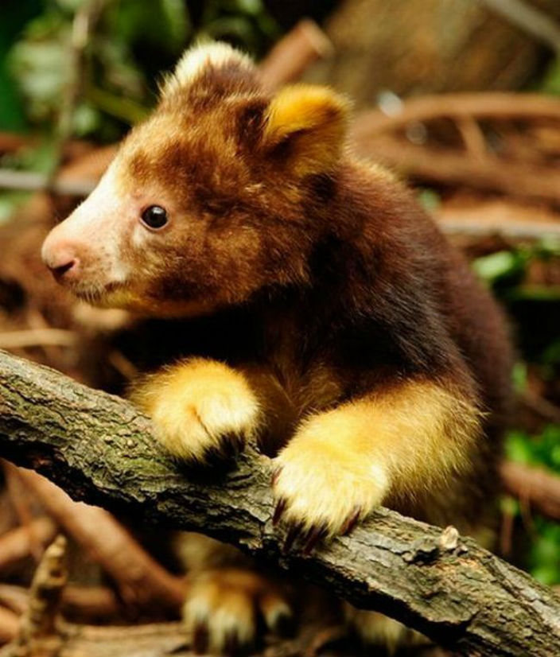

**He is safe**

http://dzivniecini.lv/images/posts/17_f5b9b5c474551b07463eef49c02bb093_1.jpg

**In this place**

[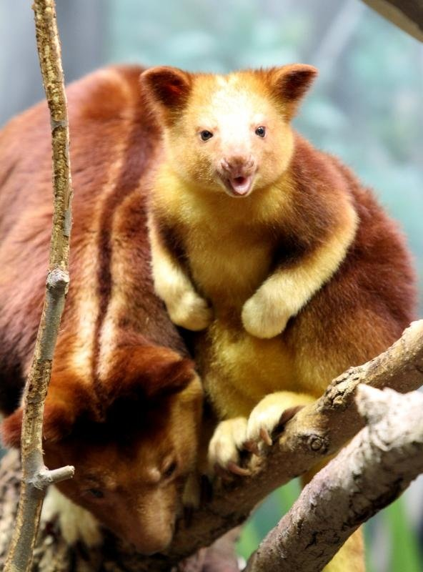](http://www.google.com/url?sa=i&rct=j&q=goodfellow's+tree+kangaroo+offspring&source=images&cd=&cad=rja&docid=mHIrYsi0W-khTM&tbnid=NXGwuRporBAysM:&ved=0CAUQjRw&url=http://blog.cleveland.com/metro/2010/02/endangered_goodfellows_tree_ka.html&ei=VfNRUYrZDJLkqAGr84GwDw&bvm=bv.44342787,d.aWc&psig=AFQjCNH1iPNTvotv0HgU3JPYg5EGPlQy0w&ust=1364411557333830)

http://blog.cleveland.com/metro/2010/02/endangered_goodfellows_tree_ka.html

**There lived a little Tree Kangaroo**

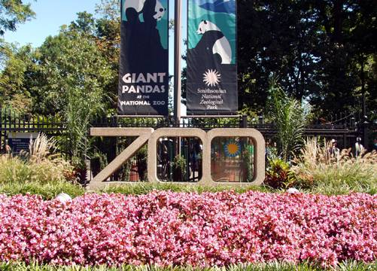

**In the Papua New Guinea Zoo**

http://www.pbase.com/image/34012768

[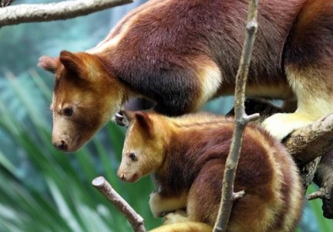](http://www.google.com/url?sa=i&rct=j&q=tree+kangaroo&source=images&cd=&cad=rja&docid=nKGA2JlNTtHK5M&tbnid=CP_dlgcQwNQTrM:&ved=0CAUQjRw&url=http://www.tumblr.com/tagged/goodfellow's%20tree%20kangaroo&ei=aO9RUf4PkuSoAavzgbAP&bvm=bv.44342787,d.aWc&psig=AFQjCNHLGsvAFeBhNq9u97Wk9VG6gbr_qw&ust=1364410458760520)

http://www.tumblr.com/tagged/goodfellow's%20tree%20kangaroo

By Jenna Koerner