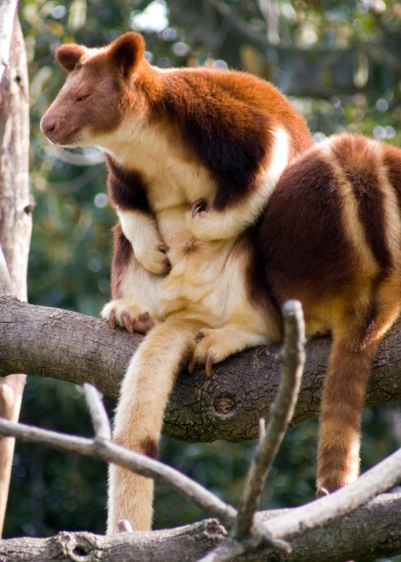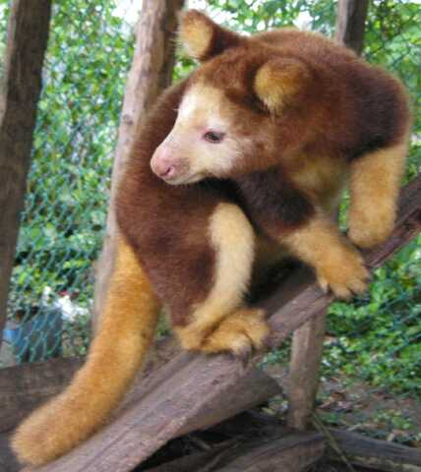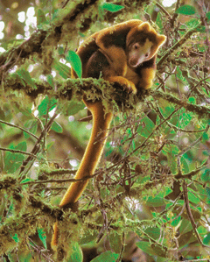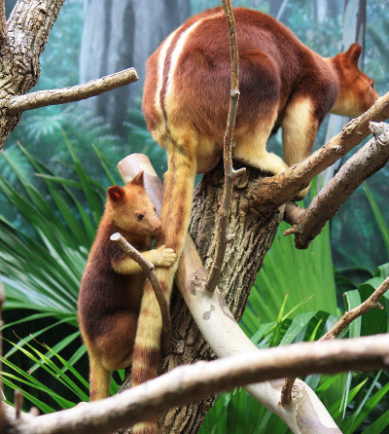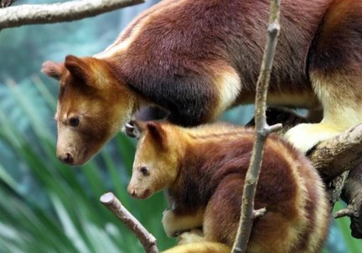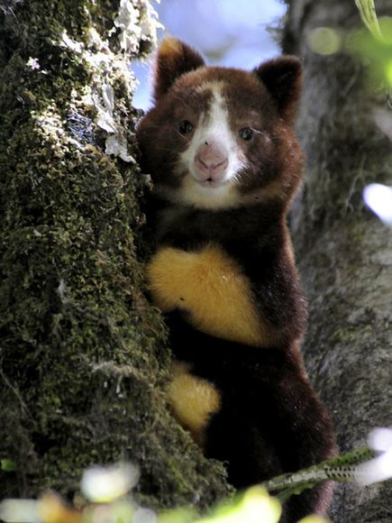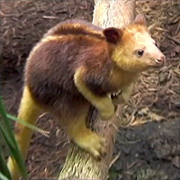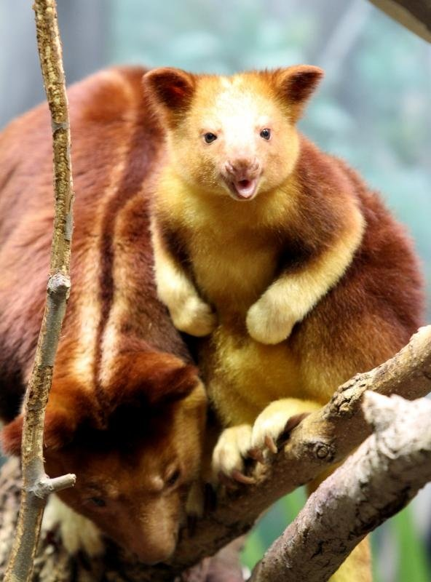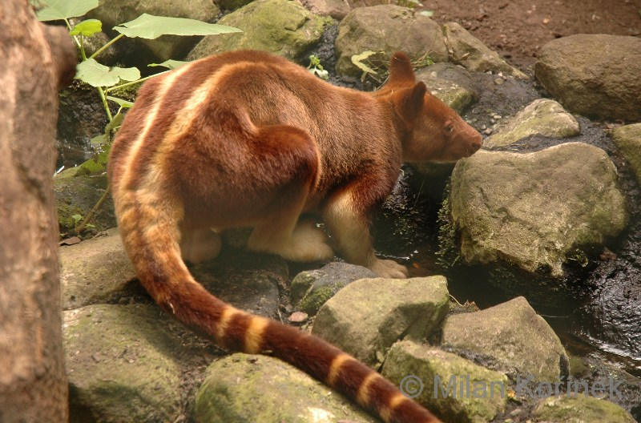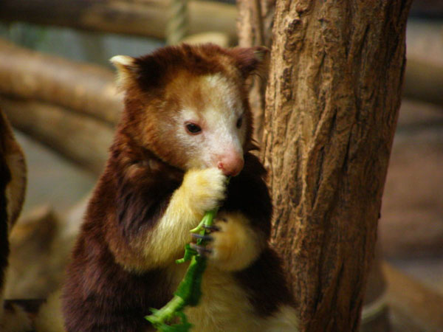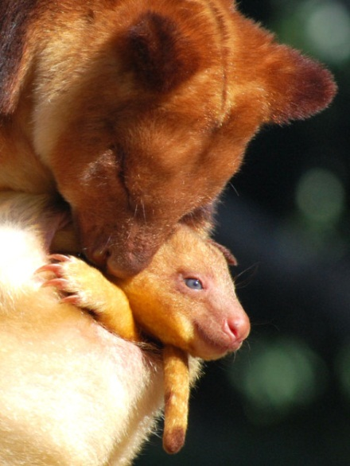
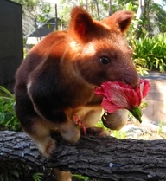
http://wwf.panda.org/what_we_do/endangered_species/tree_kangaroo/
http://www.perthzoo.wa.gov.au/animals-plants/asia/goodfellows-tree-kangaroo/
http://animaldiversity.ummz.umich.edu/accounts/Dendrolagus_goodfellowi/
http://www.arkive.org/goodfellows-tree-kangaroo/dendrolagus-goodfellowi/
http://www.angelfire.com/mo2/animals1/kangaroo/goodfellow.html

In the Papua New Guinea zoo
There lived a little tree kangaroo
He is safe
In this place
From his natural predators
Out of the two he has
The humans are the biggest creditors
They tear up his home as
A cat to a rug
He is fond of great big bear hugs
It’s getting late
It’s time he ate
He likes water chestnuts and hibiscus flowers
He pretends they give him super powers
Since tree kangaroos are mostly nocturnal
They sleep during the day
And write in their journal
So a fire should ignite
To watch these furry creatures
The goodfellow tree kangaroo has very distinct features
We’ll have to say goodnight to all of them
We’ll start around 6 am
Goodnight zoo
Goodnight tree kangaroo
Goodnight to the food you eat
Goodnight to your large clawed feet
Goodnight golden back stripes
There are only 14 types
Of tree kangaroos
But only good fellow’s has stripes and a banded tail
Colored like the Holy Grail
Goodnight to the most solitary animal
Goodnight you little valuable
Goodnight zoo
And Goodnight tree kangaroo

