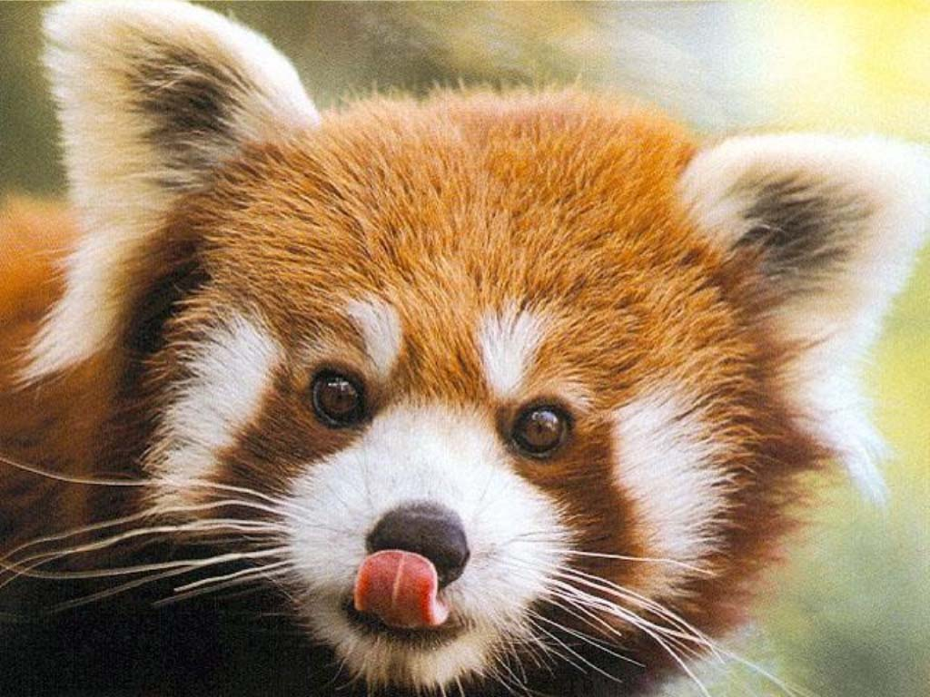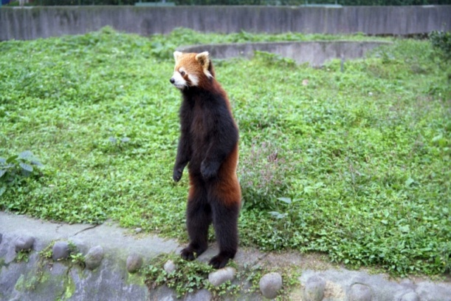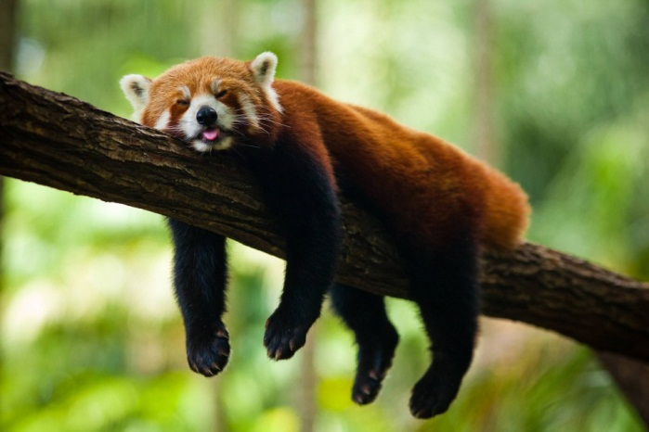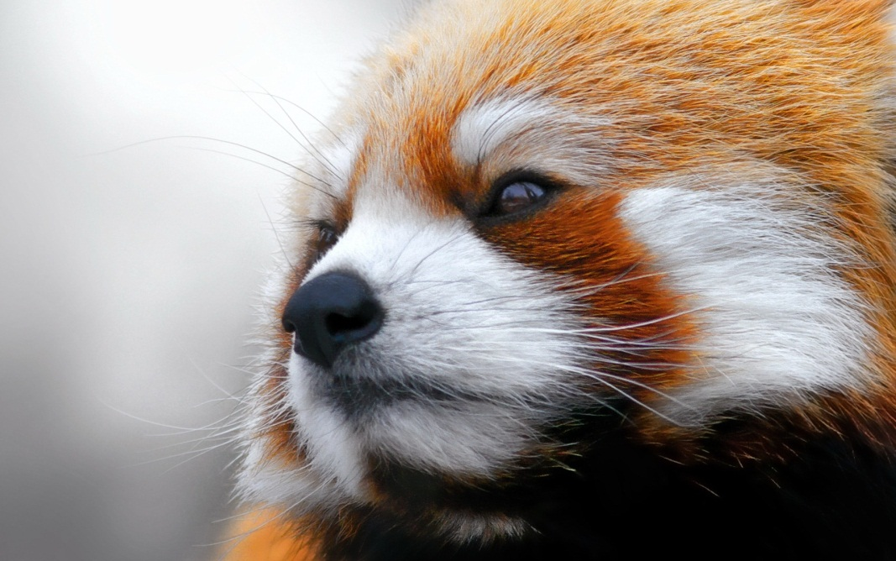­­­

The red panda can grow up to four feet long, but their tail makes up about half of their body length. They have mostly red-brown fur, excepting the markings on their face and the six rings on their tail. Their fur gets darker on their undersides and becomes almost black near their paws. They end up looking like a cross between a red fox and a raccoon. They are a relative of the greater panda.

The red panda (**Ailurus fulgens fulgens and Ailurus fulgens styani)** is endangered due to lack of habitat and poaching. Although red pandas live in a large range of temperate forests that extends from western Nepal to northern Myanmar, they can only find bamboo, a staple of their diet, in narrow bands of that range. They are restricted to these small, fragile areas because of their dependence on young bamboo plants, which make up much of their diet.

Images  
<http://www.listofimages.com/wp-content/uploads/2012/09/panda-red-panda-animals.jpg>  
<http://nickshell1983.files.wordpress.com/2010/07/pandastanding.jpg>  
<http://emilystankovic.edublogs.org/files/2010/07/redpanda10.jpg>  
<http://news.worldwild.org/wp-content/uploads/2008/09/red_panda.jpg>  
<http://onebigphoto.com/uploads/2012/04/red-panda-sleeping.jpg>  
<http://lh6.ggpht.com/_ymNE7hmpS8k/SfttgtG89YI/AAAAAAAAAho/1pVTaVe7jfk/panda_comic.jpg?imgmax=512>

Worldwide population is estimated at fewer than 10,000 mature individuals. Red pandas live between 10 and 15 years, and can begin reproducing at 18 months. They have a 4 1/2 month gestation period, very long for such a small mammal. They give birth in litters of one to four. Red pandas have few predators, mainly the snow leopard and poaching.

**Behavior**

Red pandas are generally solitary, but young red pandas grow relatively slowly so they spend a long time with their mothers, and they have short relationships during the annual breeding season. They are territorial, but only visit about 25% of their home ranges per month. They also sleep in trees, to protect from predators, and are very adaptable to captivity and are common at zoos.

**POPULATION**

**HOW CAN I HELP?**

There is an excellent site called redpandanetwork.org, it is essentially a group that tries to protect red panda populations by working with the governments in the area to preserve the forests and monitor the population. They also help impoverished villagers in Nepal and fight global warming. You can help in several ways, volunteering, donating, or just raising awareness through your favorite websites.  
Also, use Firefox as your browser: The name Firefox is based on a nickname for the red panda.

sources:  
<http://en.wikipedia.org/wiki/Red_panda>  
<http://animals.nationalgeographic.com/animals/mammals/red-panda/>  
<http://m.wwfnepal.org/about_wwf/conservation_nepal/shl/thematic_solutions_nepal2/species_nepal/red_panda/>  
<http://redpandanetwork.org/red_panda/about-the-red-panda/>

**DIET**

The red panda eats mostly bamboo, but it can only eat the youngest, most tender shoots and leaves. When the weather is warm enough, they also eat insects and fruit. Bamboo is hard to digest, so red pandas lose as much as 15 percent of their body weight during the winter, when other foods are not available. To cope with the lack of food during the winter months they have a very low metabolism, close to the level of sloths.

**APPEARANCE**

**THE RED PANDA**