Giant Panda – ailuropoda melanoleuca
By: Nolan Hesler Period 1
Underneath the mystic clouds above Emerald Mountain in South-Central China, there sat a mother panda with her cub. The cub's brothers had all grown past three years of age and had since left the care of the mother.
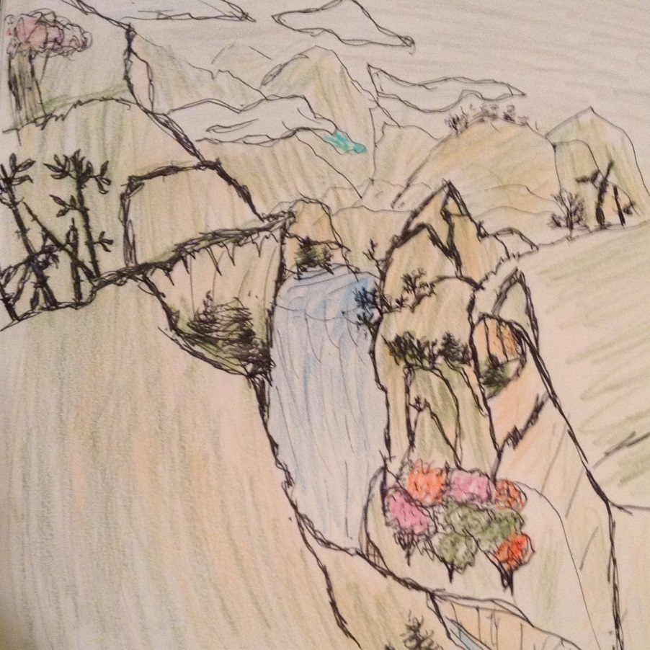

Zhong, the cub, was still young enough to stay with her. Zhong's father had left the two before Zhong was bigger than a stick of butter. At that time, he was almost 1/900th of his mother's size.
High in the lush temperate forest was the bamboo grove they called home, although the two pandas never stayed in one place for too long. The mother didn't ever like to have her fighting defenses put into action.
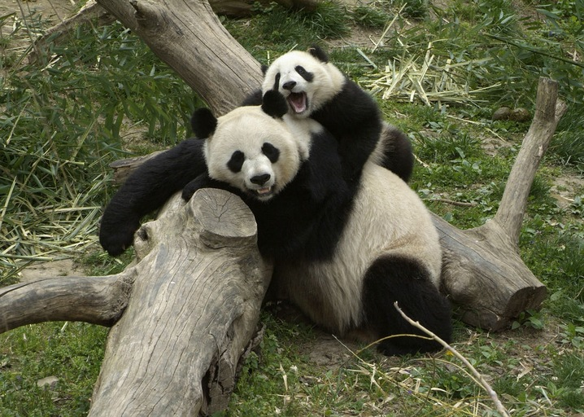

Zhong and his mother tended to prefer the bamboo from higher up the mountain, anyway, for it was older and larger. The stalks that grew around the two were still young and too watery.
"Come," said the mother, "we shall travel up the mountain to find more bamboo; our pile is low." She said almost everything with a caring smile that Zhong loved. They left to search for bamboo to eat, and found some.
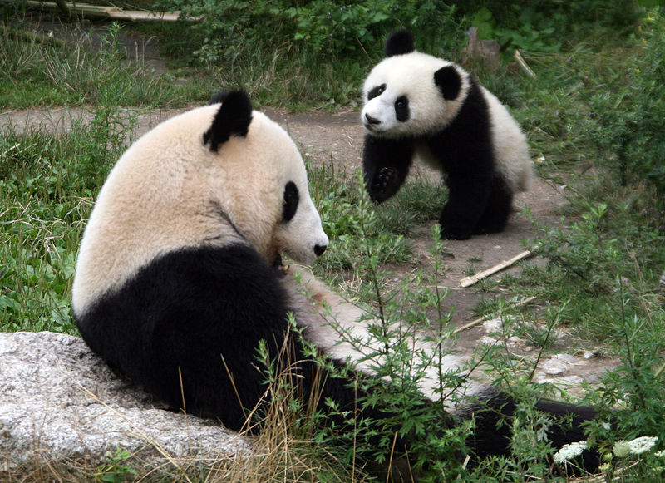

"This bamboo is over one-hundred years old, Zhong."
"I almost feel sad eating it, but we've only eaten twenty-one pounds today."
The mother panda nodded. "Yes, but we need no less than forty pounds each day."

After they had eaten the thick, green bamboo with their large molars, the mother decided to rest. Zhong, however, saw Ping, the best of his many friends, in a nearby clearing. With the mother's approval, he joined Ping below.
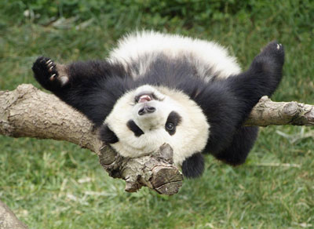
"Hey, Zhong! I've been waiting to climb with you for a long time," Ping said while looking up at some of the tallest trees on Emerald Mountain.

"We're going to climb those trees. I would race you, but I ate too much today..."
So, being excellent climbers, the friends climbed the trees. Zhong knew Ping loved to see the mountain, and it was a treat; there was rarely time for it.
However, as Ping neared the top, having climbed to the top first, his excited grin changed to one of horror. Zhong, nervous, reached the top of his tree.

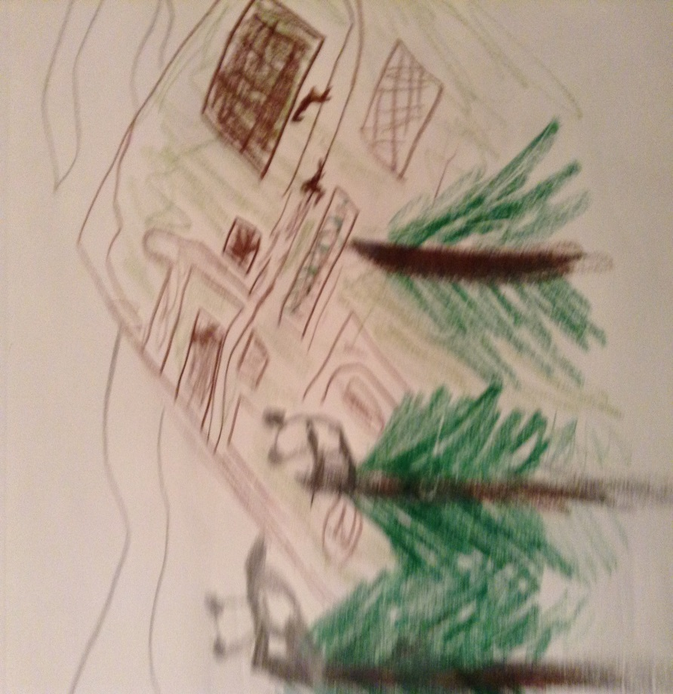

What was once beautiful green mountainside was now a patchwork of fields and roads. It was not a pretty sight to behold. Sharing silent disappointment, Ping and Zhong climbed down the trees.
Ping decided that he wanted to return home. Zhong said goodbye and began to retrace his earlier steps. Snow fell from above, sticking to his fur. At a stream on the way, he drank water from melted icecaps.

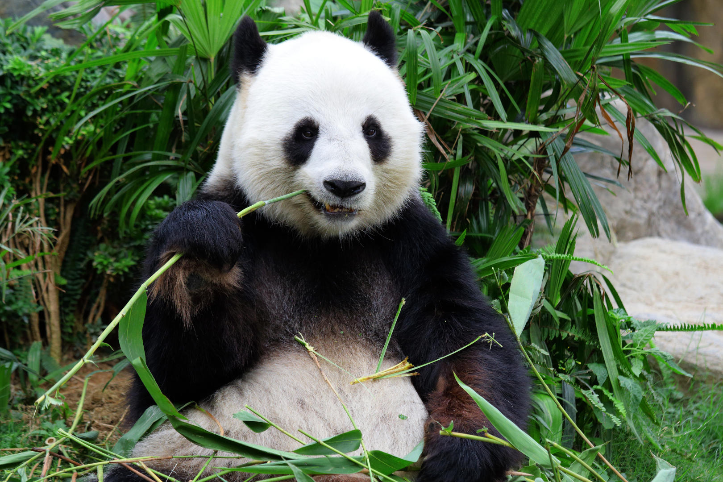

Toward his bamboo grove, Zhong started to notice a sound. It was desperate, struggling, and grave. His feet moved him toward the sound, faster and faster, until he finally knew what it was.
Once he smashed through a bush, Zhong found a dirt road. A strange wooden cart was getting farther and farther away from him. He saw his mother, but quickly looked away; just her barely-breathing body made tears come to his eyes.

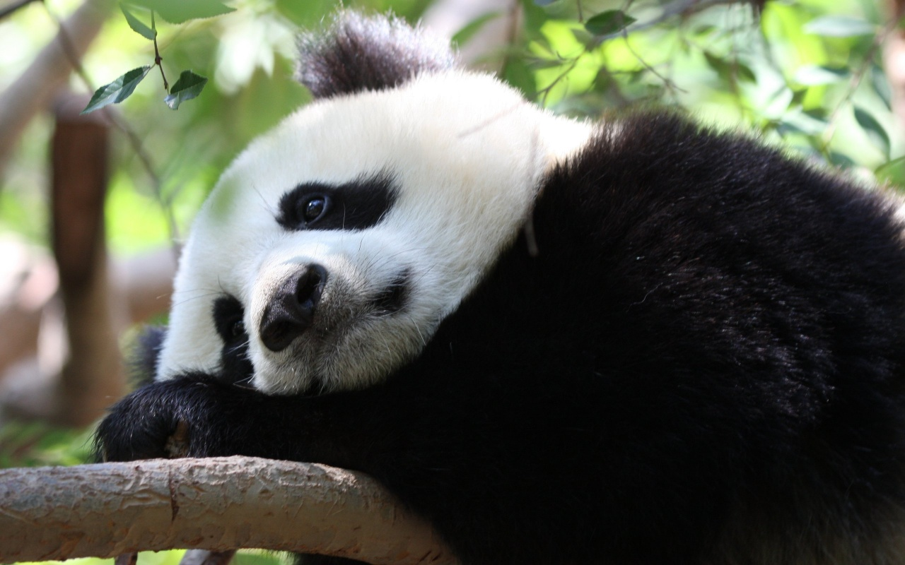

Ping jumped out of a bush toward Zhong with a rustle, having followed him.
Zhong didn't feel social, and buried his head in an exotic grass.

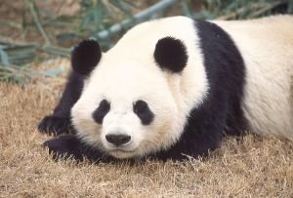

Ninety-nine percent of the time, Zhong didn't feel like eating musk deer or grasses, but he noticed that he did when he was depressed. So, he ate his pillow.
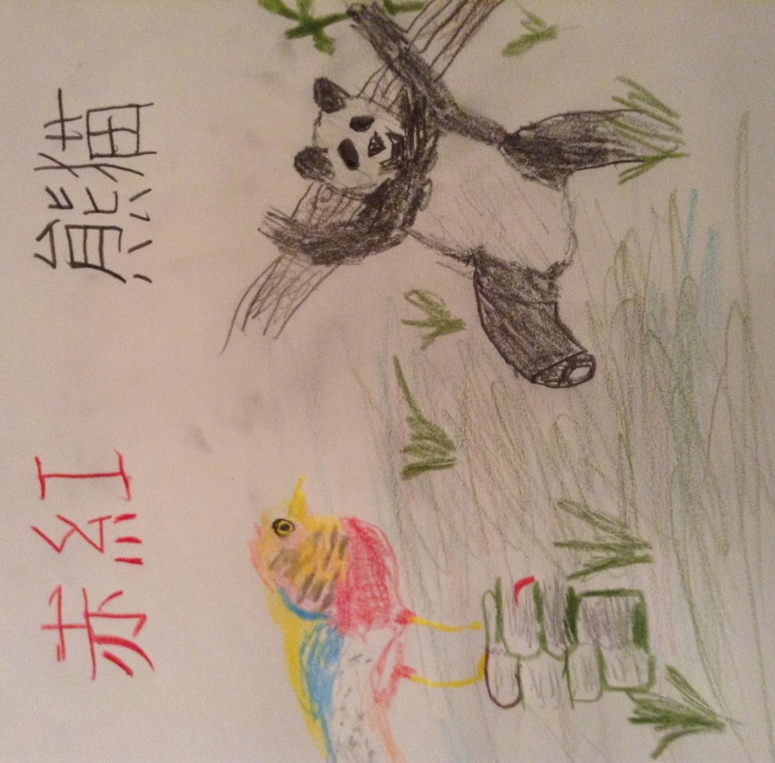
When he awoke from a sad slumber, Zhong saw a colorful bird watching him; he remembered that it was the Golden Pheasant, a wise sage that lived on Emerald Mountain.

"Zhong, I have heard word of your mother from Ping... You are going to live with me now. My name is Chihong, and I will teach you the ways of this mountain."
Knowing better than to argue, Zhong lived under the watch of Chihong from then on.
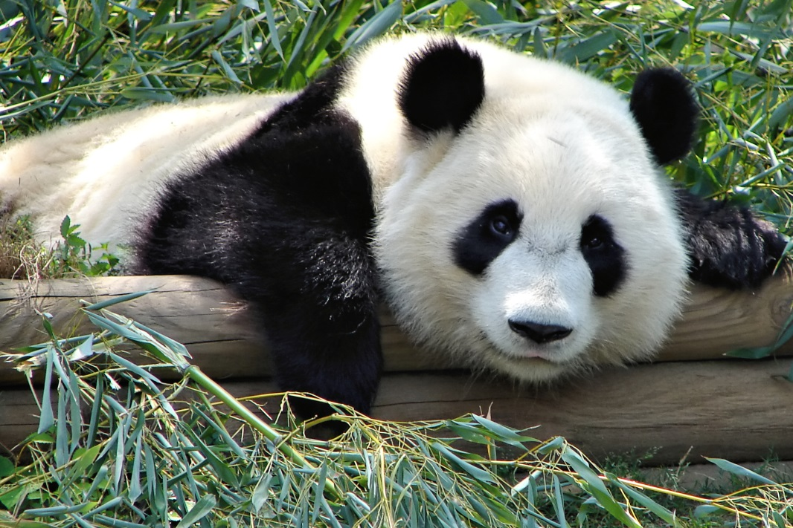
One day, Chihong looked like he was thinking deeply while sitting on a stack of books in his large nest. He opened his beak once Zhong returned from his lunch. "You are not hungry?"

"The bamboo is becoming scarce, and I can't cross the fields of the farmers who farm here to find any more," Zhong replied.
"Ah, the ways of men have blocked nature's light. Do you see?"
"What I see is the population of pandas on this mountain becoming smaller and smaller each month. Why is that?"
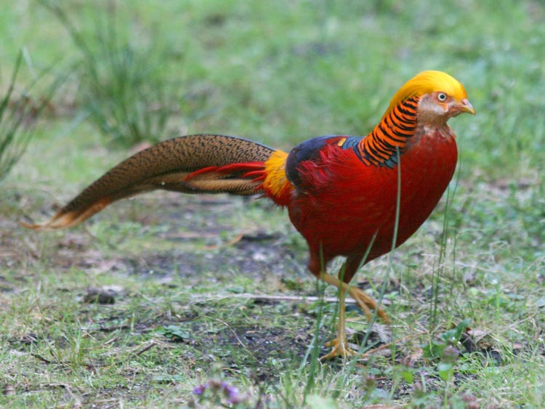
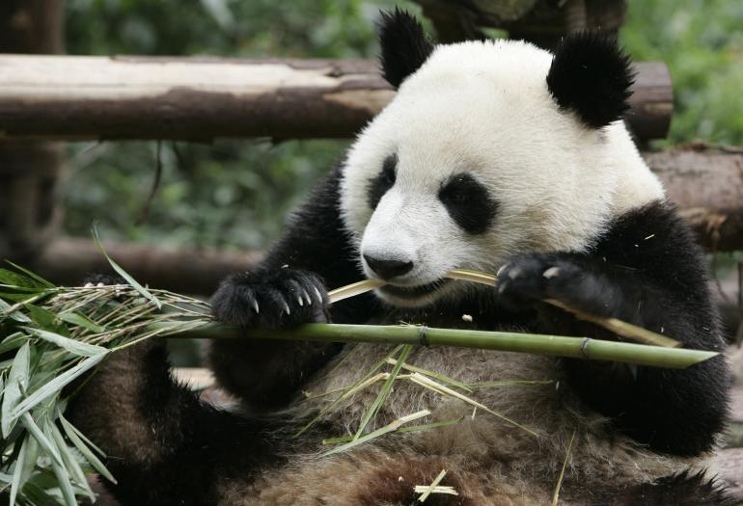
"See, ailuropoda melanoleuca, or Giant pandas, like yourself, have been kept from your natural course... I am sure you have seen the damage caused by the increasing amount of agriculture on this very mountain. They slash away at your bamboo and your temperate forest habitats, and with so few being born during the small glint of time in the spring, it is no wonder your friends are fighting for their lives."

Chihong dusted snow from his head. "You are what men call endangered, which means that you must be very careful with where you go and what you do from this time on," Chihong gazed thoughtfully at Zhong.
Zhong was one of 1,826 wild giant pandas.
"Why do men not care for my -our- survival? Don't they realize that we live here, too?" Zhong, angry, picked at the brown grass nearby.

Chihong inhaled and exhaled deeply before speaking. "Some men never realize what they do to animals like giant pandas. However, some actually care deeply about your life. In fact, you are under Category 1 protection here, and a hummingbird recently spoke of a Grain-to-Green thinking where the government of the Chinese humans asks farmers to demolish their farm and replant trees for grain and money. So, there are people out past these trees that really do want the best for you."
"What about the people that want panda fur?"
"The hunting of your species is illegal; some hunters are even given death sentences. What say you to that?"

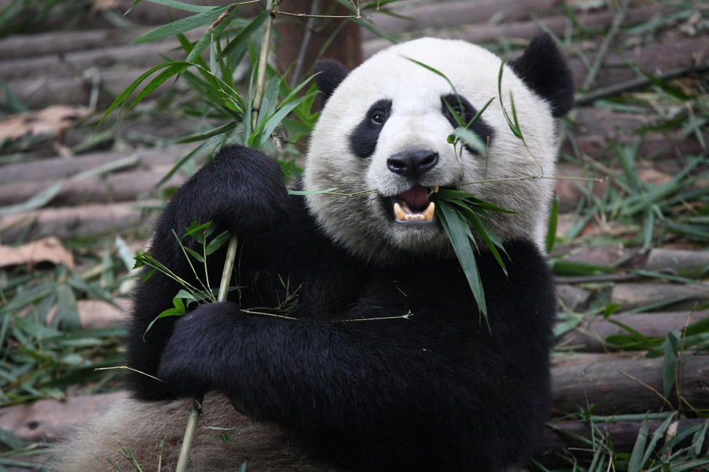

Zhong remained silent, thinking of his mother's face. Chihong spoke once more. "Although humans and their agriculture are your main enemy, people can also be your friend. However, tigers and martens are not blameless- they harm panda cubs...rarely, but it still happens."
The black and white bear sat and thought about all that Chihong had said.
Were all of his words true? Do some humans actually care? Zhong slept for a while with thoughts running everywhere in his mind.

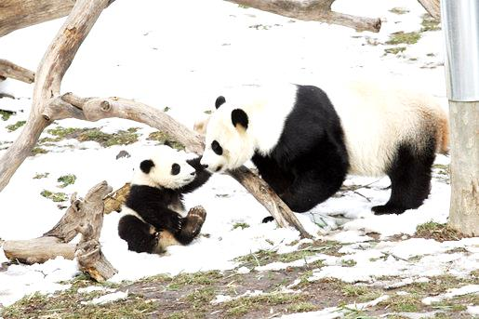

Eventually, snow fell over Emerald Mountain. Zhong returned from breakfast one day to find a crimson feather drift by in the wind. He raced to the spot and found Chihong's nest closed up and quiet.

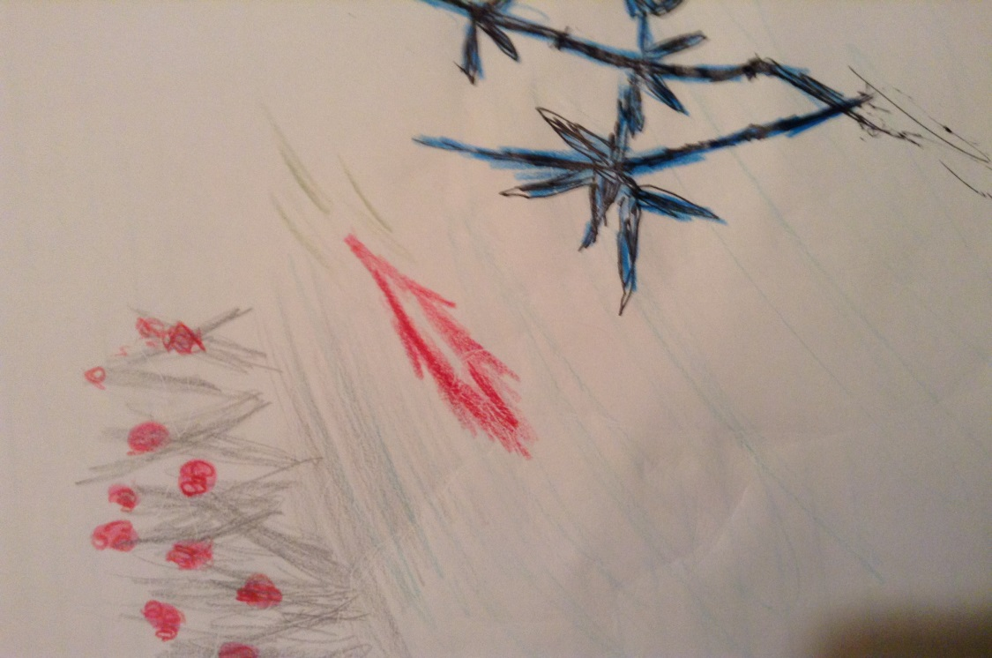

Then Zhong spotted Chihong in the sky. The bird shouted down at him, "I must migrate. You do not know of this, but the cold is my enemy- one I must escape. Farewell, Zhong! Someday, we shall meet again!"

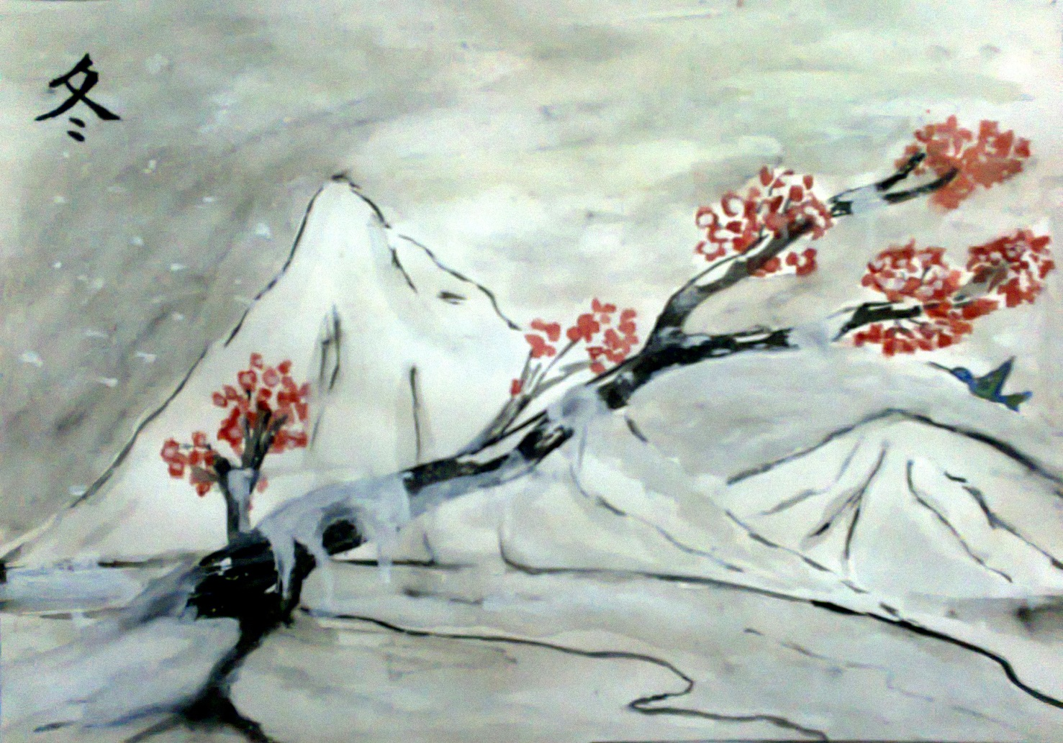

Soon, Chihong was just a red speck in the sky above the mountain.

Zhong vowed that he would remember Chihong’s wisdom forever, and would pass the knowledge to his female partner, and she to her children once the white mountain became Emerald once again.
Information Sources
https://www.worldwildlife.org/species/giant-panda
http://www.iucnredlist.org/details/712/0
https://nationalzoo.si.edu/Animals/GiantPandas/
http://www.arkive.org/giant-panda/ailuropoda-melanoleuca/#text=All
http://eol.org/pages/328070/media

Picture Sources
http://www.worldwildlife.org/pages/species-spotlight-giant-panda
http://www.pbs.org/newshour/rundown/which-bears-took-home-giant-panda-zoo-awards/
http://nationalzoo.si.edu/Animals/PhotoGallery/GiantPandas/14.cfm
http://en.wikipedia.org/wiki/Tai_Shan_(giant_panda)
http://www.ibtimes.com/wild-giant-panda-population-rise-finds-new-survey-1831658
http://bajeerancko.blogspot.com/
http://commons.wikimedia.org/wiki/File:Atlanta_Zoo_Panda.jpg
http://a-z-animals.com/animals/giant-panda-bear/
http://www.whatsupyasieve.com/2012/09/17/lockout-blues/
http://www.gobirding.eu/Photos/GoldenPheasant.php
http://community.how-to-draw-and-paint.com/group/chinesebrushpaintingandsumiegroup/forum/topics/january-2012-challenge-winter-scene

