ADOBE SPARK MOVIE DIRECTIONS https://sparkadobe.com
Create a FREE account. Choose a login and password.
LOG IN to the website.
Choose My Projects from the top of the page.
Click on yellow + button on top right of page to add a new project.
Click on red + VIDEO button on right side of page to make a video slideshow.
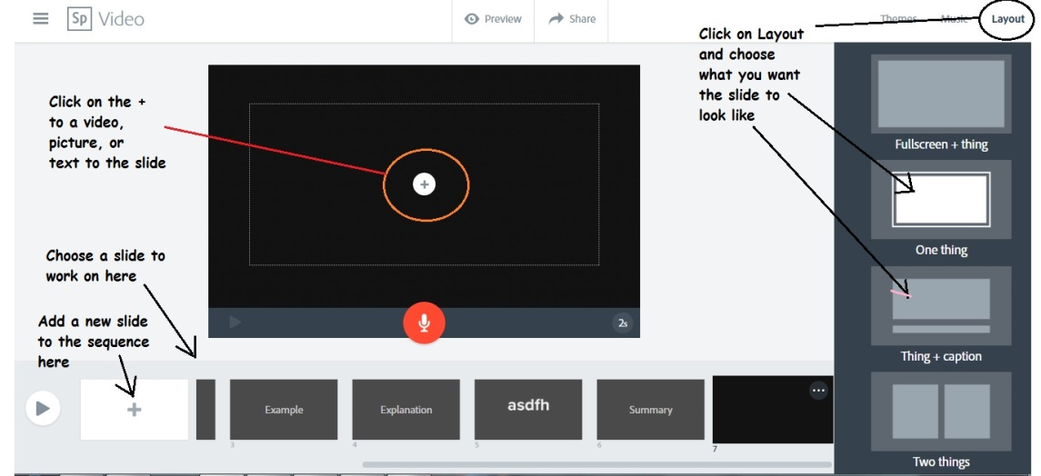
You can watch a little slide show about making a presentation
OR Click on the “I’m ready” button.

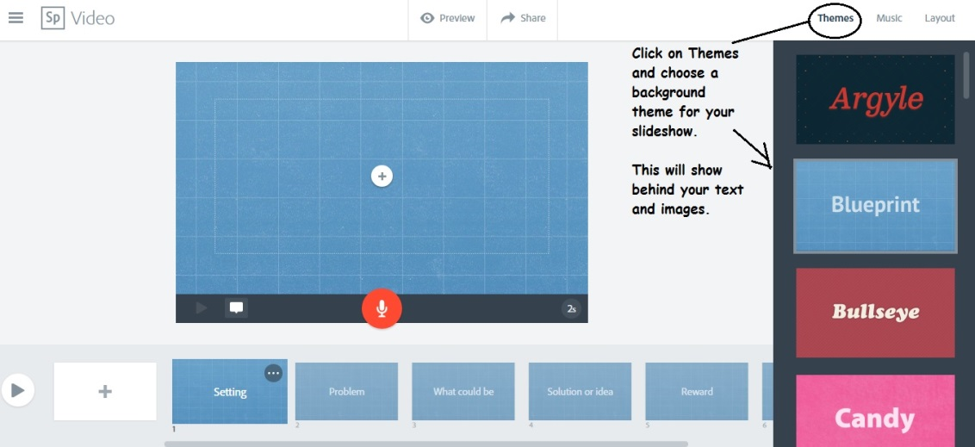

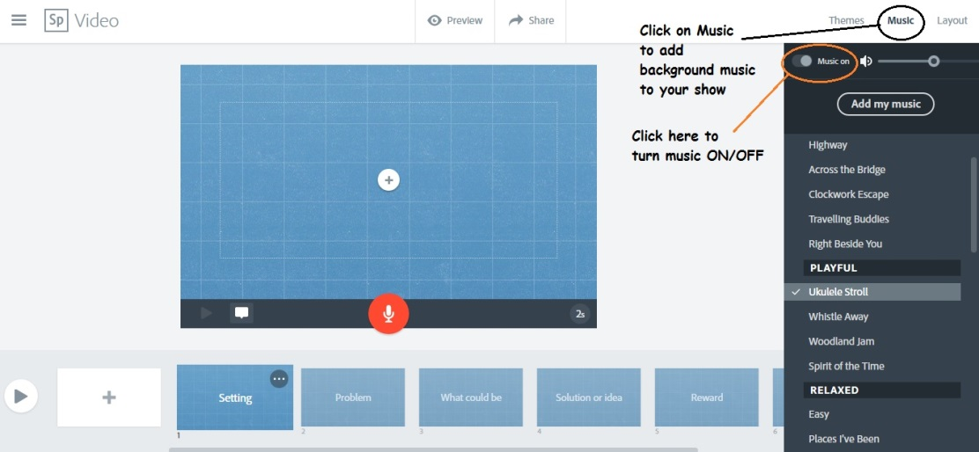
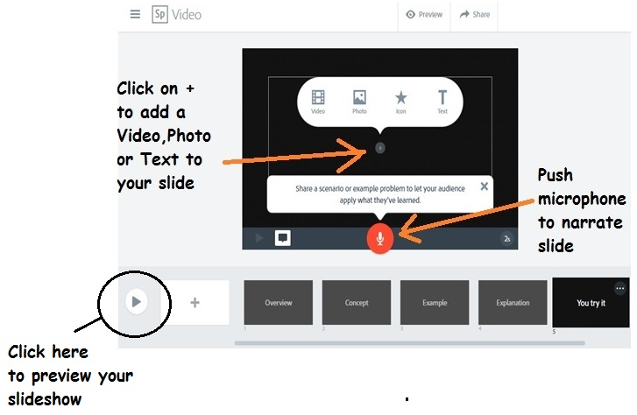
NARRATING YOUR MOVIE
TO ADD NARRATION TO YOUR SLIDE PRESS AND HOLD MICROPHONE BUTTON
LET GO WHEN YOU ARE DONE TALKING.

There is a slight lag when you record.
TO START RECORDING hold microphone button down and count to 3. Then start talking.
TO STOP RECORDING finish talking count to 3 then RELEASE microphone button.
You can record as many times as you like to get it to sound the way you want it.
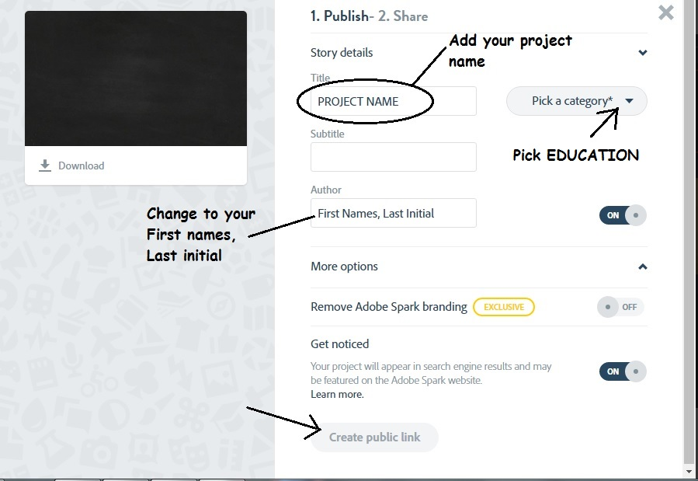
SHARE YOUR VIDEO
When your presentation is finished, click on at the top of the page.

Open a new INTERNET tab
Open your k12.sd.us EMAIL.
Copy the link to your project.
Email it to:
Kelly.Riedell@k12.sd.us

