Food Web
Name____________________
You are Ranger with the local game fish and parks department. A nearby oil company is requesting permission to access a small deposit within your park. They are willing to give the park a sizeable donation for the ability to use your land. Unfortunately, the area that they want to access is home to a large grassland that is used by many of the parks herbivores. The board members of your park want to accept the offer to boost the success of the park. You know that letting the oil company disrupt this section of land could upset the balance of the entire ecosystem. Your job is to create a convincing argument for why the oil company should not be allowed to use park land.
Your argument must include:
- The identities of the primary producers, primary consumers, and secondary consumers, etc.) in the park
- A detailed food web connecting the animals in the park to one another
  - Use the template provided
  - Connect the organisms to one another using arrows
  - Make sure the arrow is pointing to the organism being eaten from the organisms doing the eating
- Your explanation of how allowing the oil company to destroy grassland could affect the populations of all the organisms in the park
- STAPLE YOUR COMPLETED QUESTIONS TO THIS SHEET
The following organisms live within the park and must be included in your food web:

Dall Sheep
Whitetail Deer
Gray wolves
Mountain Lion
Red fox
Jackrabbits
Hawk
Field mouse
Weasel
Plants (grass, flowers, nuts, seeds)

Example Food Web Project
Primary Producer(s)

Primary Consumer(s)

Secondary consumer(s)

Tertiary Consumer(s)

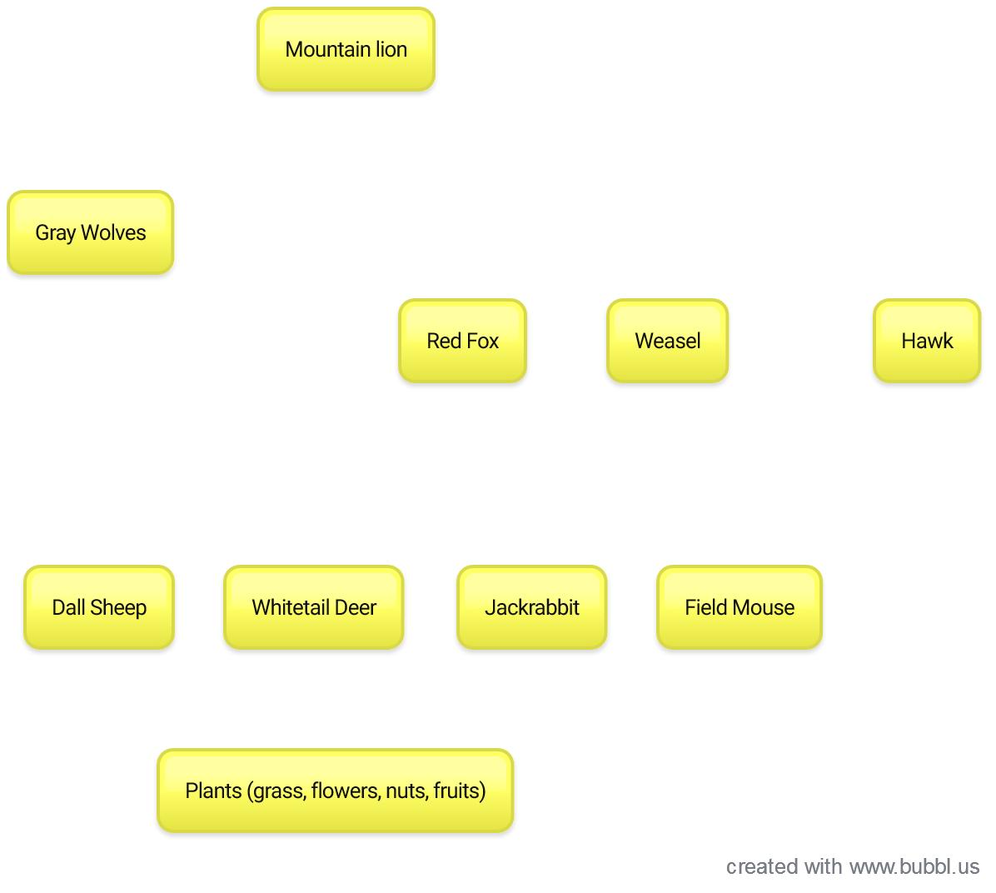
 | ANALYTICAL RUBRIC
CRITERIA / TRAITS / SKILLS |  | Exceeds Expectations  (6.2 pts) | Meets Expectations  (5.2 pts) | Below Expectations  (3.8 pts) | Failure to Complete  (0 pts)
- Identification of organisms:  Student identifies each organism as a primary producer, primary consumer, secondary consumer, etc…. |  | All organisms are identified (either written or graphically) as the correct level or producer or consumer | Organism identifications have most vocabulary used correctly and include all organisms | Vocabulary is not used correctly. Some identifications are missing. | No organisms are identified
2. Food Web  - Includes all listed organisms  - Correctly connects related organisms  - Labeled and organized |  | All organisms are included and correctly connected to one another in a clearly organized format. | All organisms are included in the food web, connections are mostly correct | An incomplete food web is included with only partial inclusion of the organisms. Less than half of connections are incorrect. | No food web included
3. Explanation of food web  - Defines a food web  - Explains how organisms are connected |  | Clearly states the definition of a food web and logically explains the placement of organisms in the food web. | Description of a food web is given and clear; explanation of where the organisms fit in is given | Some information to describe a food web is missing or explanation of the placement of organisms is incomplete | No definition or explanation supplied.
4. Argument  - Logically identifies risks of removing a key resource  - References food web |  | Argument clearly and logically describes the impact of the mining project and references the created food web correctly | Argument describes the impact of the project with several references to the created food web | Argument does not logically display the risks of the mining project or lacks references to the food web | No argument is given
5. Organization and Neatness  (Perform self-evaluation after 1st draft) |  | Report logically organized to include all information. Evidence of proofreading is present with less than 3 spelling or grammar errors that distract from the content. | Report clearly presents information in an understandable format. There are no more than 3 spelling and grammar errors that distract from the content. | Report presents information in an easy to understand format. There are no more than 5 spelling and grammar errors that distract from the content. | Report had no logical organization. Displays poor grammar and/or sentence structure with more than 10 errors that distract from the content.

A= 28-31 pts B= 24.8-27.8 pts C=21.8-24.6 pts D= 18.6-21.6 pts F=18.4 and below

