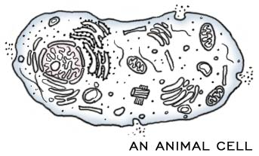
DIFFERENCES IN ANIMAL CELLS, PLANT CELLS, AND BACTERIA
ANIMAL CELL | PLANT CELL | BACTERIA
Eukaryotes | Eukaryotes | Prokaryotes
Cell membrane | Cell membrane | Cell membrane
Nuclear membrane | Nuclear membrane | NO nuclear membrane
NO cell wall | Cell wall made of  CELLULOSE | Cell wall made of  PEPTIDOGLYCAN
Has ribosomes | Has ribosomes | Has ribosomes
DNA in multiple chromosomes | DNA in multiple  chromosomes | DNA is a single  circular ring
Small vacuoles | Really big vacuole | NO vacuoles
Has lysosomes | Has lysosomes | NO lysosomes
Has centrioles | NO centrioles | NO centrioles
NO chloroplasts | Chloroplasts | NO chloroplasts
SMALLER | SMALL | SMALLEST

CELL THEORY CELL SIZE

1. All living things are made of CELLS
2. Cells are the basic unit of structure & function in an organism
(= basic unit of LIFE)
3. New cells are produced from EXISTING cells

PLANT cells > ANIMAL cells > BACTERIAL CELL

CELL MEMBRANE (= PLASMA MEMBRANE)

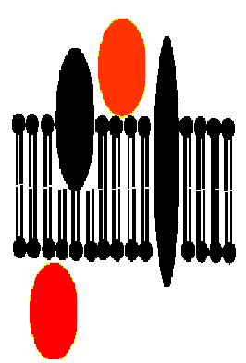
Made mainly of PHOSPHOLIPIDS and PROTEINS

HYDROPHOBIC “tails” of phospholipids make molecules line up as a LIPID BILAYER with POLAR heads facing OUTWARD and
NON-POLAR tails facing INWARD

MEMBRANE PROTEINS:
- GLYCOPROTEINS –recognize self
- TRANSPORT PROTEINS-move molecules across membranes
FUNCTION:
Membranes are SELECTIVELY PERMEABLE (=Semi-permeable)
Allow certain molecules to pass through; but keep others out
Controls what enters and leaves cell
Helps with HOMEOSTASIS
CYTOPLASM= gel-like material + organelles between nucleus and cell membrane

GOLGI BODY

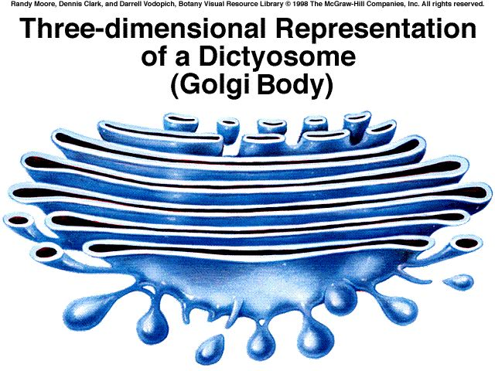
Looks like a “STACK OF PANCAKES”

Made of MEMBRANES

FUNCTION:
Modify, sort, and package substances from ER for TRANSPORT out of cell

NUCLEUS NUCLEOLUS
NUCLEUS is:
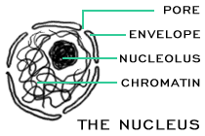
- Surrounded by DOUBLE NUCLEAR MEMBRANE
CONTROL CENTER OF CELL
- CONTAINS CELL’S GENETIC MATERIAL (_DNA_)
- Contains NUCLEOLUS (Dark spot)
which makes RIBOSOMES (RNA)

DNA is scrunched up as CHROMOSOMES
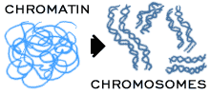
in DIVIDING CELLS
DNA is spread out as CHROMATIN
in NON-dividing cells

VACUOLE
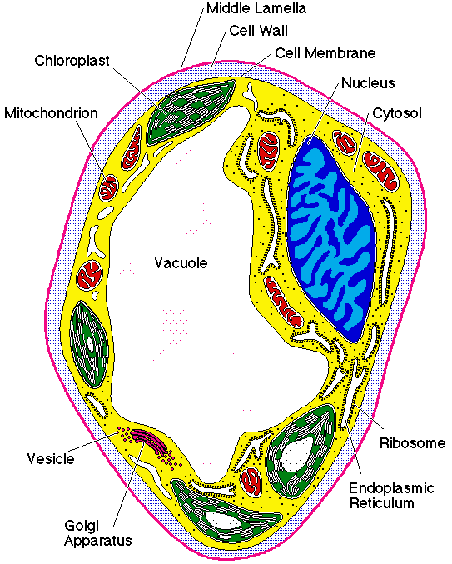
STORAGE SPACE FOR: FOOD, ENZYMES, WATER, WASTE
Huge in PLANT cells ,
small in ANIMAL cells,
NOT in BACTERIA

MITOCHONDRION (plural: MITOCHONDRIA)

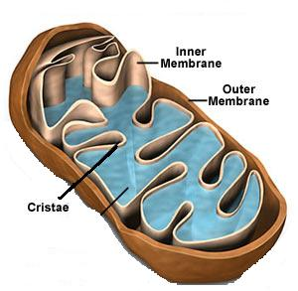
Surrounded by DOUBLE membrane
Contains its own DNA
POWER PLANT of cell
Burns GLUCOSE
Stores energy released as ATP

Folded inner membrane = CRISTAE (increases surface area for more chemical reactions)

RIBOSOMES
Can be FREE IN CYTOPLASM or ATTACHED to Rough ER

MADE OF PROTEINS & RNA

FUNCTION: MAKE PROTEINS

ENDOPLASMIC RETICULUM(ER)
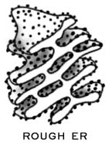
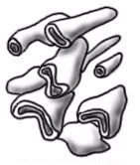
Internal network of MEMBRANES
Rough ER:
Attached ribosomes make PROTEINS
Acts as highway to TRANSPORT molecules inside cell
ROUGH ER SMOOTH ER Smooth ER:
(with ribosomes) (NO ribosomes) Makes membrane lipids

Regulates CALCIUM in muscles
Breaks down TOXINS in liver

LYSOSOMES
Sac containing DIGESTIVE ENZYMES
FUNCTION:
Digests: CARBOHYDRATES, PROTEINS, WASTE, UNWANTED CELLS OR CELL PARTS, BACTERIA

Plays a role in APOPTOSIS “programmed cell death”
”Cell suicide” for the good of the organism

CHLOROPLASTS
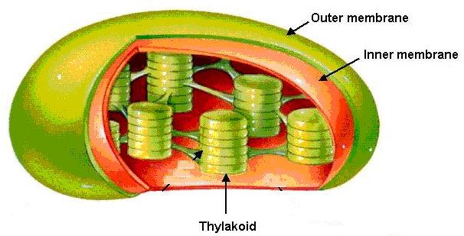
Surrounded by DOUBLE membrane
Has own DNA
THYLAKOID membrane sacs inside contain
CHLOROPHYLL where PHOTOSYNTHESIS happens

FOUND ONLY IN PLANT CELLS
CENTRIOLES

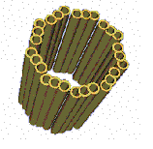
Made of PROTEINS called MICROTUBULES

Only seen in ANIMAL cells during cell division

Function: PULL CHROMOSOMES APART

CELL WALL

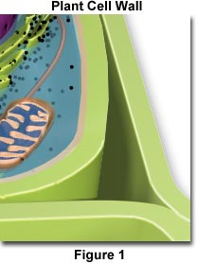
Found OUTSIDE the CELL MEMBRANE
Provides SUPPORT & PROTECTION

CELLULOSE makes plant cells sturdy

Bacteria have cell walls made of PEPTIDOGLYCAN instead.

