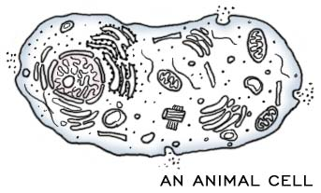
DIFFERENCES IN ANIMAL CELLS, PLANT CELLS, AND BACTERIA

ANIMAL CELL | PLANT CELL | BACTERIA
Eukaryotes | Eukaryotes | Prokaryotes
Cell membrane | Cell membrane | Cell membrane
Nuclear membrane | Nuclear membrane | NO nuclear membrane
NO cell wall | Cell wall made of  CELLULOSE | Cell wall made of  PEPTIDOGLYCAN
Has ribosomes | Has ribosomes | Has ribosomes
DNA in multiple chromosomes | DNA in multiple  chromosomes | DNA is a single  circular ring
CYTOSKELETON | CYTOSKELETON | CYTOSKELETON
Small vacuoles | Really big vacuole | NO vacuoles
Has lysosomes | Has lysosomes | NO lysosomes
Has centrioles | NO centrioles | NO centrioles
NO chloroplasts | Chloroplasts | NO chloroplasts
SMALLER | SMALL | SMALLEST

CELL THEORY CELL SIZE

1. All living things are made of _________
2. Cells are the basic unit of structure & function in an organism
(= basic unit of _______)
3. New cells are produced from _________ cells

_____________ cells > ________________ cells > ______________ cell

CELL MEMBRANE

Made mainly of _______________________ and _____________________
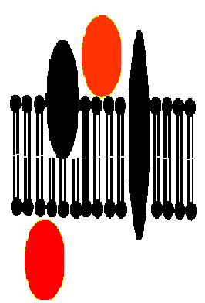
HYDROPHOBIC “tails” of phospholipids make molecules line up as a LIPID ________________ with POLAR heads facing _______ and
NON-POLAR tails facing ________

MEMBRANE PROTEINS:
___________________ - recognize “self”
___________________ PROTEINS- move molecules across membrane
FUNCTION:
Membranes are ________________________________________
(=Semi-permeable)
Allow certain molecules to pass through; but keep others out
_________________ what enters and leaves cell
Helps with _________________________

___________________= gel-like material + organelles between
nucleus and cell membrane
GOLGI BODY

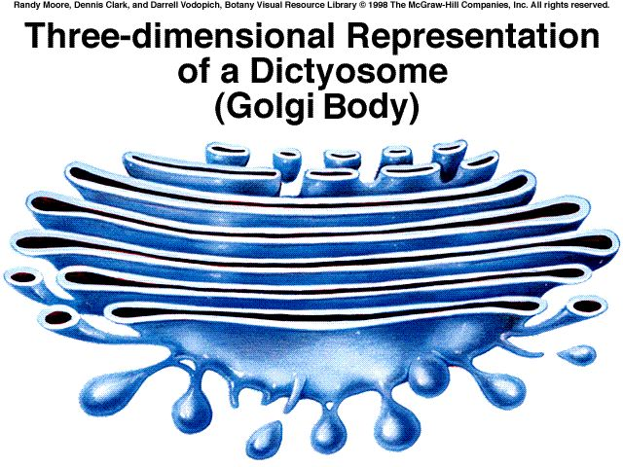
Looks like a “______________________________”

Made of ______________________

FUNCTION: Modify, sort, and package substances
from ER for ___________________ out of cell
NUCLEUS NUCLEOLUS
NUCLEUS is:
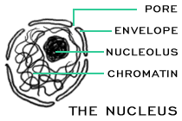
- Surrounded by ________________
NUCLEAR MEMBRANE
- __________________ CENTER OF CELL
- CONTAINS CELL’S GENETIC MATERIAL ( __________)
- Contains NUCLEOLUS (Dark spot)
which makes _______________ (RNA)

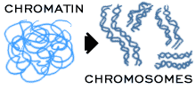
DNA is scrunched up as _________________
in DIVIDING CELLS
DNA is spread out as__________________
in NON-dividing cells

VACUOLE
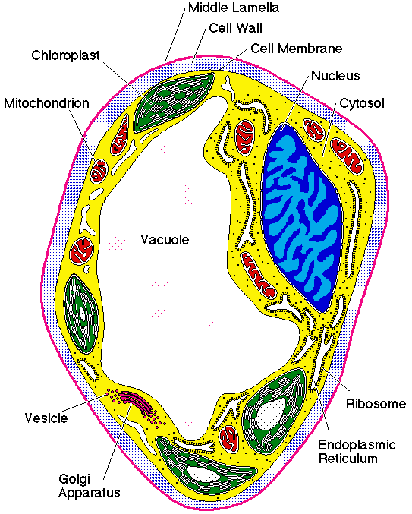
STORAGE SPACE FOR: _______________________________________
Huge in ________________cells,
small in _________________ cells,
NOT in ______________________

MITOCHONDRION (plural: MITOCHONDRIA)

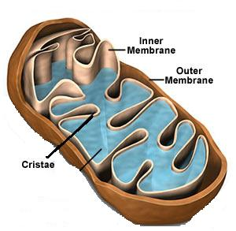
Surrounded by _____________ membrane
Contains its own ___________
______________________ of cell
Burns ____________
Stores energy released as ________

Folded inner membrane = ________________ (increases surface area for more chemical reactions)

RIBOSOMES

Can be ________________________________ or _______________ to Rough ER

MADE OF ______________ & ________

FUNCTION: _____________________

ENDOPLASMIC RETICULUM(ER)
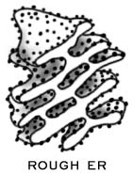
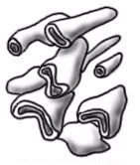
Internal network of ____________________
Rough ER:
Attached ribosomes make ________________________
Acts as highway to ____________________ molecules
inside cell
ROUGH ER SMOOTH ER
(with ribosomes) (NO ribosomes) Smooth ER:
Makes membrane lipids (_______________________),

Regulates ________________ in muscles
Breaks down _________________ in liver

LYSOSOMES
Sac containing _________________________

FUNCTION:
Digests: _____________________________________________

Plays a role in __________________ “programmed cell death”
Cell suicide for the good of the organism

CHLOROPLASTS
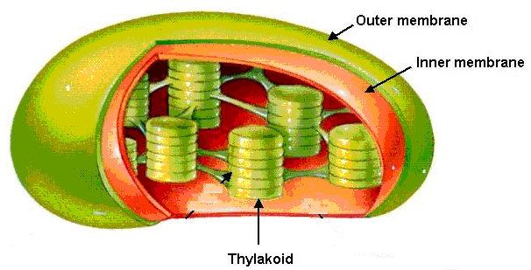
Surrounded by ____________ membrane
Has own ________
_______________ = membrane sacs inside
Contain CHLOROPHYLL where
_______________________ happens

FOUND ONLY IN _____________ CELLS

CENTRIOLES

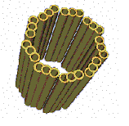
Made of PROTEINS called _________________________

Only seen in __________________ cells during cell division

Function: _____________________________________

CELL WALL

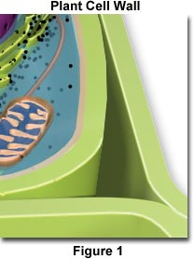
Found OUTSIDE the ________________________
Provides __________________ & ___________________

___________________ makes plant cells sturdy

Bacteria have cell walls made of ___________________ instead.

