NAME ___________________

CELL PARTS PRACTICE

IDENTIFY THE CELL PARTS IN THE PICTURE BELOW:
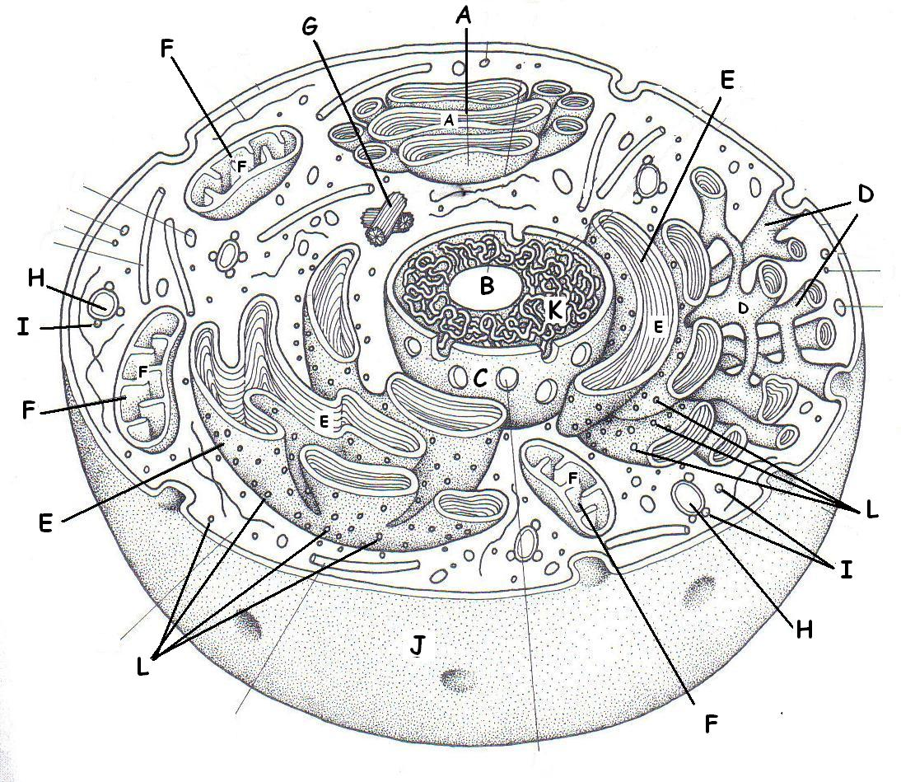

_____ Nucleolus _____ Mitochondrion ____ Vacuole

_____ Centrioles _____ Chromatin (DNA) _____ Golgi body

_____ Ribosomes _____ Smooth ER _____ Rough ER

_____ Cell membrane _____ Nuclear membrane _____ Lysosomes

MATCH THE CELL PART WITH ITS FUNCTION:

______ System of membranes WITHOUT ribosomes A. NUCLEAR MEMBRANE
that breaks down toxins; regulates calcium, and
makes lipids for membranes B. CELL MEMBRANE

______ System of membranes WITH RIBOSOMES attached C. CELL WALL
that acts as a highway to transport molecules inside cells
D. SMOOTH ER
______ Modifies, sorts, and packages molecules for storage
or transport out of cell E. ROUGH ER

______ Double bilayer that surrounds the genetic material F. GOLGI BODY
and controls what enters & leaves nucleus
G. VACUOLE
______ Storage space for water, food, enzymes, or waste

______ Phospholipid bilayer that controls what enters
and leaves the cell

______ Found outside of the cell membrane in plants
& bacteria; provides support & protection

* * * * * * * * * * * * * * *

______ Makes proteins A. NUCLEOLUS
______ Makes ribosomes B. CHLOROPLAST

______ Place where photosynthesis happens in plant cells C. LYSOSOME

______ Control center of cell that contains the DNA D. MITOCHONDRIA

______ Log-like structures that pull the chromosomes E. CYTOPLASM
apart during division
F. RIBOSOMES
______ Sac of digestive enzymes to break down food or
unwanted cells, or cell parts G. CENTRIOLES

______ Power plant of cell; burns glucose & makes ATP H. NUCLEUS

______ Gel-like material and organelles found inside the
cell between the cell membrane and the nucleus

