Name ___________________________*

Darwin’s Theory of Evolution
(Chapter 15-1 and 15-2 pp 368-377)

MULTIPLE CHOICE
Circle the answer that best completes the statement.

A well supported, testable explanation of phenomena that have occurred in the natural world is called a ________________
A. hypothesis
B. theory
C. law
D. prediction

Darwin’s voyage on the H.M.S.______________ led him to propose a revolutionary hypothesis about life.
A. Collie
B. Cheetah
C. Beagle
D. Lion

Darwin’s hypothesis about how life changes over time in now called the Theory of _________________.
A. Evolution
B. Variation
C. Derived characters
D. Use and disuse

Of all the places he visited, the ___________ Islands influenced Darwin’s ideas about evolution the most.
A. Hawaiian
B. Aleutian
C. Beagle
D. Galapagos

In addition to observing living organisms, Darwin studied the preserved remains of ancient organisms called _________________
A. fossils
B. homologous structures
C. adaptations
D. vestigial organs

On the Galapagos Islands, Darwin observed that the characteristics of many animals and plants ________
A. all looked alike
B. varied from island to island
C. were acquired through use

Which of the following best describes how LAMARCK would explain giraffes with long necks?
A. Long-necked giraffes eat more grass than short necked giraffes so their necks grow longer.
B. Natural variation in the population produces some longer and some shorter-necked giraffes and longer necked giraffes can reach food more easily.
C. Some giraffes have acquired longer necks by stretching to reach food and passed that trait on.
D. Giraffes just started out with long necks and haven’t changed.

Which of the following ideas, proposed by Lamarck, was later found to be incorrect?
A. All species were descended from other species
B. Acquired characteristics can be inherited.
C. Living things change over time.
D. Organisms are adapted to their environments.

* * * * * * * * * * * * * * *

MATCH THE SCIENTIST with his contribution

_____ proposed that Earth was shaped by geological forces A. CHARLES DARWIN
that took place over millions of years B. THOMAS MALTHUS
C. JEAN-BAPTISTE LAMARCK
_____ proposed that organisms acquired or lost traits D. CHARLES LYELL
during their lifetime by selective use or disuse of organs E. JAMES HUTTON

_____ predicted that the human population will grow faster than
the space and food needed to sustain it

_____ Proposed that the forces that shape the Earth are still happening

_____ proposed a hypothesis he called natural selection to explain how
living things change over time

* * * * * * * * * * * * * * *

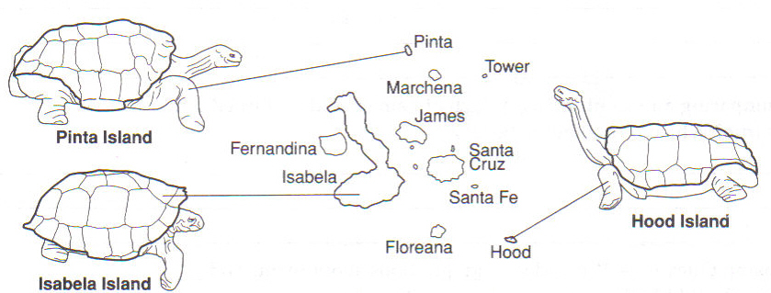

The tortoises on which island would be best able to get food in a place where vegetation is sparse and hard to reach?
A. Hood island
B. Isabela island
C. Pinta island

