EVOLUTION REVIEW Chapter 15 NAME __________________________

1. Name the two geologists whose ideas about the age of the earth and processes that shaped it influenced Darwin.

____________________________ & ______________________________

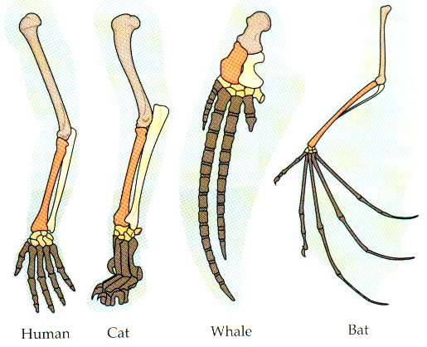
2. These are examples of________________ structures because they come from the same embryonic tissue.

3. Name 5 kinds of evidence that support Darwin’s Theory of Evolution.

___________________________________________

___________________________________________

___________________________________________

___________________________________________

____________________________________________
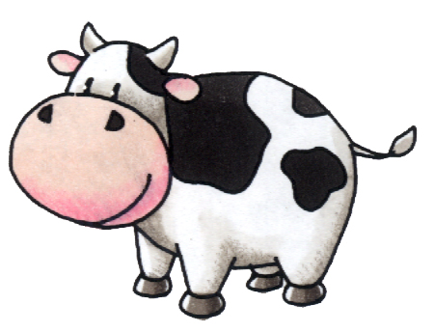

4. Breeding cows that give the most milk or the fastest horses
is an example of ____________________

5. Darwin’s idea that each living species has descended with changes from other species over time is called ______________ ______ _____________

6. The ability of an organism to survive in its environment is called ______________.

7. Lamarck proposed that organisms could alter the size or shape of their bodies through use or disuse and pass these traits on to their offspring. This idea is called INHERITANCE OF ____________________ traits.
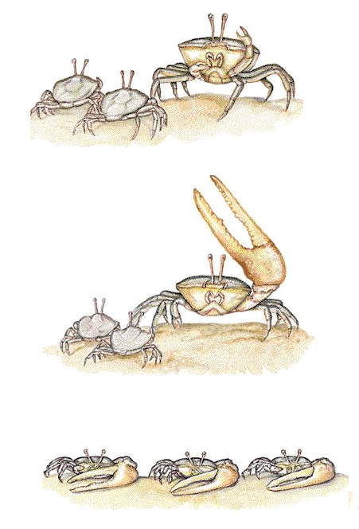

8. Tell why he was incorrect.

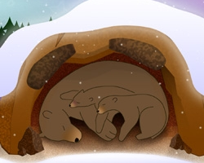
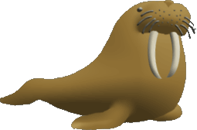
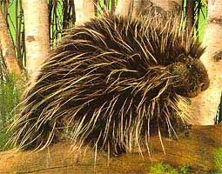

9. Physical characteristics like walrus tusks and porcupine quills or behavioral characteristics like hibernating and living in herds are examples of inherited traits called _____________________that help an organism to survive and reproduce in its environment.

10. In addition to observing living organisms, Darwin studied the preserved remains of ancient organisms called ____________________.

11. Name the island where Darwin observed finches, iguanas, and turtles that led to his Theory of Evolution. _________________________

12. A well-supported testable explanation of phenomena that have occurred in the natural world
is called a _______________.

13. The process in which organisms that are better suited to their environment survive and reproduce is called ________________ ____ ____ ___________.

14. Which of the following is NOT part of Darwin’s Theory of Evolution?
A. Organisms in a population show a natural variation in heritable traits.
B. Organisms must compete for resources because organisms produce more offspring than can survive.
C. Individuals best suited to their environment will survive and reproduce most successfully passing on their traits.
D. Species alive today are descended with modification from ancestral species that lived in the distant past.
E. Evolution unites all organisms into a single “tree of life”
F. Acquired traits can be inherited.

15. ________________ organs are reduced in size and no longer functional.

16. Give an example of #15. ______________________________________

17. Name the naturalist whose ideas about evolution were similar to Darwin’s and who prompted Darwin to publish his book “On the Origin of Species”.

______________________________________

18. Whales and wolves share a common ancestor but don’t look anything alike. This is an example of __________________ evolution.

19. Whales and sharks are not closely related but have similar body shapes. This is an example of
__________________ evolution.

20. Tell one reason why human chromosome #2 suggests a relationship between humans and chimpanzees.

____________________________________________________________

