NAME _______________________________*

EVOLUTION STARTS WITH ?
(Chapter 15)

1. E __ __ __ __ __ __ __ __, or change over time, is the process by which modern organisms have descended from ancient organisms

2. A scientific T __ __ __ __ __ is a well supported, testable explanation of phenomena that have occurred in the natural world.

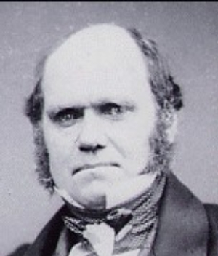
3. C __ __ __ __ __ __ D __ __ __ __ __ was an English naturalist who made numerous observations during his travels on the Beagle which led him to pose a hypothesis about how life changes over time.

4. F __ __ __ __ __ __ are the preserved remains of ancient organisms that provide evidence for how life has changed over time.
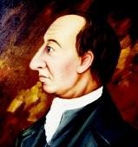

5. J __ __ __ __ H __ __ __ __ __ proposed that the Earth is shaped by geological forces over extremely long periods of time, and that the Earth is very old

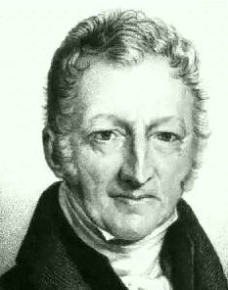

6. T __ __ __ __ __ M __ __ __ __ __ __ predicted that the human population would grow faster than the resources needed to sustain it.

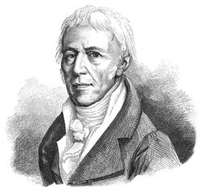

7. J __ __ __ - B __ __ __ __ __ __ __ L __ __ __ __ __ __ proposed that the selective use or disuse of an organ led to a change the organ that was then passed on to the offspring.

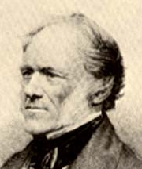
8. C __ __ __ __ __ __ L __ __ __ __ explained that the geological processes seen happening on the Earth now have shaped Earth’s geological features over long periods of time.

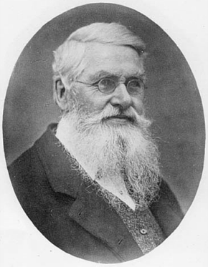

9. A __ __ __ __ __ W __ __ __ __ __ __ published his own theory of evolution by natural selection about the same time as Charles Darwin.

10. The S __ __ __ __ __ __ __ F __ __ E __ __ __ __ __ __ __ __ means that members of each species compete regularly for food and other necessary resources.

11. F __ __ __ __ __ __ is the ability of an individual to survive and reproduce in its specific environment.
12. Any inherited characteristic that increases an organism’s chance of survival, like webbed feet, sharp claws, or speed, is called an _A_ __ __ __ __ __ __ __ __ __.

13. The process whereby individuals that are better suited to their environment survive and reproduce more successfully is called N __ __ __ __ __ __ S __ __ __ __ __ __ __ __ , which Darwin nicknamed
S __ __ __ __ __ __ __ O __ T __ __ F __ __ __ __ __ __

14. Structures that have different mature forms but develop from the same embryonic tissues are called
H __ __ __ __ __ __ __ __ __ S __ __ __ __ __ __ __ __ __.

15. Homologous structures that are so reduced in size that they no longer function, like the human appendix or legs in skinks, are called _V_ __ __ __ __ __ __ __ __ organs

16. Choosing to breed cows that produce the most milk or the fastest horses is termed
A __ __ __ __ __ __ __ __ __ S __ __ __ __ __ __ __ __.

17. The idea that each living species has descended with changes over time from other species is called
D __ __ __ __ __ __ with M __ __ __ __ __ __ __ __ __ __ __.

18. Charles Darwin’s observations of finches and turtles on the G __ __ __ __ __ __ __ __ Islands led to his Theory of E __ __ __ __ __ __ __ __.

19. A giraffe that stretches its neck longer by reaching for food and then passes this long-necked trait on to offspring is an example of I __ __ __ __ __ __ __ __ __ __ of A __ __ __ __ __ __ __
traits.

20. Dolphins, penguins, and sharks are distantly-related species that share similar characteristics which help them live in water. This is an example of C __ __ __ __ __ __ __ __ __ evolution.

21. Even though the Galapagos finches share a common ancestor, they have evolved to fit the ecosystems of their individual islands. This is an example of D __ __ __ __ __ __ __ __ evolution.

22. Another name for divergent evolution is A __ __ __ __ __ __ __ R __ __ __ __ __ __ __ __.

