NAME _____________________________ *

FUNDAMENTALS OF BIOLOGY SEMESTER 1 TEST

MULTIPLE CHOICE:
Circle the letter for the answer that best completes the statement.

INTRO TO BIOLOGY - Chapters 1 & 2

1. Molecules that are “water fearing” and try to stay away from water and other polar molecules are called ________________
A. hydrophilic
B. hydrophobic
C. polar
D. ions

2. Glycogen, cellulose, and starch are all examples of __________________.
A. proteins
B. nucleic acids
C. polysaccharides
D. lipids

3. DNA and RNA are examples of ________________________
- proteins
- carbohydrates
- nucleic acids
- lipids

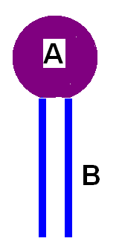
4.
Which part of a phospholipid molecule is HYDROPHOBIC?
A. the glycerol/phosphate “head”
B. the lipid “tails”

5. Humans are ______________________________.
- unicellular autotrophs
- multicellular autotrophs
- unicellular heterotrophs
- multicellular heterotrophs

6, The process in which organisms keep their internal conditions fairly constant is called ________
A. metabolism
B. homeostasis
C. hydrolysis
D. dehydration synthesis

7. The membrane proteins with carbohydrates attached that help cells identify “self” are called
A. phospholipids
B. glycogen
C. hemoglobin
D. glycoproteins

8. Polar molecules are ___________________
A. hydrophilic
B. hydrophobic

9. Animal cells store their glucose as ____________________.
A. glycogen
B. starch
C. hemoglobin
D. cellulose

10. Which of these molecules BELOW is used to build PROTEINS?
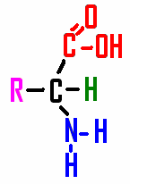
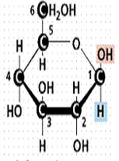
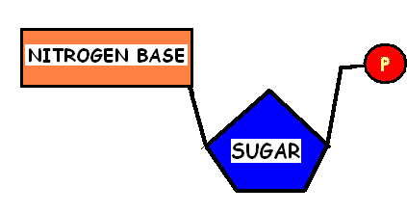

A B C

A.  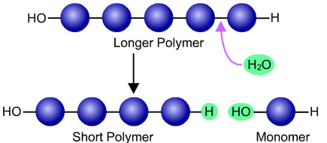 | B.  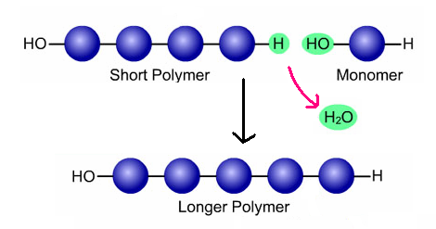

11. Which of the diagrams above shows DEHYDRATION SYNTHESIS?

A or B (Circle one)

* * * * * * * * * * * * * * *

CELL STRUCTURE AND FUNCTION - Chapter 7

12. Prokaryotic cells DO NOT HAVE _________________.
A. ribosomes
B. a cell membrane
C. DNA
D. a nuclear membrane

13. DNA that is SPREAD OUT in the nucleus of NON-DIVIDING cells is called _______________
A. chromatin
B. chromosomes

14. Which cell part is involved with APOPTOSIS?
A. mitochondria
B. smooth ER
C. chloroplasts
D. lysosomes

15. Humans are ________________
A. prokaryotes
B. eukaryotes

MATCH THE CELL PART WITH ITS FUNCTION:

16. ______ System of membranes WITHOUT ribosomes A. RIBOSOMES
that breaks down toxins; regulates calcium, and
makes lipids for membranes B. VACUOLE

17. ______ System of membranes WITH RIBOSOMES attached C. ROUGH ER
that acts as a highway to transport molecules inside cells
D. SMOOTH ER
18. ______ Modifies, sorts, and packages molecules for storage
or transport out of cell E. CELL WALL

19. ______ Storage space for water, food, enzymes, or waste F. MITOCHONDRIA

20. ______ Makes proteins G. NUCLEOLUS
21, ______ Makes ribosomes H. CENTRIOLES

22, ______ Log-like structures that pull the chromosomes I. GOLGI BODY
apart during division

23. ______ Power plant of cell; burns glucose & makes ATP

24. ______ Found outside the cell membrane; contains cellulose in plants
and peptidoglycan in bacteria

* * * * * * * * * * * * * * *

TRANSPORT CHAPTER 7-4

MATCH THE MOLECULE WITH THE KIND OF TRANSPORT IT USES TO CROSS CELL MEMBRANES:

25. _______ Oxygen & carbon dioxide A. PROTON PUMP

26. _______ Water B. DIFFUSION
27. _______ H⁺ ions C. FACILITATED DIFFUSION (with AQUAPORINS)
28. _______ glucose . D. FACILITATED DIFFUSION (with CARRIER proteins)

MULTIPLE CHOICE: Circle the letter of the answer that best completes the sentence.
29. ALL molecules will automatically move _______________________
A. easily across a membrane
B. from a low concentration to high concentration
C. from a high concentration to low concentration

30. The substance that is dissolved in a liquid to make a solution (like the sugar when you make Koolaid) is called the ________________
A. solvent
B. solute

31. Endocytosis, exocytosis, and proton pumps are kinds of _________________ transport.
A. active
B. passive

* * * * * * * * * * * * * * *
USE THE LETTERS FROM THE PICTURES TO ANSWER THE QUESTIONS:

The black dots in the diagrams below represent dissolved molecules (solutes)

A B C
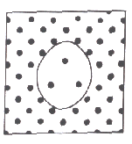
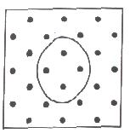
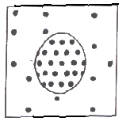

Which diagram:
32. ______ Shows a cell in HYPOTONIC conditions

33. ______ Shows a cell in HYPERTONIC conditions

34. ______ Shows a cell that will stay the same size

35. ______ Shows an animal cell that will shrink smaller
36. ______ Shows an animal cell that will swell and burst

* * * * * * * * * * * * * * *
MITOSIS - Chapter 8-1 & 8-2

37. In which type of cell would you find a cell plate?
A. animal cell
B. plant cell
C. bacterial cell

38. Which phase of mitosis is called “reverse prophase”?
A. anaphase
B. metaphase
C. cytokinesis
D. telophase

39. The center spot in a chromosome that holds the chromatid arms together is called a ____________
A. centriole
B. centromere
C. cleavage furrow
D. cell plate
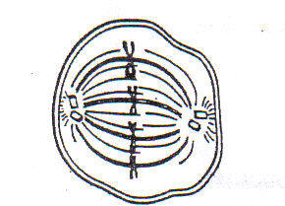

40.This diagram shows a cell in _____________________
A. prophase
B. telophase
C. anaphase
D. metaphase

41. Cells leave the cell cycle and STOP dividing in ______ phase.

S G₁ G₂ G₀

42. Cell makes a copy of its DNA in _______ phase.

S G₁ G₂ G₀

43. DNA scrunches up, centrioles appear, and the nuclear membrane disappears during _________________.
A. prophase
B. metaphase
C. anaphase
D. telophase

44. Chromatid arms separate and move to opposite ends of the cell during ____________________
A. prophase
B. metaphase
C. anaphase
D. telophase

45. Cytoplasm is split between two cells during ___________________
A. G₁ phase
B. anaphase
C. prophase
D. cytokinesis

46. ________________ is made up of G₁, S, G₂ phases.
A. mitosis
B. interphase
C. prophase
D. cytokinesis

* * * * * * * * * * * * * *

GENETICS Chapter 11

47. Organisms with two DIFFERENT alleles for a trait are called __________________
A. homozygous
B. heterozygous

48. In order for a RECESSIVE trait to show, an organism must have__________________ .
A. one recessive and one dominant allele
B. two dominant alleles
C. two recessive alleles

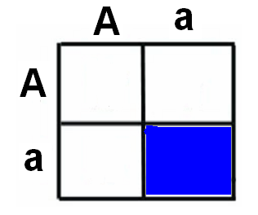

49. Tell the GENOTYPE for the offspring in the shaded box in this Punnett square?

AA Aa aa

50. TheAPPEARANCE of an organism is called its _____________________.
A. genotype
B. phenotype
C. allele

51. An allele that IS MASKED or HIDDEN BY ANOTHER choice for a trait is called __________________.
A. recessive
B. dominant

52. The different gene choices for a trait (like green, blue, or brown eyes) are called _____________
A. chromosomes
B. autosomes
C. alleles
D. traits

53. If you cross two DOMINANT LOOKING parents and get a RECESSIVE LOOKING baby, the parents must BOTH be ___________________.
A. heterozygous
B. homozygous recessive
C. homozygous dominant
D. Impossible. You can’t cross 2 dominant looking parents and get a recessive looking baby.

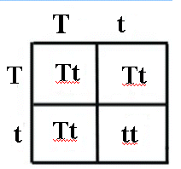
54. What is the probability that the offspring from this cross will show the DOMINANT trait?
A. 0%
B. 25%
C. 50%
D. 75%
E. 100%

55. Which molecule found on the surface of cell membranes is responsible for producing blood types?
- phopholipids
- glycoproteins
- ATP
- RNA

56. Which of the blood types you learned about is called the “Universal donor” because
in an emergency it can be given to people with all different types blood?

A B AB O

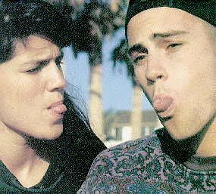
57. In humans Tongue rolling (T) is dominant over non-rolling (t).
Which of the following is the correct Punnet square to use to show a cross if BOTH PARENTS are HETEROZYGOUS tongue-rolling parents.

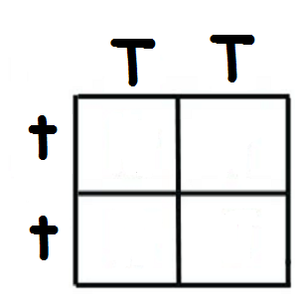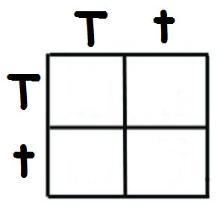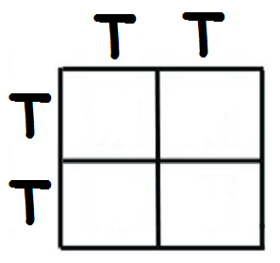

A B C

* * * * * * * * * * * * * *

HUMAN GENETIC DISORDERS (Chapter 14)

58. A person with Trisomy-21 has __________________ syndrome.
A. Down
B. Klinefelter
C. Turner
D. Achondroplasia

59. A person with phenylketonuria should avoid foods containing which food group?
A. carbohydrates
B. proteins
C. lipids

60. X-linked recessive disorders like hemophilia and colorblindness show up more frequently in ______
A. females
B. males

* * * * * * * * * * * * * * *

FIND SOMETHING TO DO QUIETLY UNTIL EVERYONE IS FINISHED WITH THEIR TEST.

