REEBOP GENETICS

BODY SEGMENTS:
3 body segments (B) is DOMINANT over 2 body segments (b).



TAIL:
CURLY tail (T) is DOMINANT over STRAIGHT tail (t)
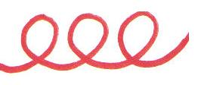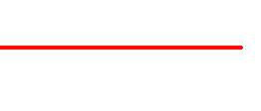

EYES:
Having eyes (E) is dominant over NO EYES (e)

2 eyes = EE or Ee No eyes = ee

ANTENNAE:
ROUND antennae (A) are dominant over FLOWERED antennae (a)



HOVER WINGS:
Having HOVER WINGS (H) is dominant over NO WINGS (h)
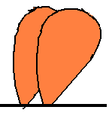

LEGS:
BLUE legs (L) is dominant over YELLOW legs (l)
