NAME ________________________________

BLOOD TYPES PUNNETT SQUARES #3
BLOOD TYPES:
In the ABO blood type system the A and B alleles are DOMINANT to the O allele and A and B are CO-DOMINANT with each other.

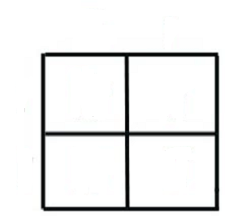
Make a cross between a mom with AO genotype and a dad with BO genotype.

What are the possible GENOTYPES of the offspring?

________ _________ _________ _________

What is the probability the offspring will have

A type blood __________

B type blood __________

O type blood __________

AB type blood __________

* * * * * * * * * * * * * * *

Make a cross between a mom with AO genotype and a dad with BB genotype.

What are the possible genotypes of the offspring?

________ _________

What is the probability the offspring will have

A type blood __________

B type blood __________

O type blood __________

AB type blood __________

* * * * * * * * * * * * * * *

Make a cross between a mom with AA genotype and a dad with OO genotype.
What are the possible genotypes of the offspring?

________

What is the probability the offspring will have

A type blood __________

B type blood __________

O type blood __________

AB type blood __________

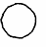
Draw a picture of what the blood cells from
the offspring from this cross would look like.

Which blood type is called the “universal donor” because they can give blood to anyone?

A B AB O

Which blood type is called the “universal recipient” because they can receive blood from anyone?

A B AB O

JERRY SPRINGER GENETICS:
Wanda tells Jerry Springer that she thinks either Ralph or Fred could be the father of her baby.
Wanda’s genotype is AO. Wanda’s baby has type O blood.
Ralph’s genotype is AB. Fred’s genotype is BO.

Make two crosses to show who could be the father of Wanda’s baby.

Ralph X Wanda Fred X Wanda

Is it possible for Ralph to be the baby’s father? YES NO

Is it possible for Fred to be the baby’s father? YES NO

IF Wanda’s baby has type O blood, what are the possible genotypes for men who COULD BE the father of Wanda’s baby ?

________ _________ ________

