NAME __________________________

HUMANS in the BIOSPHERE 6-3 and 6-4
( pp 150 - 160 )

MULTIPLE CHOICE. CIRCLE THE CORRECT ANSWER/ANSWERS.

Circle the THREE problems burning fossil fuels causes.
A. acid rain
B. global warming
C. ozone depletion
D. smog

Which kind of atom is found in Ozone gas?
A. water
B. hydrogen
C. nitrogen
D. oxygen

Ozone depletion has been caused by _______________________________
A. burning fossil fuels
B. deforestation
C. urban sprawl
D. CFC’s

The pesticide that endangered eagles and other fish eating birds of prey is ______________
A. EPA
B. CITES
C. DDT
D. ozone

Which of the following are considered to be examples of invasive species?
(Circle THREE)
A. buffalo in South Dakota
B. leafy spurge in South Dakota
C. Zebra mussels in South Dakota
D. rabbits in Australia

Which of the following environmental problems was the Montreal Protocol intended to help?
A. acid rain
B. global warming
C. deforestation
D. ozone depletion

Which of the following environmental problems was the Kyoto Accord intended to help?
A. acid rain
B. global warming
C. deforestation
D. ozone depletion

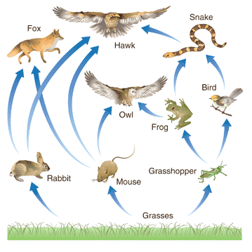
Look at this food web and determine which of the following organisms would accumulate the highest levels of chlorinated pesticide.
A. hawk
B. rabbit
C. frog
D. tree

During the late 1950’s-early 1960’s people living near Minamata Bay, Japan became ill with a crippling neurological disease, later discovered to be caused by mercury being dumped into the ecosystem there. The toxin passed along the food chain and people became ill from eating fish caught in the bay.

These 2 questions are examples of which concept you learned about?
A. dead zones
B. acid rain
C. biological magnification
D. burning fossil fuels

Tell the 5 big environmental problems that will have to be dealt with in your lifetime.

________________________________________ _____________________________________

________________________________________ _____________________________________

________________________________________

Why have forests been called “the lungs of the earth” ?

____________________________________________________________________

Explain how deforestation plays a role in global warming.

______________________________________________________________________________

________________________________________________________________________________

Tell 2 reasons why we should find alternatives to burning fossil fuels.

1. _____________________________________________________________________________

2. _____________________________________________________________________________

What is “hidden water”? ____________________________________________________________

________________________________________________________________________________
MATCH THE VOCAB WORD WITH ITS DEFINITION

HABITAT FRAGMENTATION ENDANGERED POLLUTANT BIODIVERSITY
BIODIVERSITY HOT SPOTS INVASIVE THREATENED BIOLOGICAL MAGNIFICATION

EXTINCT OZONE LAYER ACID RAIN SMOG

____________________________ plants or animals that have migrated or been introduced into places where they are not native and for which there are no natural predators or parasites to control their population

____________________________ A species whose population size is rapidly declining and will become extinct if the trend continues without intervention

____________________________ A species whose population size in declining and may become endangered if the trend continues

____________________________ A species that is no longer living

____________________________ The increasing concentration of a harmful substance in organisms at higher trophic levels in a food chain or web

____________________________ is the sum total of all the variety of organisms in an ecosystem and is a measure of an ecosystem’s health

_____________________________ The development of land which divides a habitat into isolated “islands”

_____________________________ atmospheric layer in which ozone (0₃) gas is relatively concentrated which protects us from the sun’s ultra-violet radiation

_____________________________ precipitation containing nitric and sulfuric acids caused by burning fossil fuels

_____________________________ Any harmful material that can enter the biosphere through land, water, or air

_____________________________ Places where unique ecosystems are threatened and where the concentration of money and efforts may produce the most results

_____________________________ a mixture of chemicals (smoke + fog) that occurs as a gray-brown haze in the atmosphere

