Change in an organism over time; Process
by which modern organisms have Another name for a “living thing”
descended from ancient organisms
The process in which cells change as they Embryonic cell that has the potential to
grow and develop to become specialized differentiate into a variety cell types
with different functions
Attraction between oppositely charged regions All the chemical reactions through which
of nearby molecules involving the hydrogen an organism builds up or breaks down
atoms of one molecule and the partially materials as it carries out its life
negatively charged atoms in another molecule processes
Process in which offspring are produced from Process in which offspring are produced
the genetic material of a single parent by combining genetic material from 2 parents
Organism that obtains energy from the food Organism that can capture energy from
it consumes; also called a consumer sunlight or chemicals and use it to produce its own food; also called a producer
Process by which organisms maintain a A signal to which an organism responds
relatively stable internal environment
Describes a non-polar molecule that tries Describes a polar molecule that mixes
to stay away from water; means easily with water: means “water loving”
“water fearing”
Chemical reaction in which smaller molecules Protein that acts as a biological catalyst
are joined together by removing an H and in living things to help chemical reactions
an OH to make a water molecule happen faster
Chemical reaction in which a molecule
is broken apart by the addition of the Reactant in an enzyme-catalyzed reaction
H and OH from a water molecule
Place on an enzyme where the substrate Molecule with an uneven pattern of electric
attaches charge; more + on one side, more – on the other
Macromolecule made mainly of carbon and Compound made up of carbon, hydrogen
hydrogen atoms; includes fats, oils, waxes and oxygen atoms usually in a ratio of
and steroids, which is generally hydrophobic 1 C: 2 H: 1 O which is a major source
of energy for the human body
Macromolecule that contains carbon, hydrogen, Macromolecule made of nucleotide subunits
oxygen, and nitrogen, made by joining amino containing carbon, hydrogen, oxygen,
acid subunits which is needed by the body nitrogen, and phosphorus which stores and
for growth and repair and to act as enzymes transports information in cells and helps in protein synthesis
Double stranded nucleic acid that contains Molecule such as glycogen, starch, or
the sugar deoxyribose and the nitrogen cellulose, made by joining many
bases A, T, C, & G monosaccharide (sugar) molecules together
Single stranded nucleic acid that contains Monomer made up of a 5-carbon sugar
the sugar ribose and the nitrogen bases a nitrogen base, and a phosphate group,
A, U, C, & G that is used to build nucleic acids
Subunit used to make proteins made up of
a carbon atom attached to a hydrogen, a
carboxyl group (-COOH), an amino group (-NH₂)
and a variable R group

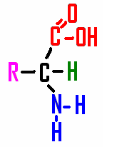
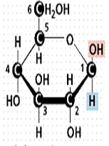

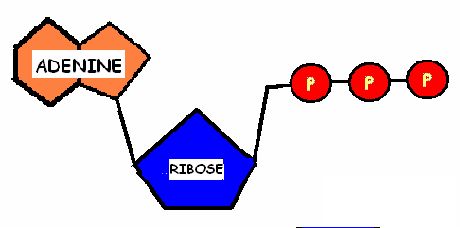
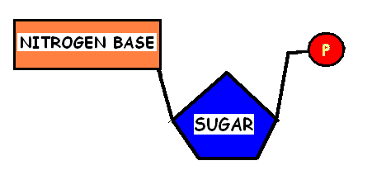

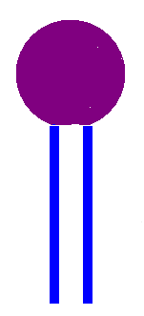
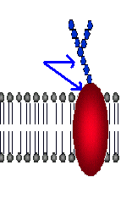

ORGANISM EVOLUTION
STEM CELL DIFFERENTIATION
METABOLISM HYDROGEN BOND
SEXUAL ASEXUAL
REPRODUCTION REPRODUCTION

AUTOTROPH HETEROTROPH

HOMEOSTASIS STIMULUS
HYDROPHILIC HYDROPHOBIC

ENZYME DEHYDRATION
SYNTHESIS

SUBSTRATE HYDROLYSIS

POLAR MOLECULE ACTIVE SITE

CARBOHYDRATE LIPIDS

NUCLEIC ACID PROTEIN
POLYSACCHARIDE DNA

NUCLEOTIDE RNA

AMINO ACID

GLUCOSE AMINO ACID

NUCLEOTIDE ATP

GLYCOPROTEIN PHOSPHOLIPID

