Change in an organism over time; Process
by which modern organisms have Another name for a “living thing”
descended from ancient organisms
The process in which cells change as they Embryonic cell that has the potential to
grow and develop to become specialized differentiate into a variety cell types
with different functions
Attraction between oppositely charged regions of nearby All the chemical reactions through which
molecules involving the hydrogen atoms of one molecule an organism builds up or breaks down
and the partially negatively charged atoms of another materials as it carries out its life processes
molecule
Process in which offspring are produced from Process in which offspring are produced
the genetic material of a single parent by combining genetic material from 2 parents
Organism that obtains energy from the food Organism that can capture energy from sunlight
it consumes; also called a consumer or chemicals and use it to produce its own food; also called a producer
Process by which organisms maintain a A signal to which an organism responds
relatively stable internal environment
Describes a non-polar molecule that tries Describes a polar molecule that mixes
to stay away from water; means easily with water: means “water loving”
“water fearing”
Chemical reaction in which smaller molecules Protein that acts as a biological catalyst
are joined together by removing an H and in living things to help chemical reactions
an OH to make a water molecule happen faster
Chemical reaction in which a molecule
is broken apart by the addition of the Reactant in an enzyme-catalyzed reaction
H and OH from a water molecule
Place on an enzyme where the substrate Molecule with an uneven pattern of electric charge
attaches more + on one side, more – on the other
Macromolecule made mainly of carbon and Compound made up of carbon, hydrogen and
hydrogen atoms; includes fats, oils, waxes oxygen atoms usually in a ratio of 1 C: 2 H: 1 O
and steroids, which is generally hydrophobic which is a major source of energy
Macromolecule that contains carbon, hydrogen, Macromolecule made of nucleotide subunits
oxygen, and nitrogen, made by joining amino containing carbon, hydrogen, oxygen, nitrogen
acid subunits which is needed by the body and phosphorus which stores and transports
for growth and repair and to act as enzymes information in cells and helps in protein synthesis

Double stranded nucleic acid that contains Molecule such as glycogen, starch, or
the sugar deoxyribose and the nitrogen cellulose, made by joining many
bases A, T, C, & G monosaccharide (sugar) molecules together
Single stranded nucleic acid that contains Monomer made up of a 5-carbon sugar
the sugar ribose and the nitrogen bases a nitrogen base, and a phosphate group,
A, U, C, & G that is used to build nucleic acids
Subunit used to make proteins made up of
a carbon atom attached to a hydrogen, a
carboxyl group (-COOH), an amino group (-NH₂)
and a variable R group

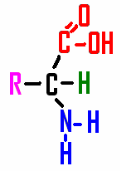
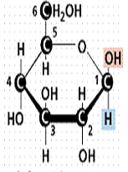

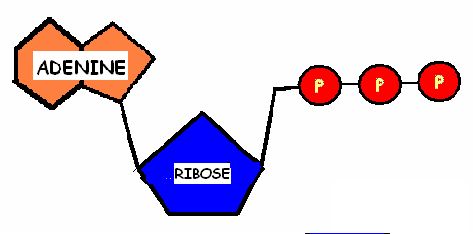
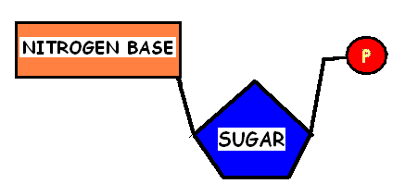

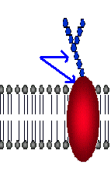
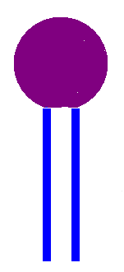

ORGANISM EVOLUTION
STEM CELL DIFFERENTIATION
METABOLISM HYDROGEN BOND
SEXUAL REPRODUCTION ASEXUAL REPRODUCTION

AUTOTROPH HETEROTROPH

HOMEOSTASIS STIMULUS

HYDROPHILIC HYDROPHOBIC

ENZYME DEHYDRATION SYNTHESIS

SUBSTRATE HYDROLYSIS

POLAR MOLECULE ACTIVE SITE

CARBOHYDRATE LIPIDS

NUCLEIC ACID PROTEIN
POLYSACCHARIDE DNA

NUCLEOTIDE RNA

AMINO ACID

GLUCOSE AMINO ACID

NUCLEOTIDE ATP

GLYCOPROTEIN PHOSPHOLIPID

