A LITTLE CHEMISTRY NAME ______________________ *
Chapter 2-1 and 2-2

MULTIPLE CHOICE:
Circle the letter for the ONE BEST answers that makes the sentence TRUE.

The attraction between the hydrogen atom in one water molecule and the negatively charged part of a nearby molecule is an example of a ____________________ bond.
A. polymer
B. acidic
C. hydrogen
D. ionic

ATOMS with an electric charge are called ________________.
A. molecules
B. electrons
C. polar
D. ions

MOLECULES that have an uneven pattern of electric charge (more positive in one area; more negative in another) are said to be _____________________
A. nucleic
B. polar
C. non-polar
D. ionic

A water molecule is made up of ___________________________.
A. two hydrogen atoms and one oxygen atom
B. one hydrogen atom and two oxygen atoms
C. one hydrogen atom and 3 carbon atoms
D. two hydrogen atoms and 1 sodium ion

Molecules that are really, really large are called ________molecules.
A. micro
B. macro

____________ molecules are “water fearing” and try to stay away from water or other polar molecules.
A. hydrophobic
B. hydrophilic

_________________ are written on the left hand side of the arrow in a chemical equation.
A. products
B. reactants

_________________ molecules are hydrophilic.
A. Polar
B. Non-polar

_________ ions are measured with a pH scale and determine the acidity of a solution.
A. Na+
B. C
C. K+
D. H+

USE words from the word bank below to LABEL THE FOLLOWING CHEMICAL REACTIONS
(Hint: Look to see what the water molecule is doing!)

DEHYDRATION SYNTHESIS OR HYDROLYSIS

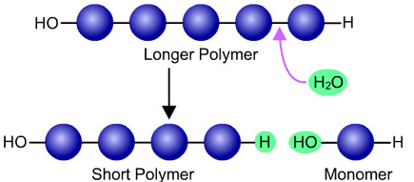 | 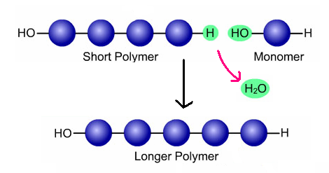

_________________________________________ _____________________________________

FILL IN THE CHARTS BELOW FOR ATOMS/IONS IMPORTANT TO LIVING THINGS:

ATOM NAME | SYMBOL
CARBON
NITROGEN
PHOSPHORUS
HYDROGEN
OXYGEN
IONS | SYMBOL
POTASSIUM ion
CHLORIDE ion
SODIUM ion
HYDROGEN ion

