BIOMOLECULES NAME ______________________ *
Chapter 2-3

MULTIPLE CHOICE:
Circle the letter for the BEST answer that makes the sentence TRUE.

NO other kind of atom can form the number and variety of molecules that ___________________ can because it can bond to 4 other atoms at the same time to make carbohydrates, lipids, nucleic acids, and proteins.
A. hydrogen
B. oxygen
C. carbon
D. sodium

A ____________________ is made up of a sugar, a nitrogen base, and a phosphate group.
A. amino acid
B. nucleotide
C. phospholipid
D. glycoprotein

Circle the nitrogen base NOT in RNA.

Adenine Thymine Guanine Cytosine Uracil

Lipids are DIFFERENT from other macromolecules because they ___________________
A. are hydrophobic and don’t dissolve in water
B. contain carbon, hydrogen and oxygen in a ratio of 1:2:1
C. dissolve easily in water
D. form large protein molecules
E. are hydrophilic

Glycogen, cellulose, and starch are all __________________.
A. proteins
B. polysaccharides
C. nucleic acids
D. lipids
E. phospholipids

Which 2 kinds of molecules combine to form cell membranes?
A. nucleic acids and carbohydrates
B. phospholipids and proteins
C. carbohydrates and nucleic acids
D. polysaccharides and RNA

Adenine, thymine, guanine, cytosine, and uracil are all _____________________
A. amino acids used to make proteins
B. carbohydrates used to make polysaccharides
C. lipids used to make phospholipids
D. nitrogen bases used to make nucleotides

Which part of a phospholipid molecule is NON-POLAR & HYDROPHOBIC?
A. the lipid “tails”
B. the glycerol/phosphate “head”

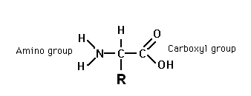
This molecule is a(n) ____________________________
A. nucleic acid
B. amino acid
C. phospholipid
D. carbohydrate

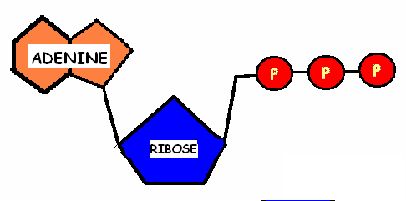
This molecule is ___________________
A. insulin
B. hemoglobin
C. glucose
D. a phospholipid
E. ATP

Glucose, ribose, and deoxyribose are all ____________________________
A. lipids
B. polysaccharides
C. monosaccharides
D. nucleic acids

DNA and RNA are both ____________________________
A. lipids
B. carbohydrates
C. nucleic acids
D. proteins

* * * * * * * * * * * * * *

MATCH THE MOLECULE WITH THE SUBUNIT THAT BUILDS IT:
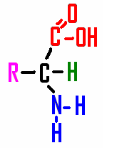
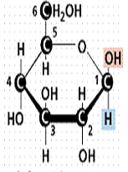
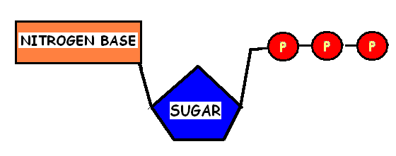
________ POLYSACCHARIDES

________ NUCLEIC ACIDS

________ PROTEINS

A B C

* * * * * * * * * * * * * *

Match the molecule with its description:

LIPIDS CARBOHYDRATES PROTEINS NUCLEIC ACIDS

____________________________ made by joining AMINO ACID SUBUNITS in long chains which provide a wide variety of functions in cells

____________________________ made from carbon, hydrogen, and oxygen atoms in a 1:2:1 ratio

____________________________ made from NUCLEOTIDE SUBUNITS which store and carry INFORMATION
____________________________ HYDROPHOBIC FATS, OILS, WAXES, AND STERIOIDS made mainly from
carbon and hydrogen atoms in long chains or multiple rings

COMPARE:  KINDS OF CARBOHYDRATES | # of SUGARS it contains | GIVE an EXAMPLE
MONOSACCHARIDES

POLYSACCHARIDES

COMPARE NUCLEIC ACIDS: | DNA | RNA
How many strands does it have? SINGLE or DOUBLE
Which NITROGEN BASES
does it contain?
Which SUGAR does it contain?

What is its FUNCTION?

MATCH MOLECULES FROM THE WORD BANK with their DESCRIPTION BELOW:

WATER HEMOGLOBIN GLYCOGEN CELLULOSE STARCH

DNA RNA INSULIN GLYCOPROTEIN PHOSPHOLIPID ATP

Protein hormone that tells animal cells to store blood glucose as glycogen
Double stranded nucleic acid made from nucleotides subunits containing A, T, G, and C that stores genetic info in cells
Protein found in red blood cells that carries oxygen to the body

Membrane protein with carbohydrates attached that helps cells identify “self” and plays a role in blood types, organ transplants, and germ recognition
Macromolecule with a polar glycerol/phosphate “head” and 2 non-polar hydrophobic “tails” used to make cell membranes
Single stranded nucleic acid made from nucleotide subunits
containing A, U, C, and G which carries information from the DNA to the cell for protein synthesis
Storage form of glucose used by plant cells

Storage form of glucose used by animal cells

Structural polysaccharide made from glucose subunits that makes plants sturdy
Nucleotide subunit made from ribose sugar, adenine, and 3 phosphates which stores and transports ENERGY in cells
Polar molecule made from 1 oxygen and 2 hydrogen atoms that is required by all living things

