ENZYMES 2-4 Name _______________________________

MULTIPLE CHOICE
Circle the letter of the answer that correctly completes the sentence.

Reactants in an enzyme catalyzed chemical reaction are called __________________
A. organics
B. products
C. substrates

The place on an enzyme where the substrate attaches is called the __________ site.
A. attachment
B. active
C. energy
D. stimulus

Macromolecule that can act as enzymes are ______________________.
A. proteins
B. lipids
C. nucleic acids
D. carbohydrates

When enzymes are placed in extreme pH or temperature conditions they unwind and change shape. This is called _________________
A. desensitizing
B. polarizing
C. denaturing

Enzymes are ___________________________
A. used up during chemical reactions
B. unchanged during chemical reactions and reusable
Which ending is often found at the end of enzyme names?
A. –ose
B. –ase
C. –ize
____________________________________________________________________________
MATCH EACH COMPONENT IN THE ENZYME CATALYZED REACTION BELOW WITH ITS NAME BY WRITING THE LETTER ON THE LINE PROVIDED.
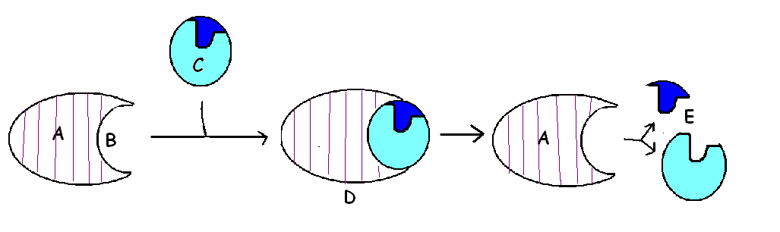
_____ PRODUCTS
_____ SUBSTRATE
_____ ACTIVE SITE
_____ ENZYME-SUBSTRATE COMPLEX
_____ ENZYME

