NAME ______________________________*

MITOSIS 10-1, 10-2, & 10-3 ?’s
(pp 240-252)

MULTIPLE CHOICE:
Circle the letter of the answer that best completes the statement.

DNA that is spread out in a non-dividing cell is called _____________________.
- chromosomes
- chromatin

The two copies of each chromosome that are the same size, same shape, and carry genes for the same traits are called ___________________________ chromosomes.
A. maternal
B. paternal
C. homologous

DNA that is scrunched up in a dividing cell is called _____________________.
A. chromosomes
B. chromatin

The two chromatid arms on a chromosome are ____________________.
A. identical copies
B. similar but not identical

Homologous chromosomes are _____________________.
A. identical copies
B. similar but not identical

Cells spend most of their lifetime in _____________________ phase of interphase.
- Mitosis
- S
- G₁
- G₂

The log-shaped structures that appear next to the nucleus during prophase to pull the chromosomes apart
are called _______________
A. centromeres
B. centrioles
C. chromatids

The framework of microtubules to which chromosomes attach during cell division which guides them to the poles is the _______________.
A. centrioles
B. centromere
C. spindle

USE WORDS FROM THE WORD BANK TO LABEL THE DIAGRAM:

CHROMOSOME CHROMATID CENTROMERE HOMOLOGOUS PAIR

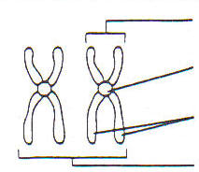
_______________________________

__________________________

__________________________

___________________________

* * * * * * * * * * * * * * *

MATCH THE PHASE WITH WHAT HAPPENS:
You CAN use them more than once!

Interphase (I) Prophase (P) Cytokinesis (C) Anaphase (A)

Telophase (T) Metaphase (M)

_______ DNA is all spread out as chromatin and nuclear membrane is visible

_______ DNA scrunches up and chromosomes are first visible

_______ Chromosomes line up in middle of cell

_______ DNA is copied and cell prepares to divide

_______ Chromatid arms separate and move to opposite ends of the cell

_______ Nuclear membrane & nucleolus disappear

_______ Two nuclei are visible

_______ First dividing phase

_______ Made up of G₁, S, G₂

_______ Centrosomes containing centrioles & spindle fibers appear next to nucleus

_______ Cytoplasm is split between two cells

_______ Spindle fibers and centrioles disappear

_______ Chromosomes unwind into chromatin & nucleus returns
USE WORDS IN THE WORD BANK TO IDENTIFY THE FOLLOWING PHASES OF MITOSIS:
Hint: look at what is happening in each cell

INTERPHASE METAPHASE CYTOKINESIS PROPHASE TELOPHASE ANAPHASE

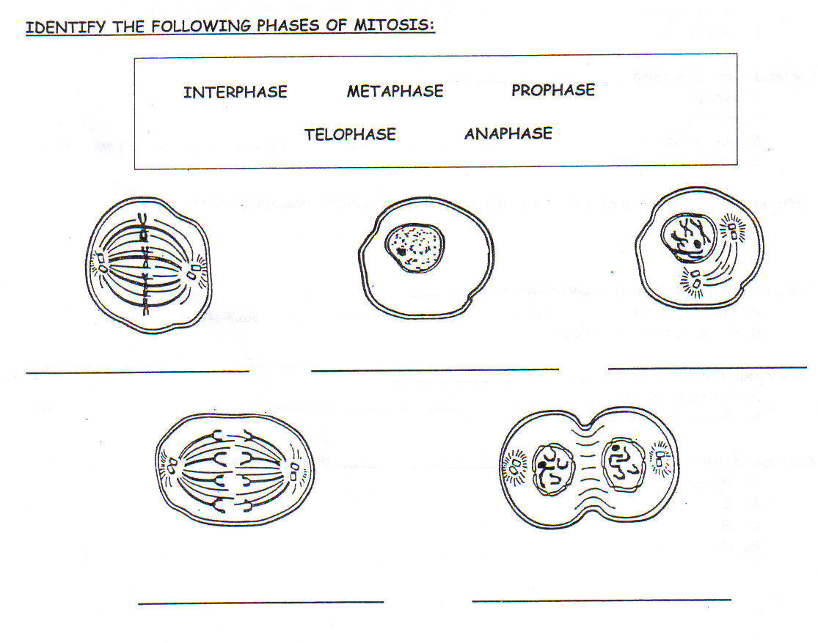
_______________ __________________ ____________________

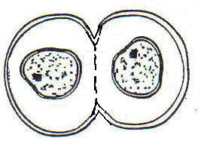

_________________ ___________________ ___________________

* * * * * * * * * * * * * * *

MATCH THE PHASE WITH WHAT HAPPENS:

S G₁ G₂ G₀ Mitosis (M)

_______ Cells leave the cell cycle and stop dividing

_______ Division of chromosomes happens; made up of telophase, anaphase, prophase, metaphase

_______ Cell makes the molecules and organelles needed for cell division

_______ Cell is reading the DNA code and “doing its job”

_______ Cell makes a copy of its DNA

