Name _________________________ *

PHOTOSYNTHESIS: An Overview
8-2 & 8-3

MULTIPLE CHOICE: CIRCLE THE ANSWER THAT BEST COMPLETES THE SENTENCE.

Pigments like (chlorophyll and carotene) are molecules that plants use to _________________________.
A. join ATP
B. transport electrons down the Electron Transport chain
C. charge up NADPH
D. absorb energy from light

Chlorophyll absorbs light very well in the _______________ regions of the visible spectrum.
(Circle all that are true)
A. blue-violet
B. green
C. red
D. yellow

Most plants appear green because chlorophyll _________________________________________.
A. reflects green light
B. absorbs green light

Which gas is given off by green plants during photosynthesis?
A. ATP
B. water vapor
C. carbon dioxide
D. oxygen

Which gas is taken out of the atmosphere and used by green plants during photosynthesis?
A. ATP
B. water vapor
C. carbon dioxide
D. oxygen

The Calvin cycle is another name for the __________________________ reactions.
A. light-independent
B. light-dependent

Where in the cell are the enzymes that help with the Calvin cycle?
A. cytoplasm
B. thylakoid space
C. stroma

Where in the cell are the enzymes that carry out the light dependent reactions found?
A. stroma
B. in the thylakoid membrane
C. in the cytoplasm
Circle ALL of the following that are REACTANTS in the light-dependent reactions.
A. CO₂
B. O₂
C. H₂0
D. ATP
E. NADPH
F. GLUCOSE

Circle ALL of the following that are PRODUCTS of the light-dependent reactions.
A. CO₂
B. O₂
C. H₂0
D. ATP
E. NADPH
F. GLUCOSE

Circle ALL of the following that are REACTANTS in the light-independent reactions.
A. CO₂
B. O₂
C. H₂0
D. ATP
E. NADPH
F. GLUCOSE

Circle ALL of the following that are PRODUCTS of the light-independent reactions.
A. CO₂
B. O₂
C. H₂0
D. ATP
E. NADPH
F. GLUCOSE

Which TWO molecules act as carriers for energy and high energy electrons during photosynthesis?
A. ATP
B. O₂
C. NADPH
D. CO₂

Name 3 factors that affect the rate at which photosynthesis occurs.
1. ___________________________

2. ___________________________
3. ___________________________

USE THE LETTERS IN THE DIAGRAM AT THE LEFT TO IDENTIFY:
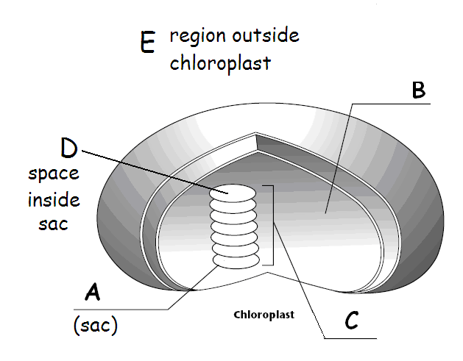
______ stroma

______ thylakoid

______ granum

______ thylakoid space

______ cytoplasm

* * * * * * * * * * * * * * *

Write the complete overall chemical equation for photosynthesis using chemical symbols AND NUMBERS instead of words:

___________
__________________ + ___________________ → __________________ + ___________________

In addition to water and carbon dioxide, what two things are required for photosynthesis to happen?

_______________________ and _______________________

Why are the carotenoid colors (like red, orange, brown) visible in leaves IN THE FALL, but NOT other times of the year?

___________________________________________________________________________________

