1. Which THREE colors (wavelengths) of light does chlorophyll absorb best?

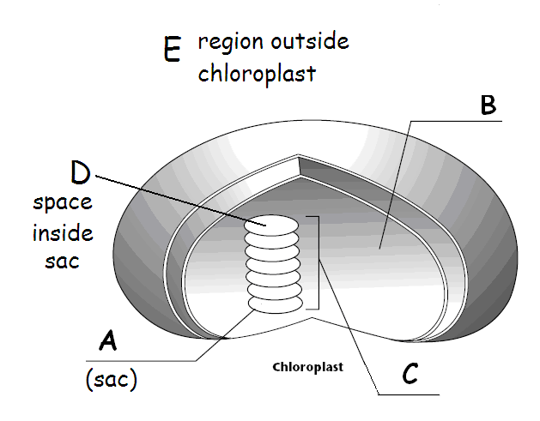
2. Which of these is a thylakoid?

3. This cup looks red because it _______ red light.
absorbs reflects

4. WRITE THE CHEMICAL EQUATION FOR PHOTOSYNTHESIS USING NUMBERS AND CHEMICAL SYMBOLS.

5. The other name for the LIGHT INDEPENDENT reactions is _______________.

6. Name the 3 products of the LIGHT DEPENDENT reactions.

7. Where does the CARBON and OXYGEN in GLUCOSE (C₆H₁₂O₆) come from?

8. Tell where the enzymes for the CALVIN CYCLE are found?

9. Name B.

10. Name the TWO molecules that act as carriers for energy and high energy electrons during photosynthesis.

11. Removing a P from ATP _________ energy.
stores releases

12. Name C.

13. Tell where the enzymes for the LIGHT DEPENDENT reactions are found.

14. Tell the REACTANTS in the CALVIN CYCLE.

15. Name the PIGMENT that makes plants green and helps with photosynthesis.

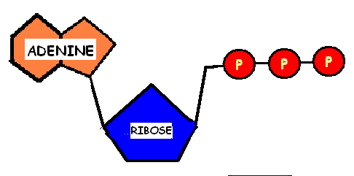
16. Name this molecule

17. Organisms (like green plants) that can make their own food are called ____________.

18. What gas is given off by plants during photosynthesis?

19. Name the part of photosynthesis during which ATP and NADPH and OXYGEN are made.

20. Increasing the intensity of light a plant receives would _________ the rate of photosynthesis.
increase decrease

