CELLULAR RESPIRATION NAME ___________________________ *
Chemical Pathways 9-1 pp 221-225

MULTIPLE CHOICE. Circle the answer that best completes the sentence.

_______________________ is the first step in cellular respiration that begins releasing energy stored in glucose.
A. Alcoholic fermentation
B. Lactic acid fermentation
C. Glycolysis

If oxygen is NOT present, glycolysis is followed by _____________________
A. Krebs cycle
B. electron transport chain
C. fermentation

Name the 3 carbon molecule produced when glucose is broken in half during glycolysis.
A. pyruvic acid
B. lactic acid
C. citric acid

Since fermentation does not require oxygen it is said to be __________________.
A. aerobic
B. anaerobic

What do Calories measure?
A. temperature
B. energy stored in food
C. amount of alcohol
D. pH

Name the TWO new high energy electron carriers used during cellular
respiration that are different than the one used for photosynthesis. _________ _________

GLYCOLYSIS results in the net production of ______ ATP’s.

0 1 2 3

Which gas is given off during ALCOHOLIC fermentation?

A. CO₂
B. O₂

MATCH THE LETTER IN THE DIAGRAM WITH THE LABEL:
(You can use them MORE THAN ONCE)
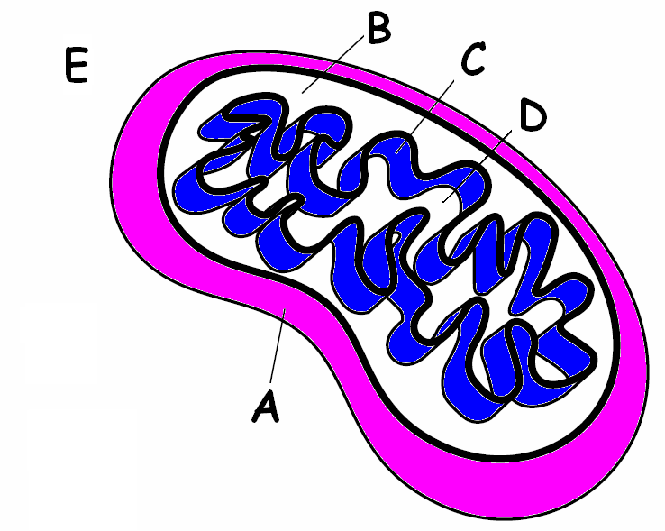
______ MATRIX

______ INTERMEMBRANE SPACE

______ CYTOPLASM

______ OUTER MEMBRANE

______ INNER MEMBRANE (CRISTAE)
______ Place GLYCOLYSIS happens

* * * * * * * * * * * * * *
Write the complete overall chemical equation for cellular respiration using NUMBERS AND CHEMICAL SYMBOLS instead of words:

____________ + _______________ → ________________+_________________+________________

Compare the equation for cellular respiration to the one you learned for PHOTOSYNTHSIS below.

light
6 H₂O + 6 CO₂ → C₆H₁₂O₆ + 6 O₂

How are these equations related?

_________________________________________________________________________________

* * * * * * * * * * * * * * *
Tell the kind of fermentation used in each example:
Yeast uses this to make bread dough rise ________________________

Your muscle cells use this during rapid exercise when oxygen is low ________________

Bacteria and yeast use this to make beer and wine _____________________

Bacteria use this to make cheese, yogurt, and sour cream ___________________

If alcoholic fermentation is used to make bread dough rise, how come you don’t become intoxicated when you eat the bread?

_____________________________________________________________________

