NAME ______________________________*

The Krebs Cycle and Electron Transport
9-2 pp 226-232

MULTIPLE CHOICE:
Circle the answer that best complete the statement.

Which of the following shows the correct sequence during cellular respiration?
A. Electron transport chain → glycolysis → Krebs cycle
B. Glycolysis → Electron transport chain → Krebs cycle
C. Krebs cycle → Electron transport chain → glycolysis
D. Glycolysis → Krebs cycle → Electron transport chain

Where do the NADH and FADH₂ produced in glycolysis and Krebs cycle go during cellular respiration?
A. They enter the electron transport chain and are used to make ATP
B. They become part of a carbon dioxide molecule and end up in the atmosphere
C. They enter fermentation and make alcohol and lactic acid

Because cellular respiration requires oxygen it is said to be _________________
A. aerobic
B. anaerobic

How many total ATP molecules are produced by 1 molecule of glucose completing cellular respiration ?

2 6 24 36

CIRCLE ALL OF THE FOLLOWING THAT ARE PRODUCED DURING THE KREBS CYCLE
(More than one correct)
A. ATP
B. NADH
C. FADH₂
D. CO₂

Which gas is taken in and used in cellular respiration?
A. carbon dioxide
B. oxygen

Which gas is released during cellular respiration?
A, carbon dioxide
B. oxygen

Which stage of cellular respiration produces the most ATP?
A. glycolysis
B. Krebs cycle
C. Electron transport

What molecule is produced at the end of the Electron transport chain when oxygen receives the electrons and hydrogens from NADH and FADH₂?
A. oxygen
B. carbon dioxide
C. glucose
D. water

Where do the carbons from glucose end up following cellular respiration?
A. enter the electron transport and end up as water
B. enter fermentation and become alcohol
C. exit to the atmosphere as CO₂ gas

WRITE OUT THE EQUATION FOR CELLULAR RESPIRATION USING NUMBERS AND SYMBOLS.

__________ + ___________ → ____________________ + _____________________ + ___________________

* * * * * * * * * * * * * * *

MATCH THE LETTER IN THE DIAGRAM WITH THE LABEL:
(You can use them MORE THAN ONCE or NOT AT ALL)
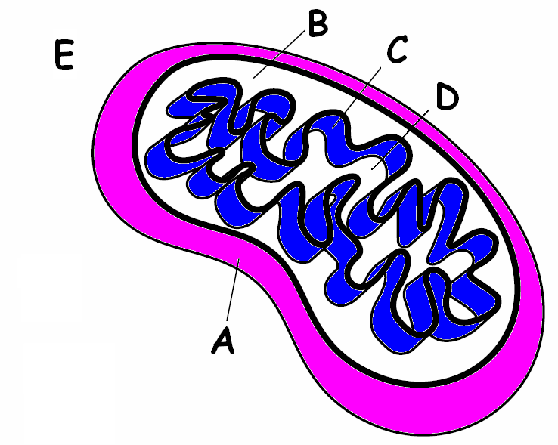
______ Place where glycolysis happens

______ Place where enzymes for the Electron
Transport Chain are located

______ Place where Krebs cycle happens

