OSMOSIS STUDY GUIDE NAME ________________________

Label the pictures below (isotonic, hypertonic, or hypotonic)
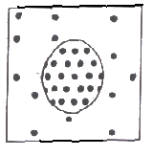 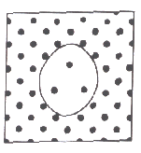 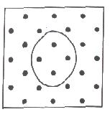
_________________ __________________ _________________

__________tonic means there is a GREATER concentration of solute molecules OUTSIDE the cell than inside.

__________ tonic means there is a LOWER concentration of solute molecules OUTSIDE the cell than inside.

__________tonic means there is the SAME concentration of solute molecules outside the cell as inside.

The pressure inside a plant cell caused by water pushing against the cell wall is called
___________________ pressure.

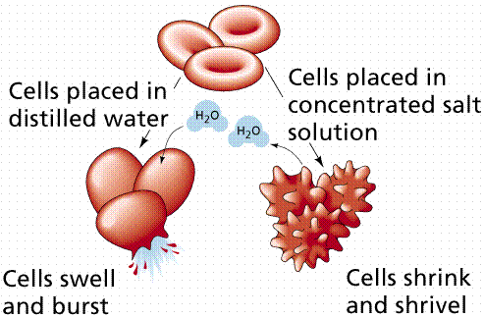
Water ________________ cells placed in a HYPOTONIC solution.
enters leaves

____________ cells can SWELL AND BURST, but plant cells have a
___________ ___________ to keep them from bursting.

Placing plant cells in a HYPOTONIC solution causes the osmotic pressure to
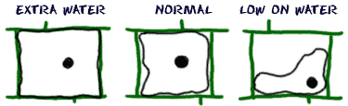
increase decrease (Circle ONE)

Plant and animal cells stay the same size when placed in an ________tonic solution because the amount of water leaving the cell is the same and the amount of water entering.

Placing plant cells in a HYPERTONIC solution causes the osmotic pressure to increase decrease
and the cell membrane will pull away from the cell wall. (Circle ONE)
Animal cells will SHRINK when placed in a
_________ tonic solution.

