NAME ____________________________

OSMOSIS & DIFFUSION LAB

WHAT IS THE IODINE TEST?

If STARCH is NOT PRESENT, what color will IODINE be? _______________________

If STARCH IS PRESENT, what color will IODINE be? ___________________________

FOLLOW DIRECTIONS ON THE STATION CARDS TO SET UP EXPERIMENT.
YOU MUST GO IN ORDER FROM #1 to #7.

* * * * * * * * * * * * *

QUESTIONS TO ANSWER WHILE EXPERIMENT IS RUNNING: NOTE: START OF EXPERIMENT BEGINS WHEN MEMBRANE TUBE IS DROPPED INTO THE CUP WATER!
Were there STARCH molecules INSIDE the membrane tube YES NO
at the START of the experiment?

How do you know? ___________________________________________________

Were there STARCH molecules OUTSIDE the membrane tube YES NO
in the CUP WATER at the START of the experiment?

How do you know? ___________________________________________________

Were there IODINE molecules INSIDE the membrane tube YES NO
at the START of the experiment?

How do you know? _________________________________________________________

Were there IODINE molecules OUTSIDE the membrane tube YES NO
in the CUP WATER at the START of the experiment?

How do you know? ___________________________________________________

* * * * * * * * * * * *

THINK ABOUT IT: WHAT COULD HAPPEN?
IF STARCH molecules stay in the membrane sac, what color would you expect the water in the cup to be at the end of the experiment?
A. clear
B. golden brown
C. black

IF STARCH molecules stay in the membrane sac, what color would you expect the water INSIDE THE BAG to be at the end of the experiment?
A. clear
B. golden brown
C. black

If some starch molecules pass through the membrane sac and move into the cup water where the iodine is, what color will the cup water be at the end of the experiment?
A. clear
B. golden brown
C. black

If ALL of the iodine molecules stay in the cup water and don’t enter the membrane sac, what color would you expect the WATER INSIDE the membrane sac to be at the end of the experiment?
A. clear
B. golden brown
C. black

If ALL of the iodine molecules stay in the cup water and don’t enter the membrane sac, what color would you expect the WATER IN THE CUP to be at the end of the experiment?
A. clear
B. golden brown
C. black

If some of the iodine molecules move from the cup water into the membrane sac with the starch, what color would you expect the membrane sac to be at the end of the experiment?
A. clear
B. golden brown
C. black



STOP HERE AND WAIT FOR EXPERIMENT TO RUN!

TEST AT END OF DAY 1: (Test at end of class)

What color is the water OUTSIDE THE MEMBRANE BAG in the cup? _______________________

What color is the water INSIDE the membrane bag? ________________________

QUESTIONS TO ANSWER AT THE END OF THE DAY 1:
Were there IODINE molecules OUTSIDE the membrane tube YES NO
IN THE CUP WATER at the END of the experiment?

How do you know? ___________________________________________________

Were there STARCH molecules OUTSIDE the membrane tube YES NO
at the END of the experiment?

How do you know? ___________________________________________________

Were there IODINE molecules INSIDE the membrane tube YES NO
at the END of the experiment?

How do you know? ____________________________________________________

Were there IODINE molecules INSIDE the membrane tube YES NO
at the END of the experiment?

How do you know? _________________________________________________________

What happened to the STARCH that was INSIDE THE MEMBRANE SAC at the start of the experiment?
A. Some of the starch molecules passed through the membrane sac and moved into the cup water.
B. ALL the starch molecules left the membrane sac and moved into the cup water.
C. All of the starch molecules stayed inside the membrane sac.

What happened to the IODINE that was IN THE CUP WATER at the start of the experiment?
A. SOME of the iodine molecules moved from the cup water into the membrane sac.
B. ALL the iodine molecules left the cup water and moved into the membrane sac.
C. All of the iodine molecules stayed inside the cup water.

STOP HERE AND WAIT UNTIL TOMORROW!

FINISH THIS EXPERIMENT THE NEXT DAY:
Carefully remove your membrane bag from the cup and check to see how the water level changed.
CAREFULLY dry off the membrane bag and use the SAME BALANCE you used yesterday to determine its mass.

___________________ = mass of membrane bag at beginning of day 2
-___________________ = mass of membrane at beginning of day 1
__________________________________________________________________

___________________ Difference in mass

What happened to the MASS of the membrane bag?
A. It decreased
B. It increased
C. It stayed the same

What happened to the WATER LEVEL in the cup?
A. It decreased
B. It increased
C. It stayed the same
What did the WATER molecules do during this experiment?
A. Water moved from the cup into the membrane sac.
B. Water moved out of the membrane tube into the cup.
C. The water level did not change.

FINAL QUESTIONS:
Which substances were able to pass through the membrane in this experiment?

starch iodine water

Which substances DID NOT pass through the membrane in this experiment?

starch iodine water

Draw a picture to show how the molecules moved during this experiment | Use RED dots for IODINE  Use BLUE dots for STARCH

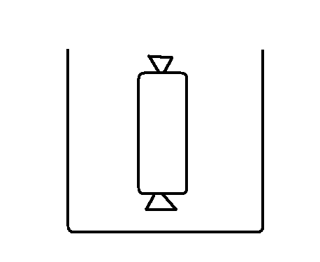

AT START OF EXPERIMENT AT END OF EXPERIMENT

Look at the molecular structure for GLUCOSE and STARCH below:
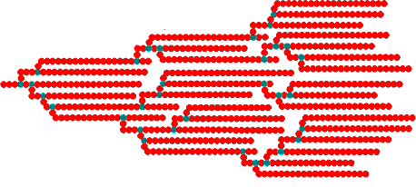
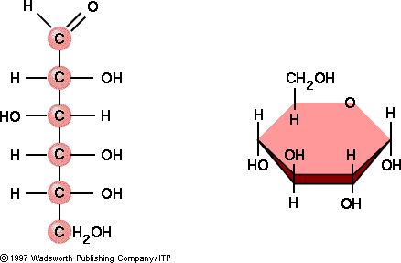

GLUCOSE

STARCH

WHY DO YOU THINK THE STARCH MOLECULES WERE NOT ABLE TO CROSS THE MEMBRANE AND GET OUT OF THE MEMBRANE BAG?

_________________________________________________________________

Membranes that allow certain molecules to pass
through but NOT others are called _______________________________________

What do we call the movement of WATER
across a selectively permeable membrane? ______________________________

