This is where you begin. You first need to go to the <https://members.k12.sd.us/> site and click on Member Sign-In. You will need to click on the gray Sign-In box down below.

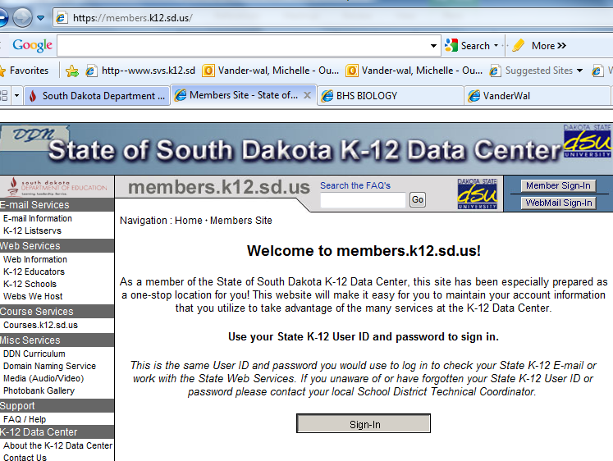



This is what next will appear for you. Click next on the blue Black Board Learning title.

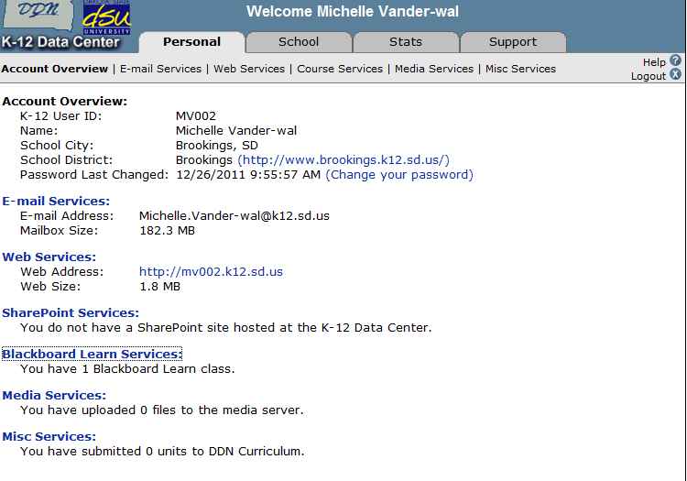



Put your class name that you wish to have in Class Name and Submit.

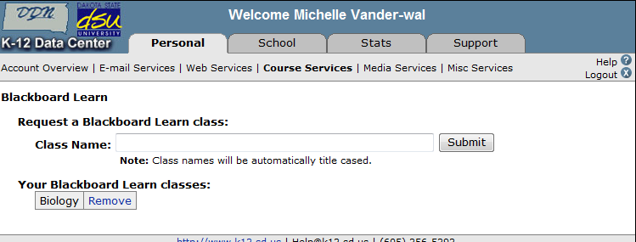



They will let you know through e-mail. This usually does not take long.