You may have to help students with the following steps. They have done them all semester but what can I say:

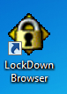 Students need to click on this icon.

The students need to first put in Username: bhstraining

Passcode: bhstraining1

If someone has trouble on the first sign in spot, I find the student usually has typed “bhstraining “ with an invisible blank.

Then the following window appears:

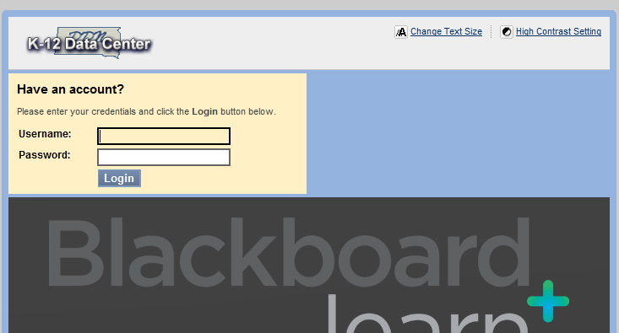

Each student has a Username: Password: assigned to them individually from the state. T

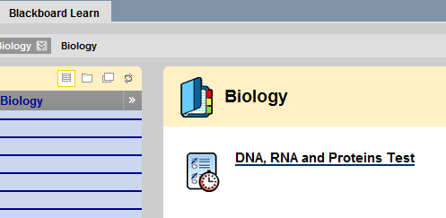



Now the student has to select the current chapter test.

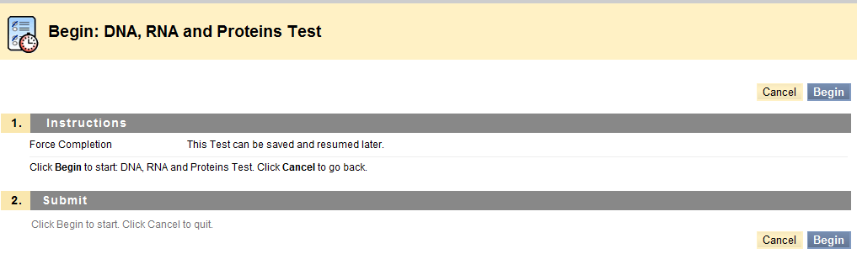 The student now can select either “Begin” and start their test.



Following the completion of the test, you do not need to record their results. The students who take it on computer will see their results. The score automatically is sent to me. I also receive an exact copy of their test too. It is pretty cool!! Many students will want to tell you their results. That’s OK. I try to keep the comments positive.

