**Students are Unable to See Their Assignments**

This is in my upper left hand corner.

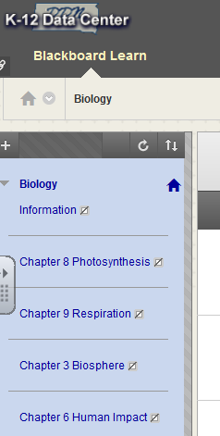



It has a choice “Hide Link” if you have a square with a line through it. Your link is hidden.



When you hover over the chapter you are interested in allowing your students to see.

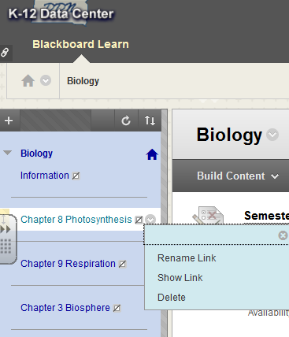

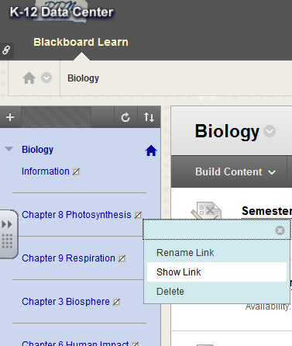

My students will now be able to see Chapter 8 Photosynthesis. If they are still not able to see all of their materials, you need to look at SETTINGS.