**How to Clear a Student Test Attempt**

After you click on the class title that you want to see your results, the Control Panel will appear in the lower left hand corner of the screen.



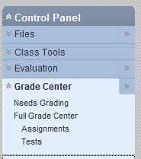



You select Control Panel🡪Grade Center🡪 Tests

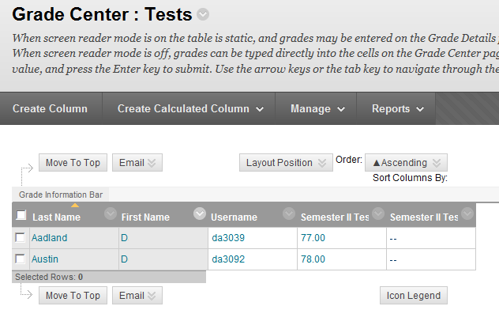

You would have all of your students visible row by row. I kept at the end of the year some students to show you an example.

Scroll to the student you are concerned about or need to look at their results. See that the 77 looks like nothing is there. Hover in the box with your cursor and the down arrow shows up. Select “View Grade Details”.

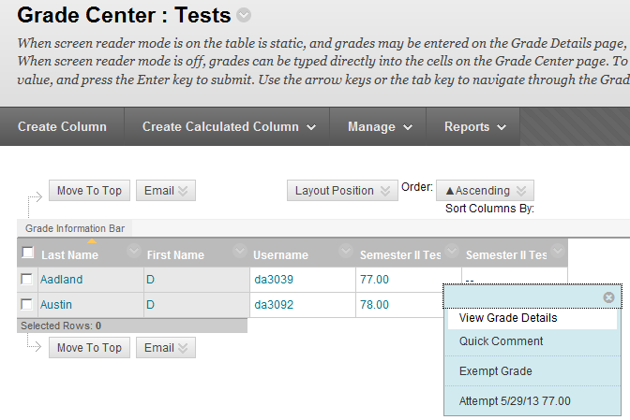



The only time I have had to clear an attempt was if a student had begun the test and somehow their computer turned off. I have the SETTINGS set so they only have one attempt at the test. If you clear the attempt they will be allowed in Blackboard Learn to start over.



Another problem I had once was the class had begun their test and the office announced they we had two minutes before they were shutting the server down. For every test we give on line, I have 30 copies of a bubble test as an alternative test. We know that that we are dependent on at least two servers for this program to work. Sometimes not all computers are working in a lab so having the paper copies allows you to use them as an option. Sometimes the computer log-in does not always work for the students. So you could have most students completing their test on-line and others completing them with a paper copy.

If you have IEP students who have to have their test read, I still do that with a paper copy. I have the SETTINGS set up that each student taking the test will have their questions randomly generated. I also have for most questions the internal parts changing the order for each student as well. The one great exception to randomizing the answers is the matching question. I manually choose the order I want to appear to the students.

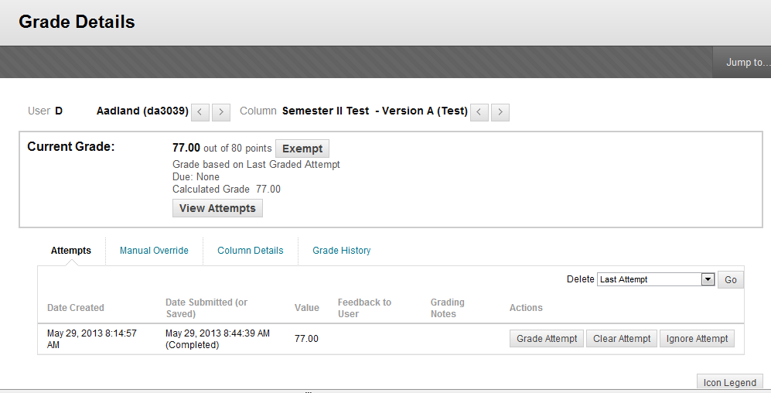



All you have to do to clear a student attempt is hit Clear Attempt.

You can also use this arrow to go to the next student’s grade details.

