**How to Make a Test**

**You first need to decide which class you are adding a test to.**

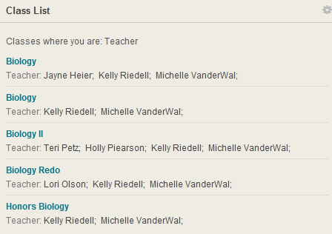



**I am going to build a new test into the first Biology listed above. I just click on it.**

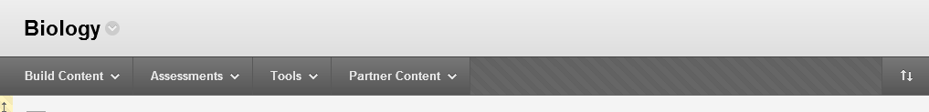



**We are going to choose Assessments.**

**Just hover over ASSESSMENTS and this drop menu appears. I want to highlight TESTS and then SUBMIT.**

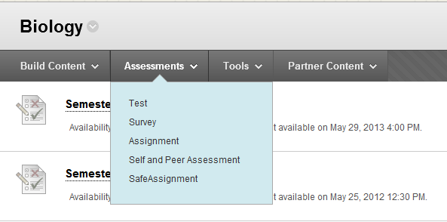



**Now we want to select CREATE.**

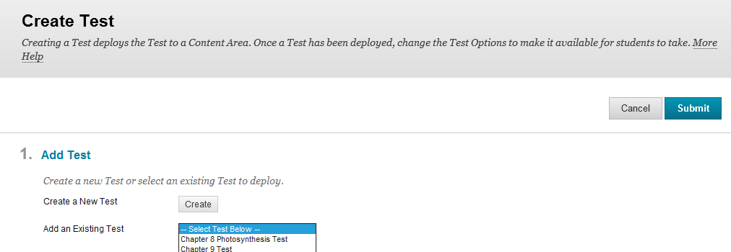



**You will need decide what you want to name your test.**

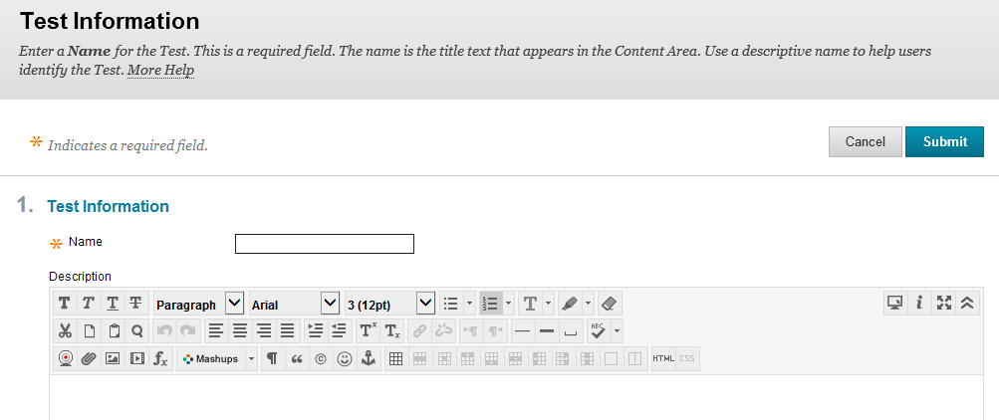



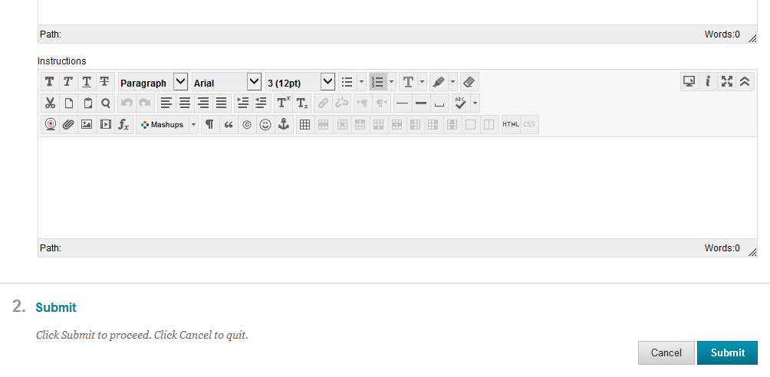



**And then SUBMIT. You can add a description about your test if you want one before submitting.**

**I want to name my test Ch 7 Transport Test and then click on SUBMIT. There are two different SUBMIT buttons. It does not matter which one you choose.**

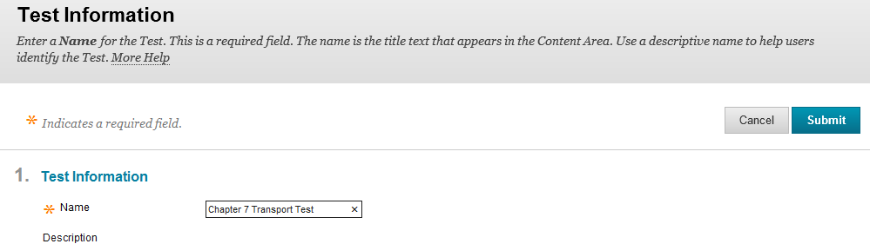



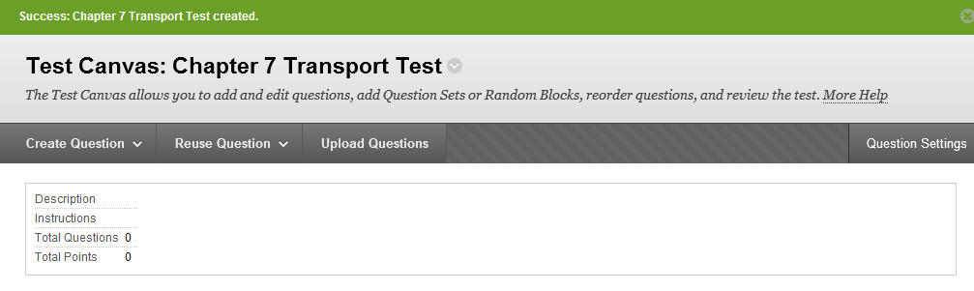

**The program is automatically set up that each question you generate will be worth 10 points. If you want each question to be a different value, you will want to click on QUESTION SETTINGS.**

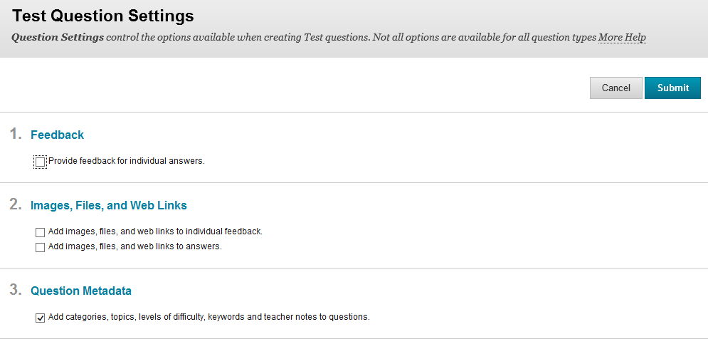

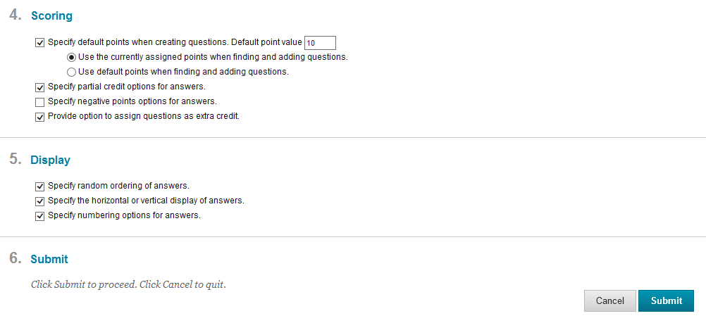



**You need to change under SCORING the DEFAULT POINTS VALUE of 10 to the value you want.**

**I want my test to be worth two points. So I deleted the 10 and switched the number to two and clicked on SUBMIT.**

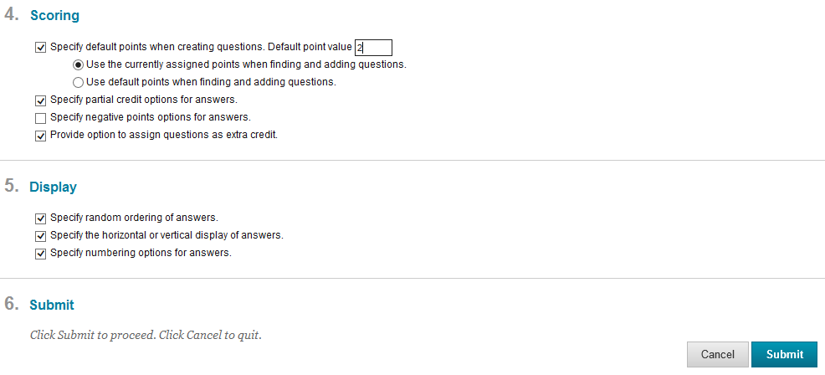



**QUESTION SETTINGS also can do each of the following. You can check out how to do this in the information included on our Blackboard Learn web site.**

**You Want to Add an Image to a Test Question- This also shows how to make a test question using the option MULTIPLE CHOICE.**

**You Want to Add an Image to a Test Answer - This also shows how to make a test question using MATCHING.**

**You Want an Extra Credit Question for a Test**

**Penalty Points for Multiple Answer Questions - This also shows how to make a test question with the option MULTIPLE ANSWER.**

**You have all of these choices you can use to build a test:**

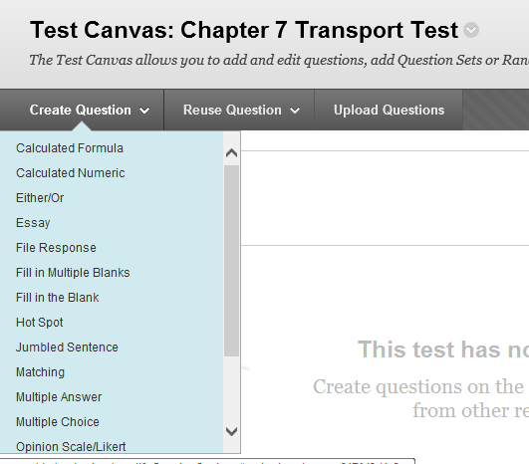



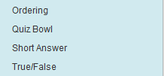

**I am going to select true/false.**

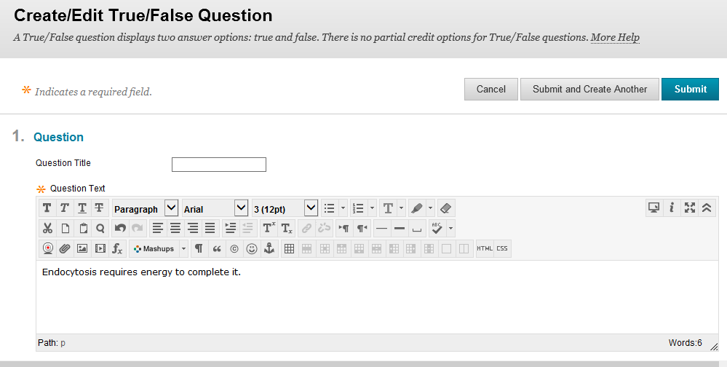



**I first typed in my statement.**

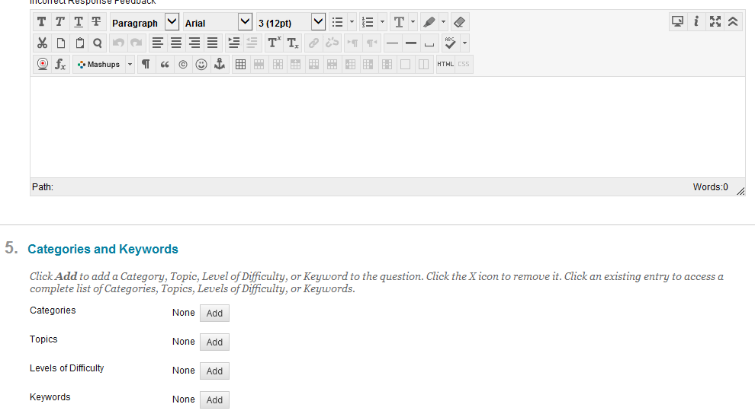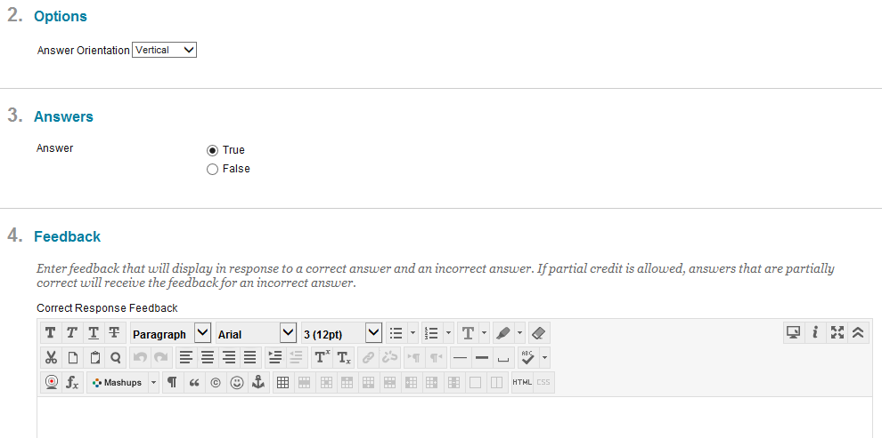



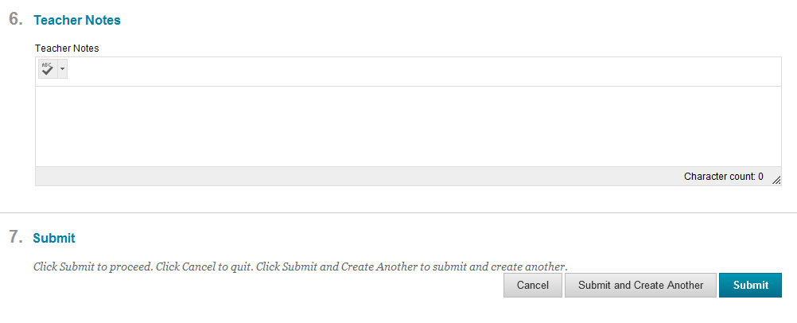



**If your statement was false, you would select false instead and click on SUBMIT & CREATE ANOTHER (if you want to do another true/false) or you can click on SUBMIT.**

**This is how a true/false looks from the student’s view:**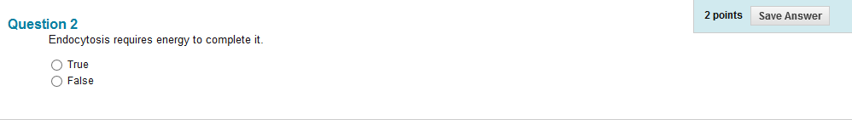

**We found SHORT ANSWER and ESSAY and FILL IN THE BLANK were much easier to grade on paper instead of grading it in Blackboard Learn.**

**Ordering was not tough to work with. Here is an example:**

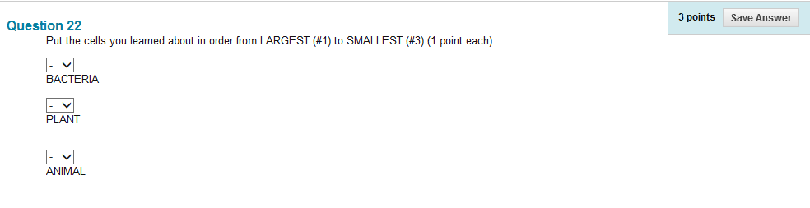

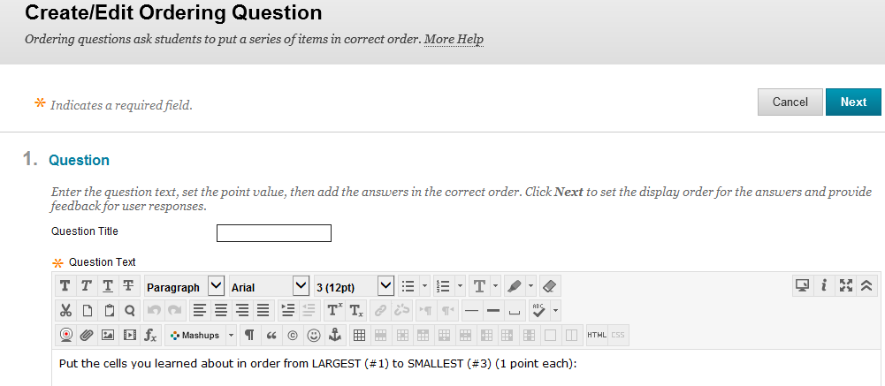

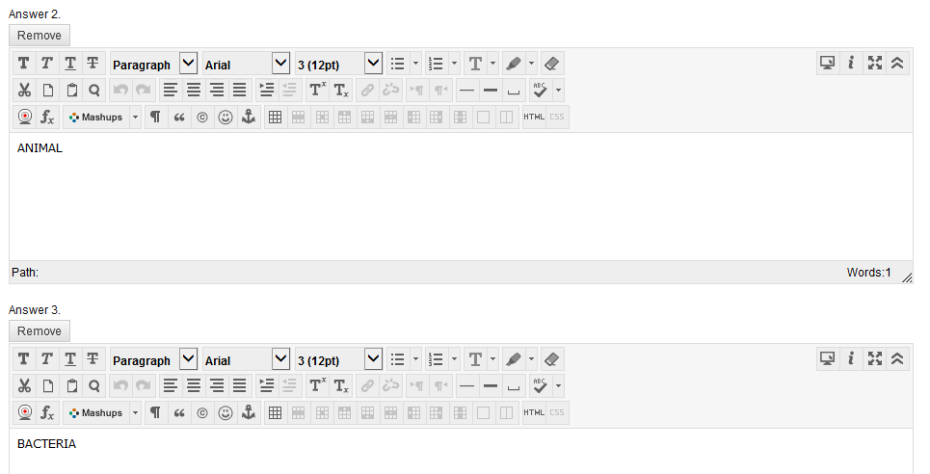

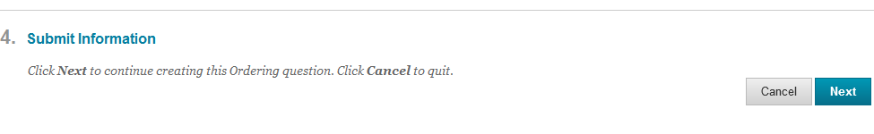



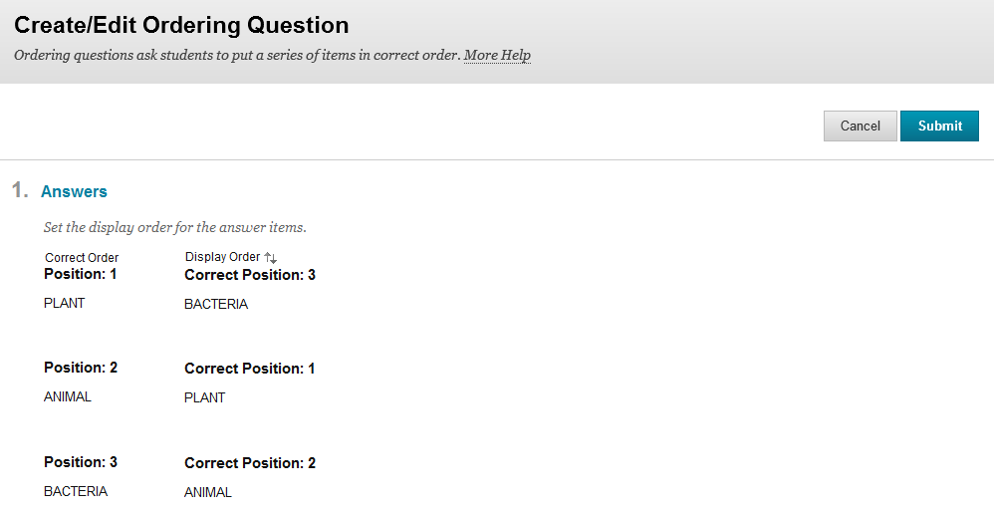



**And then you will scroll down and then click on SUBMIT.**

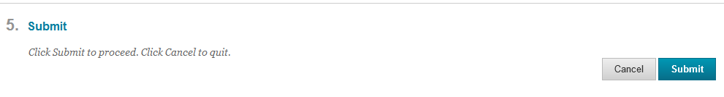



**To change the point totals from a 2 point to a 3 point question. You need to click on Points 3.**



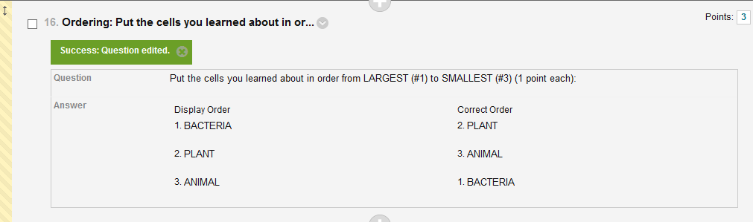

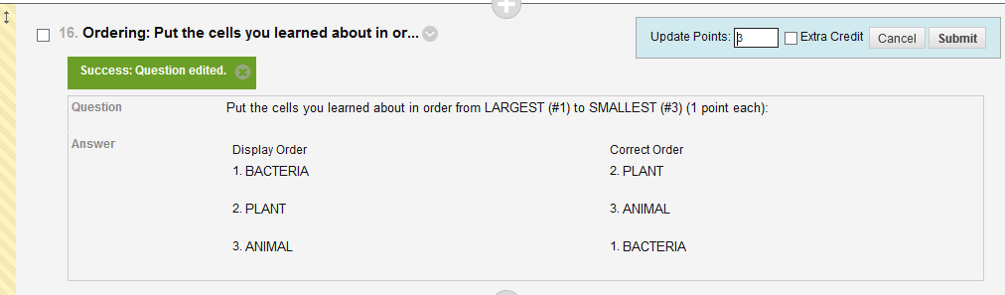



**Then change to the points you want this to be worth and click on SUBMIT.**

I addressed the test options that we use the most. Hot/spot would be something a geography teacher would use to have students locate countries on a map.

You need to locate your test. I am going to switch us to locating a test called CELL TEST. It should look something like this once you are all done with your test:

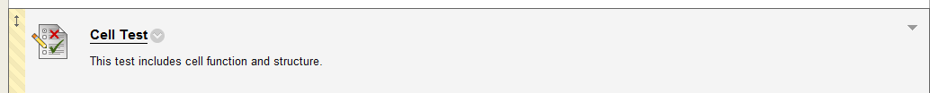



When you click on the arrow pointed down to the right of the test.

You will see the following options pop up:

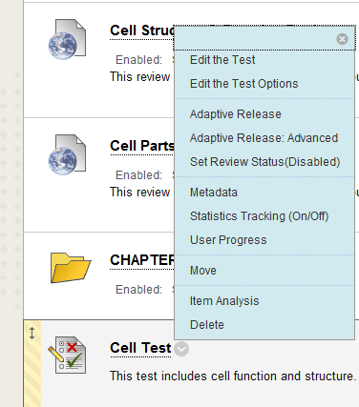



**If you want to set up your test so that you do not have to go into the test each semester and change when it is available to the students, you will want to set it up so it looks like the following:**

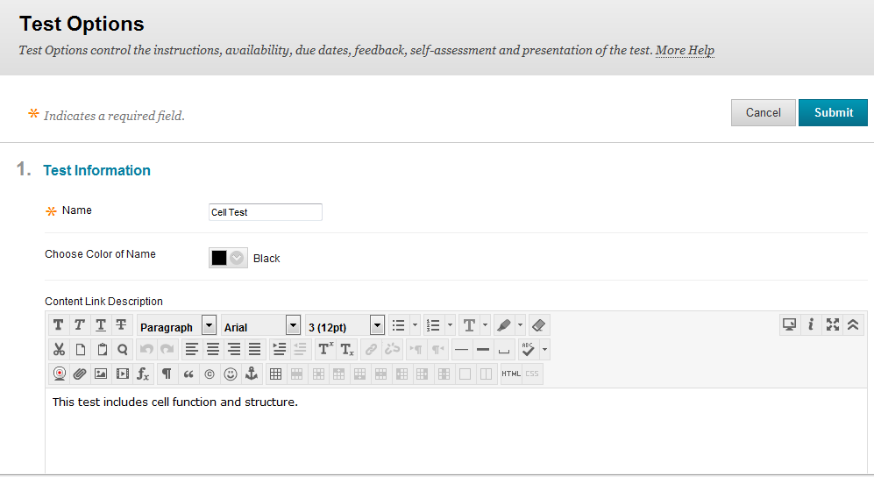



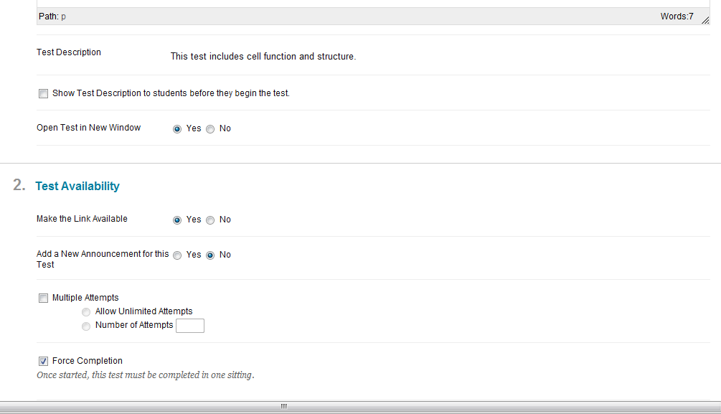



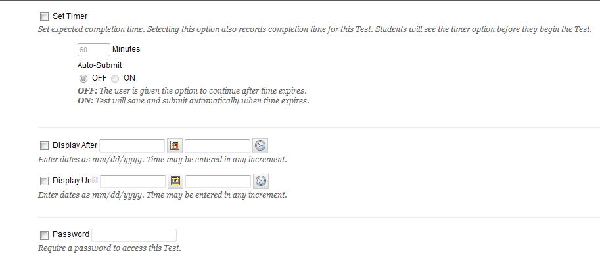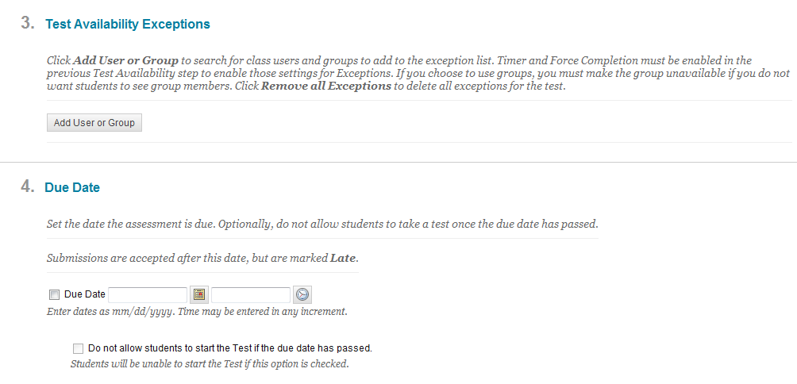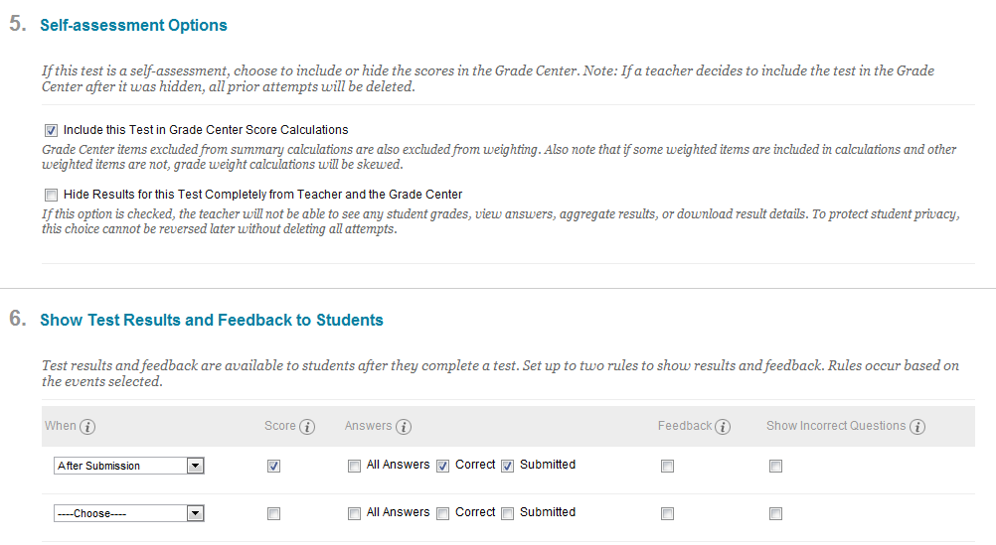



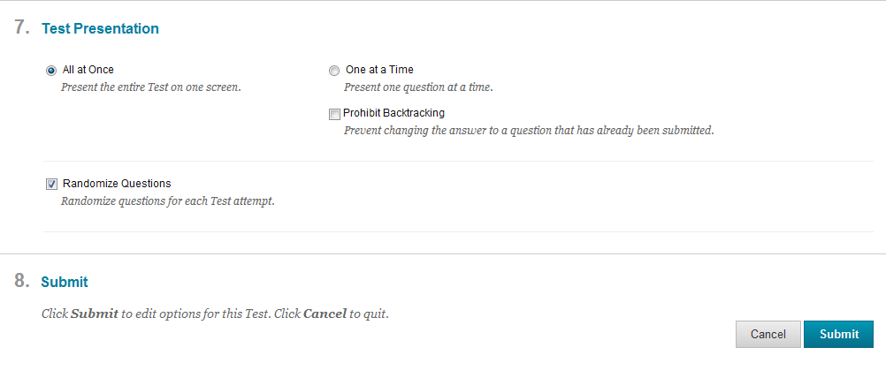



Then you click on submit.

You can go back multiple times to this setting.

**Limited Settings – We want our test to be available for a short time. These are the following changes that you want to make from the above choices:**

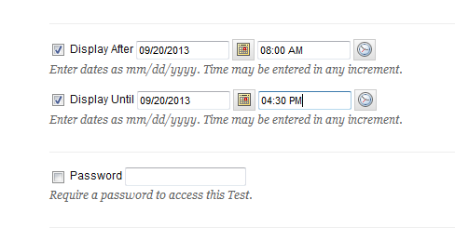



**On our semester tests, when we want to have the questions grouped together by chapters we do NOT select Randomize Questions.**

