**How to See Student Test Grades**

After you click on the class title that you want to see your results, the Control Panel will appear in the lower left hand corner of the screen.



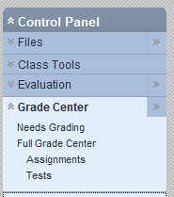



You select Control Panel🡪Grade Center🡪 Tests

